

UNIVERSITY OF COVENTRY

RCCMix : Efficient Geometry- and Context-Aware Models for Wearable Human Activity Recognition

by
Yuhao Wu
Supervisor: John Halloran

This dissertation was presented to the School of Science at Coventry University

A dissertation submitted was fulfillment for the degree of Master of computing project

November 2025

Research Dissertation: Declaration of Authorship

Print name: Yuhao Wu

Title of thesis: RCCMix : Efficient Geometry- and Context-Aware

Models for Wearable Human Activity Recognition

I declare that this dissertation and the work contained herein are my own and are the results of my original research.

I confirm that:

1. Coventry University holds the copyright to this project report and to any products developed from it.
- This project has received ethical approval; the application reference number is P189135.

Acknowledgements：
First and foremost, I would like to express my profound gratitude to my supervisor, John Halloran, for his continuous support and guidance throughout the duration of this project. I would also like to extend my sincere thanks to all the academic staff in my programme at Coventry University for their valuable contributions. Finally, I would like to express my appreciation to all the staff and students of Coventry University.

Signature: Yuhao Wu

Student ID: 15720661
Date: November 24, 2025

ABSTRACT
This dissertation investigates sensor-based human activity recognition (HAR) using body-worn inertial measurement units (IMUs), focusing on the joint optimisation of accuracy, model size, inference latency and energy consumption. A unified experimental pipeline is established on two public datasets—RealWorld HAR (waist-mounted IMU) and LARa MbientLab (wrist-mounted IMU)—with standardised preprocessing, 3-second windows and a strict Leave-One-Subject-Out (LOSO) protocol. Within this framework, six widely used baselines (K-Nearest Neighbours, Random Forest, InceptionTime, MiniRocket, MultiRocket and a Time-Series Transformer) and two recent state-of-the-art architectures (rTsfNet and DeepConvContext) are benchmarked in terms of predictive performance and computational cost. Building on insights from geometry-aware modelling (rTsfNet), contextual convolutional–recurrent architectures (DeepConvContext) and Transformer-style designs, the dissertation proposes three new models: RCCMix, Lightweight RCCMix and a Lightweight rTsfNet. RCCMix achieves a LOSO macro-F1 of 0.85 on RealWorld HAR using a single waist sensor, substantially outperforming all other models under the same protocol. RCCMix-Lightweight offers the most competitive overall performance–efficiency trade-off among all models. The Lightweight rTsfNet variant reduces the parameter budget from 3.66 MB to 1.55 MB, with LOSO macro-F1 decreasing only from 0.81 to 0.78 and with consistently improved latency and estimated energy usage. Beyond scalar scores, the study provides an in-depth analysis of model behaviour and interpretability, and introduces a rigorous, reproducible multi-dataset benchmark and multi-objective evaluation framework for real-world IMU-HAR deployment.

Contents

Research Dissertation: Declaration of Authorship 2
Acknowledgements： 2
ABSTRACT 3
Chapter 1 6
Introduction 6
Chapter 2 11
Literature Review: Wearable IMU-based Human Activity Recognition 11
2.1 Introduction and Scope 11
2.2 Wearable IMU-based HAR: Problem Setting and Datasets 14
2.3 From Classical Pipelines to Deep Time-series Models 17
2.4 Time-series-specific and HAR-specific Architectures 22
2.5 Evaluation, Robustness and Deployment Constraints 25
2.6 Synthesis: Limitations of Existing Work and Research Gap 29
Chapter 3 33
The entire experimental workflow 33
3.1 The entire experimental workflow is summarised as follows 33
3.2 Rationale for baseline and comparison models 35
Chapter 4 36
Datasets 36
4.1 RealWorld HAR (RWHAR) 36
4.2 LARa 37
Chapter 5 39
Datasets Preprocessing 39
5.1 Preprocessing of the RealWorld and LARa Datasets 39
Step 0: Reproducible environment setup 40
Step 1: Data acquisition, provenance recording and integrity checking 41
Step 2: File extraction and directory standardisation 42
Step 3: Sensor placement and channel selection 43
Step 4: Schema standardisation and column alignment 45
Step 5: Metadata audit and quality control 46
Step 6: Timestamp normalisation, alignment and resampling 47
Step 7: Signal filtering, unit conversion and outlier control 48
Step 8: Label mapping and label cleaning 49
Step 9: Leave-One-Subject-Out splitting and leakage prevention 50
Step 10: Sliding-window segmentation and window-level label assignment 51
5.2 Model-specific Input Construction, Hyperparameter Tuning and Training Protocol 58
Chapter 6 64
Baseline Models 64
6.1 KNN 64
6.2 Random Forest 66
6.3 Inceptiontime 68
6.4 Time series transformer 70
6.5 Minirocket 73
6.6 Multirocket 75
Chapter 7 78
State Of The Art Baseline Models 78
7.1 rTsfNet 78
7.2 DeepConvContext (three variants) 83
Chapter 8 90
Self-developed Models 90
8.1 rTsfNet Lightweight 90
8.2 RCCMix Lightweight and RCCMix 94
Chapter 9 103
Evaluation Methodology 103
9.1 Accuracy 103
9.2 Inference Latency (per window, HAR window, 3 s @ 50 Hz) 105
9.3 Model size (Example: RCCMix-HAR lightweight version size.ipynb) 107
9.4 Model Energy Consumption 109
9.5 Statistical Verification Methods for Algorithm Performance Evaluation (Friedman ，Nemenyi ，Wilcoxon and Cliff’s δ) 121
9.6 Model Calibration: NLL, Brier, ECE, and Temperature Scaling 124
9.7 Error analysis and diagnostic metrics(Confusion Matrix，Top-K Confusion Pairs，Subject Error Rate) 127
Chapter 10 131
Experimental setup 131
Chapter 11 136
Testing and adjustment 136
Chapter 12 142
Final Results and Evaluation 142
12.1 Accuracy, model size, inference latency, and energy consumption of all models 142
12.2 The significance testing of KNN, Random Forest, and InceptionTime on the RealWorld dataset 146
12.3 Sensitivity and robustness experiments for MiniRocket 148
12.4 Energy proxy for 6 baseline models 150
12.5 In-depth Analysis and Interpretability of RCCMix Lightweight 154
12.6 In-depth Analysis and Interpretability of RCCMix 158
12.7 Error Analysis of the Random Forest Baseline 163
12.8 Self developed models calibration results 164
Chapter 13 166
Discussion and Reflection 166
13.1 Discussion of Main Findings 166
13.2 Deployment Implications 167
13.3 Reliability, Robustness and Limitations 168
13.4 Reflection 170
Chapter 14 171
Conclusion and future work 171
14.1 Conclusion 171
14.2 Future Work 173
Chapter 15 175
15.1 Ethical Issues 175
15.2 Social Issues 178
15.3 Legal and Compliance Issues 180
Chapter 16 184
Project process 184
Reference 192
Appendices 202

Chapter 1

Introduction

Human activity recognition (HAR) using wearable sensors is an important area of ubiquitous and mobile computing. Inertial measurement units (IMUs), commonly integrated into smartphones, smartwatches and dedicated wearable devices, enable systems to recognise activities such as walking, running, sitting and climbing stairs. These capabilities support healthcare monitoring, rehabilitation, sports analytics, workplace safety and context-aware interaction. As HAR moves from controlled experiments towards real-world use, models must provide not only strong recognition performance but also low latency, compact size and energy-efficient inference.

Compared with camera-based systems, IMU-based HAR is relatively inexpensive, energy-efficient and privacy-preserving, and it can operate under varied lighting and environmental conditions. Nevertheless, IMU signals are noisy and are strongly influenced by sensor placement, orientation and differences in individual movement patterns. These factors make reliable generalisation to unseen users difficult, particularly when deployment relies on a single waist- or wrist-mounted sensor.

IMU-HAR methods have developed from classical classifiers based on manually designed statistical and frequency-domain features to deep-learning models that learn temporal representations directly from sensor signals. Representative approaches include convolutional and Inception-style networks, Rocket-family transforms and Transformer-based time-series models. More recent architectures, including rTsfNet and DeepConvContext, introduce geometry-aware or context-aware mechanisms to improve orientation robustness and capture longer-term temporal relationships.

Despite this progress, important limitations remain. Many studies use different datasets, preprocessing procedures and evaluation protocols, making direct model comparison difficult. Deployment characteristics—including model size, inference latency and energy consumption—are also frequently treated as secondary considerations. Furthermore, it remains unclear whether the principles underlying geometry-aware and context-aware models can be combined or simplified to achieve a better balance between predictive performance and computational efficiency.

This dissertation addresses these limitations through a unified evaluation framework for single-IMU HAR and the development of three new architectures: RCCMix, RCCMix-Lightweight and rTsfNet-Lightweight. Experiments are conducted on two complementary public datasets: RealWorld HAR using a waist-mounted IMU and LARa MbientLab using a right-wrist-mounted IMU. Both datasets are processed using consistent fixed-length windowing and label handling. A strict Leave-One-Subject-Out (LOSO) protocol is used, in which each subject is held out for testing in turn, thereby assessing whether a model can generalise to unseen users. Macro-F1 is adopted as the primary performance metric because it gives equal importance to every activity class, including less frequent classes.

The experimental study evaluates six established baselines—k-Nearest Neighbours, Random Forest, InceptionTime, MiniRocket, MultiRocket and a Time-Series Transformer—together with the recent rTsfNet and three DeepConvContext variants. All models are evaluated within the same general framework in terms of LOSO macro-F1, model size, inference latency and approximate energy consumption. Additional statistical, error, calibration and robustness analyses are performed to provide a broader understanding of model behaviour beyond predictive performance alone.

The three proposed models target complementary objectives. RCCMix combines geometry-aware conditioning with contextual temporal representation learning to prioritise recognition performance. RCCMix-Lightweight simplifies this design to improve deployment efficiency while retaining competitive performance. rTsfNet-Lightweight compresses the original rTsfNet architecture to reduce its storage and computational requirements.

The experimental results demonstrate the distinct strengths of the three proposed models. On RealWorld HAR, RCCMix achieves a LOSO macro-F1 of 0.8570, the highest score among all baseline and recent comparator models. On LARa, RCCMix obtains 0.4954. Although this is lower than InceptionTime’s 0.5199, it outperforms all evaluated state-of-the-art and proposed models while providing substantially lower inference latency than InceptionTime.

RCCMix-Lightweight offers the most competitive overall performance–efficiency trade-off among all models. On RealWorld HAR, it achieves a macro-F1 of 0.8114, closely approaching rTsfNet’s 0.8139, while delivering the shortest inference time among all evaluated models at only 0.69 ms, compared with 439.62 ms for rTsfNet. Its approximate energy consumption is also reduced from 2.020 mJ to 0.277 mJ per three-second window. On LARa, RCCMix-Lightweight slightly exceeds the original rTsfNet, with macro-F1 scores of 0.4663 and 0.4660, respectively.

rTsfNet-Lightweight provides a more direct model-compression trade-off. Relative to the original rTsfNet, it reduces model size from 3.66 MB to 1.55 MB, inference latency from 439.62 ms to 58.98 ms, and approximate energy consumption from 2.020 mJ to 0.447 mJ. Its RealWorld macro-F1 decreases moderately from 0.8139 to 0.7815. Overall, the results show that geometry- and context-aware architectures can be redesigned for substantially more efficient inference, although their effectiveness varies across sensor placements and datasets.

The main research question is:

How can accurate and computationally efficient HAR models be designed for waist- and wrist-mounted IMU settings?

This question is investigated through four supporting research questions:

RQ1: Under a strict LOSO protocol, how do classical, deep time-series and recent geometry- or context-aware models compare in terms of macro-F1?
RQ2: What trade-offs exist between macro-F1, model size, inference latency and approximate energy consumption across waist- and wrist-mounted settings?
RQ3: Can geometry-aware and contextual modelling principles be combined in RCCMix and RCCMix-Lightweight to improve predictive performance or deployment efficiency?
RQ4: To what extent can rTsfNet be simplified while preserving most of its recognition performance?

The dissertation makes four principal contributions. First, it establishes a consistent and reproducible evaluation framework across RealWorld HAR and LARa. Second, it provides a broad comparison of established and recent models under a common LOSO protocol. Third, it introduces RCCMix for stronger predictive performance, RCCMix-Lightweight for a favourable performance–efficiency balance, and rTsfNet-Lightweight for substantial compression of the original architecture. Fourth, it evaluates HAR models from a multi-objective perspective that considers predictive performance, model size, latency, approximate energy use, calibration, robustness and error behaviour.

The remainder of the dissertation is organised as follows. Chapter 2 reviews classical, deep-learning, geometry-aware and context-aware HAR methods. Chapters 4–5 describe the datasets, preprocessing and evaluation protocol. Chapters 6–7 present the baseline and recent comparator models, while Chapter 8 introduces the three proposed architectures. Chapter 12 reports and analyses the experimental results. Finally, Chapters 13–14 discuss the study’s limitations, summarise its contributions and identify directions for future research.

Chapter 2

Literature Review: Wearable IMU-based Human Activity Recognition

2.1 Introduction and Scope
Human Activity Recognition (HAR) refers to the use of computational models to infer high-level human behaviours from sensor observations. In wearable-sensor HAR, the input is typically a multichannel time series recorded by body-worn sensors, while the output is an activity label such as walking, running, sitting, stair ascent, stair descent, carrying, or a work-related action. With the growth of ubiquitous computing, mobile devices and wearable sensing, HAR has moved from early laboratory systems designed to recognise simple locomotion into an enabling technology for mobile health, active assisted living, smart eldercare, sports monitoring and industrial workflow analysis (Bulling et al., 2014; Lara and Labrador, 2013; Nweke et al., 2018). In these application areas, model outputs may support decisions about rehabilitation, fall risk, chronic-condition monitoring, workplace safety or task compliance. Therefore, the practical value of a HAR system depends not only on whether it achieves high offline classification accuracy, but also on whether it is generalisable, reliable and feasible for deployment.

A persistent challenge in HAR is the gap between controlled experimental evaluation and real-world use. Many early studies collected data under scripted laboratory conditions, with a limited number of participants, predefined activities, standardised sensor placements and relatively clean signals. Such datasets are useful for algorithm development because they make comparisons easier. However, they may also encourage a narrow focus on average accuracy under favourable assumptions. In real deployments, wearable HAR systems must deal with unseen users, different movement styles, variable wearing habits, sensor displacement, orientation changes, noise, class imbalance and limited hardware resources (Lara and Labrador, 2013; Nweke et al., 2018; Huang et al., 2024). A model that performs well under a random split on a familiar dataset may not necessarily perform well when deployed on a new person wearing the device in a different way.

From a deployment perspective, three requirements are especially important. The first is cross-subject generalisation. Since a large number of windows can be generated from a small number of participants, random window-level splits can accidentally place highly similar samples from the same subject in both training and test sets. This can produce overly optimistic performance estimates and does not answer the practical question of how the model performs on unseen users (Jordao et al., 2018; Braganca et al., 2022; Rehman et al., 2024; Tello et al., 2024). The second requirement is resource efficiency. Wearable devices such as smartwatches, waist-mounted nodes and logistics wristbands are constrained by memory, computation, latency and battery capacity. A high-performing model on a workstation or GPU may be unsuitable for continuous on-device inference if its model size, latency or energy demand is too high (Rashid et al., 2022; Daghero et al., 2022; Contoli et al., 2024). The third requirement is reliability of model outputs. In safety- or health-related settings, the system should not only classify activities accurately but also express uncertainty appropriately. Over-confident incorrect predictions can be more harmful than uncertain predictions, especially when users rely on the output as decision support (Guo et al., 2017; Nixon et al., 2019).

This chapter focuses specifically on wearable inertial measurement unit (IMU)-based HAR. HAR can be implemented using cameras, ambient sensors, WiFi, RFID and radar-based sensing, but this thesis does not attempt to review vision- or RF-based HAR systematically. Wearable IMUs, especially accelerometers and gyroscopes, are selected because they are small, low-cost, low-power and widely embedded in consumer and industrial devices. Compared with cameras, IMUs do not directly capture faces or scene imagery, making them more suitable for privacy-sensitive environments such as homes, hospitals and workplaces. Compared with ambient or RF infrastructure, IMUs can be worn by the user and do not require the environment to be instrumented in advance (Cornacchia et al., 2017; Cornacchia et al., 2017; Wang et al., 2019). These properties make IMU-based HAR particularly relevant for long-term, mobile and cross-scenario monitoring.

The scope of this review is aligned with the empirical part of the thesis. The experiments later use two public IMU-HAR datasets: RealWorld-HAR and LARa. RealWorld-HAR, introduced by Sztyler and Stuckenschmidt (2016), provides multi-subject, multi-placement wearable data for everyday activities. LARa, introduced by Niemann et al. (2020), focuses on logistics activity recognition in warehouse-like settings. In this thesis, the analysis uses the waist-mounted IMU in RealWorld-HAR and the right-wrist IMU in LARa. These two settings reflect realistic wearable form factors: waist or pocket-style sensing for daily activity recognition, and wristband or smartwatch-style sensing for logistics and industrial activity monitoring.

The purpose of the chapter is not to review each study separately. Instead, it synthesises the literature around four themes that directly support the research questions of this thesis. First, it reviews the development from classical feature-engineering pipelines to deep time-series models. Second, it examines time-series-specific and HAR-specific architectures, including InceptionTime, the ROCKET family, time-series Transformers, rTsfNet and DeepConvContext. Third, it discusses evaluation methodology, including subject-independent validation, macro-F1, calibration, statistical testing and error analysis. Fourth, it considers robustness and deployment constraints, including window configuration, sensor placement, channel selection, model size, latency and energy proxies. The chapter then identifies the central gap addressed by the thesis: the need for unified, deployment-oriented evaluation and lightweight model design for wearable IMU-based HAR under strict cross-subject conditions.

2.2 Wearable IMU-based HAR: Problem Setting and Datasets
Sensor-based HAR is usually formulated as a multivariate time-series classification problem. A wearable IMU records multiple sensor channels over time, commonly tri-axial acceleration and tri-axial angular velocity. If a recording contains T time steps and C sensor channels, the input can be represented as a sequence X in R^(T x C). Because activity labels are usually required at a manageable temporal resolution, the continuous stream is segmented into fixed-length windows, for example two to five seconds, with or without overlap. Each window is then assigned a single activity label using a dominant-label or majority-vote rule based on the annotations inside the window (Bulling et al., 2014; Lara and Labrador, 2013). This converts a continuous sensor stream into a set of window-level samples suitable for supervised classification.

Although windowing is common, it is not a neutral preprocessing decision. Window length determines the amount of temporal context available to the classifier. Short windows can reduce recognition latency and support more responsive systems, but they may not contain enough information to capture a complete gait cycle or a complex transition. Longer windows provide more stable evidence but increase delay and may merge multiple activity states into a single sample. Baños et al. (2014) showed that performance can vary substantially across different window lengths and that different activities have different optimal temporal scales. Wang et al. (2018) similarly reported that medium-length windows often offer a practical balance between responsiveness and accuracy in gait and posture recognition. Overlap can improve temporal coverage and increase the number of training windows, but Dehghani et al. (2019) showed that its apparent benefit can be exaggerated under subject-dependent random splits, while its computational cost remains real. Therefore, window length and overlap should be treated as modelling and deployment hyperparameters rather than fixed preprocessing details.

A second defining characteristic of wearable HAR is its subject-level structure. Generic time-series datasets may contain independent sequences, but HAR datasets often contain many windows generated from a small number of people. Windows from the same person share body shape, gait, movement habits, device fit and recording environment. Consequently, random splitting can produce train-test leakage even if the exact windows are not duplicated. To estimate performance on unseen users, subject-independent evaluation is needed. Leave-one-subject-out (LOSO) cross-validation is widely used for this purpose: in each fold, one participant is held out as the test set and the remaining participants are used for training and validation (Nweke et al., 2018; Jordao et al., 2018; Braganca et al., 2022). This protocol is stricter than random window-level splits and better matches real deployment scenarios in which a trained model is applied to a new user.

Sensor modality also affects the problem. A tri-axial accelerometer captures linear acceleration and gravity-related orientation information, while a gyroscope captures angular velocity. Accelerometers are often sufficient for broad locomotion and posture recognition, but gyroscopes can improve discriminability for rotational and transition-heavy activities such as stair ascent, stair descent, turning, carrying or task manipulation (Cornacchia et al., 2017; Wang et al., 2019; Zhang et al., 2022). However, adding gyroscope channels increases data bandwidth, storage, preprocessing cost and sensor power consumption. Therefore, the choice between accelerometer-only and accelerometer-plus-gyroscope input is both a modelling decision and a resource-allocation decision (Huang et al., 2024).

On-body placement is another major determinant of HAR difficulty. Sensors located near the body centre of mass, such as the waist or lower back, are generally effective for capturing global gait, posture and locomotion. Wrist or forearm sensors are more informative for hand movement, object manipulation and work-related actions, but they are also more exposed to incidental motion and noise (Cornacchia et al., 2017; Lawal et al., 2020). The same activity can produce very different signals at different body positions. For example, stair ascent recorded at the waist may reflect vertical acceleration and trunk motion, while the same activity recorded at the wrist may be affected by arm swing, load carrying or handrail use. Cross-placement transfer is therefore difficult, and many studies either fix a single placement or design position-aware or position-invariant models (Sztyler and Stuckenschmidt, 2016; Wang et al., 2019; Mekruksavanich and Jitpattanakul, 2024). This thesis focuses on single-placement settings that correspond to plausible deployment configurations: waist sensing for daily-life HAR and wrist sensing for logistics HAR.

RealWorld-HAR is a suitable benchmark for everyday IMU-based activity recognition. It was introduced by Sztyler and Stuckenschmidt (2016) as a multi-subject, multi-placement wearable dataset. Participants perform common activities such as walking, running or jogging, sitting, standing, lying, stair ascent, stair descent and jumping in everyday environments. Wearable devices are attached to several body locations, including chest, forearm, head, shin, thigh, upper arm and waist, and multiple inertial modalities are available. Compared with highly scripted laboratory datasets, RealWorld-HAR contains greater variation in movement style, environment and wearing condition. This makes it useful for studying cross-subject generalisation and position-dependent variability. Later work has also used RealWorld-HAR to demonstrate the difficulty of realistic subject-independent HAR evaluation (Bock et al., 2022). In this thesis, RealWorld-HAR is used as the representative daily-activity dataset, with the analysis restricted to the waist-mounted accelerometer and gyroscope channels.

LARa provides a complementary benchmark for industrial and logistics scenarios. It targets human activity recognition in warehouse-like environments and includes activities such as picking, carrying loads, loading, unloading, walking and stair-related movements (Niemann et al., 2020). The dataset includes wearable IMUs and additional sensing modalities such as optical motion capture and video. It also provides semantic attributes that describe task context, such as whether a worker is carrying a load or operating near a rack. This is important because, in logistics, the same nominal movement can vary significantly depending on workload, carried objects, speed and interaction with infrastructure. As a result, classification in LARa is closer to work-state recognition than to simple locomotion classification. In this thesis, the right-wrist IMU channel is used because it reflects a realistic smartwatch or logistics-wristband deployment scenario.

Together, RealWorld-HAR and LARa represent two complementary settings: free-living daily activity recognition and industrial logistics activity recognition. Both involve multiple participants, wearable IMU signals, heterogeneous movement patterns and non-trivial activity confusions, but they differ in placement, task structure and context. This combination allows the thesis to examine whether model families that appear strong in one setting remain robust, efficient and reliable in another. It also supports a more deployment-oriented evaluation of HAR models than would be possible with a single controlled laboratory dataset.

2.3 From Classical Pipelines to Deep Time-series Models
Before the widespread adoption of deep learning, most wearable-sensor HAR systems followed a classical machine-learning pipeline. This pipeline typically consisted of four stages: signal preprocessing and segmentation, hand-crafted feature extraction, optional feature selection or dimensionality reduction, and conventional classification (Lara and Labrador, 2013; Attal et al., 2015). It dominated early HAR research and remains important because classical models are transparent, mature and often competitive under limited-data or resource-constrained settings.

The central component of classical HAR is feature engineering. After the continuous sensor stream is segmented into windows, each window is converted into a feature vector. Common time-domain features include mean, variance, standard deviation, minimum, maximum, root mean square, zero-crossing rate and inter-axis correlation. These features describe intensity, variability and relationships between axes. Frequency-domain features, often derived using the fast Fourier transform or wavelet transform, include dominant frequency, energy distribution, power spectral density and spectral entropy. They are particularly useful for periodic activities such as walking and running (Lara and Labrador, 2013; Attal et al., 2015). Other physically motivated descriptors, such as signal magnitude vector, signal magnitude area, posture-related angles and geometric relationships, encode domain knowledge about orientation, movement intensity and body posture (Rosati et al., 2018).

Several studies have shown that feature design is not simply a matter of increasing dimensionality. Rosati et al. (2018) compared feature combinations across datasets and found that very large feature sets do not necessarily outperform compact and carefully selected subsets. Bennasar et al. (2022) analysed a large set of candidate features and found that a relatively small number of statistical and spectral descriptors can provide strong discriminative power across multiple scenarios. Huang et al. (2024) similarly emphasised that the value of handcrafted features lies in encoding domain knowledge in a structured way rather than merely expanding the feature space. These findings show that classical pipelines can remain effective when features are well aligned with the target activity and sensor configuration.

When feature dimensionality is high, feature selection or dimensionality reduction is often introduced to reduce redundancy, mitigate overfitting and improve computational efficiency. Filter-based methods such as mutual information, Relief-F and minimum redundancy maximum relevance aim to retain features that are strongly associated with class labels while avoiding redundant information (Wang et al., 2019; Bennasar et al., 2022). Projection methods such as principal component analysis and linear discriminant analysis transform the feature space into lower-dimensional representations (Serpush et al., 2022). However, segmentation, feature selection and classifier design interact in complex ways. Jordao et al. (2018) noted that different preprocessing and validation choices can lead to substantial differences in reported results, which makes fair cross-paper comparison difficult.

Classical classifiers commonly used in HAR include k-nearest neighbours, decision trees, random forests, support vector machines and naive Bayes. Bao and Intille (2004) were among the early studies showing that simple classifiers could achieve strong performance on multi-position accelerometer data. Ravi et al. (2005) further evaluated decision trees, kNN, naive Bayes and other methods on accelerometer-based activity recognition, demonstrating the practicality of conventional machine learning for wearable HAR. Random forests are particularly useful because they combine multiple decision trees through bagging, often improving generalisation while retaining some interpretability. They are therefore frequently treated as strong classical baselines in HAR surveys (Attal et al., 2015; Wang et al., 2019). Support vector machines can perform well in high-dimensional feature spaces, but kernel computation may become costly in large-scale or online settings (Lara and Labrador, 2013).

The advantages of classical pipelines are clear. They are modular, interpretable and relatively easy to implement. Each stage can be inspected separately, making it possible to analyse how window configuration, feature design and classifier choice affect performance. Classical models can also be compact and suitable for deployment when the feature set is small and the classifier is efficient. In some limited-data settings, carefully designed features combined with kNN or random forests can match or outperform more complex deep models (Rosati et al., 2018; Bennasar et al., 2022). For this reason, classical baselines remain necessary in systematic HAR evaluation.

However, classical pipelines also have important limitations. Feature engineering depends heavily on domain expertise and may need to be redesigned for new sensors, activity sets, body placements or sampling rates. Treating each window as a static feature vector limits the ability to model long-range temporal dependencies, multi-scale patterns and complex interactions between sensor channels. Furthermore, because many design decisions are made manually, the pipeline can become difficult to reproduce and compare fairly across studies (Jordao et al., 2018). These limitations motivated a shift toward deep time-series models that learn representations directly from raw or lightly processed IMU signals.

Deep learning introduced end-to-end representation learning into HAR. Instead of manually defining features, models such as convolutional neural networks, recurrent neural networks, long short-term memory networks, gated recurrent units and hybrid CNN-RNN architectures learn discriminative representations from data (Ismail Fawaz et al., 2019; Zhang et al., 2022; Kaseris et al., 2024). One-dimensional CNNs slide learnable kernels along the temporal axis and automatically extract local motion patterns, such as a step, a short arm movement or a transition. Early work by Zeng et al. (2014) and Yang et al. (2015) demonstrated the effectiveness of convolutional feature learning for mobile and wearable sensor-based activity recognition. Moya Rueda et al. (2018) later showed that CNN-based approaches can perform strongly when window lengths and model structure are appropriate.

Recurrent models provide a different mechanism for temporal modelling. LSTMs and GRUs update hidden states over time and are therefore designed to capture temporal order and longer dependencies. Hammerla et al. (2016) investigated deep, convolutional and recurrent models for wearable activity recognition and showed that recurrent structures can be useful when activities depend on temporal evolution. However, applying recurrent models directly to high-frequency IMU sequences can increase training difficulty and inference latency. Bai et al. (2018) argued in broader sequence modelling that convolutional temporal architectures can offer stable and efficient alternatives to recurrent networks. In HAR, a common compromise is to combine CNN layers for local encoding with LSTM or GRU layers for sequence aggregation. DeepConvLSTM-style architectures are representative of this approach and have been validated in multimodal wearable activity recognition (Ordóñez and Roggen, 2016; Hernandez et al., 2020).

More general deep time-series architectures have further extended HAR modelling. Residual convolutional networks use skip connections to train deeper one-dimensional CNNs and increase the receptive field without severe optimisation problems (Ismail Fawaz et al., 2019). Temporal convolutional networks use dilated convolutions to capture long temporal dependencies while preserving parallel computation (Bai et al., 2018). Attention mechanisms and Transformer-style models allow the model to weight informative time points or channels dynamically and to model dependencies without recurrence (Vaswani et al., 2017; Chandramouli et al., 2024). These developments show that deep HAR is moving away from single architecture recipes toward modular combinations of convolution, recurrence, dilation, residual learning and attention.

Nevertheless, deep models do not remove the need for careful evaluation. Many wearable datasets contain relatively few subjects, whereas deep models can contain many parameters. Without rigorous subject-independent validation and regularisation, they may overfit to subject-specific patterns. Moreover, many deep HAR papers still focus mainly on accuracy or F1 and do not systematically report latency, energy, calibration or statistical significance (Zhang et al., 2022; Huang et al., 2024). Therefore, the transition from classical pipelines to deep learning expands the design space but also increases the need for deployment-aware and statistically grounded evaluation.

2.4 Time-series-specific and HAR-specific Architectures
The broader time-series classification community has developed architectures that are more specialised than generic CNNs or RNNs. These methods are relevant to this thesis because they provide strong baselines and design principles for IMU-based HAR. The main families considered here are InceptionTime, the ROCKET family, time-series Transformer-style models, and HAR-specific geometry- and context-aware models such as rTsfNet and DeepConvContext.

InceptionTime represents the multi-scale convolutional direction. It adapts the Inception module to one-dimensional time series by applying multiple convolutional kernel lengths in parallel and stacking the resulting modules with residual connections (Ismail Fawaz et al., 2020). On large UCR/UEA time-series benchmarks, InceptionTime has been shown to provide a strong balance between accuracy and training efficiency. For IMU-based HAR, this architecture is attractive because human activities contain temporal patterns at several scales. Short kernels may capture brief impacts or transitions, while longer kernels may capture gait cycles or sustained posture patterns. Multi-scale convolution therefore reduces dependence on a single manually selected temporal scale and can represent both short-lived and sustained movement components (Ismail Fawaz et al., 2019; Ruiz et al., 2021).

The ROCKET family takes a different approach. ROCKET applies a large number of randomly generated convolutional kernels to a time series and extracts simple summary statistics from the convolution outputs before training a linear classifier (Dempster et al., 2020). MiniROCKET constrains the kernel configuration to make computation much faster and more deterministic, while MultiROCKET extends the representation by using additional pooling operators and transformed sequences (Dempster et al., 2021; Tan et al., 2022). Large-scale comparisons have shown that ROCKET-family methods can achieve highly competitive accuracy with extremely fast training, making them strong workhorse baselines for time-series classification (Ruiz et al., 2021). In wearable HAR, MiniROCKET is particularly appealing because it offers strong accuracy-efficiency trade-offs without expensive end-to-end neural training. However, the high-dimensional transformed representation can still create memory and classifier-training costs under large LOSO experiments.

Transformer-style models represent the self-attention direction. A Transformer encoder models pairwise relationships between time steps using self-attention, allowing the model to capture dependencies without recurrence (Vaswani et al., 2017). Time Series Transformer-style models adapt this idea to multivariate sequences and have been applied to time-series classification and regression tasks (Zerveas et al., 2021; Wen et al., 2023). In HAR, self-attention is conceptually useful because some activities depend not only on local patterns but also on how movement evolves across a window or across neighbouring windows. Attention can also be used to emphasise informative time segments, channels or sensor locations (Zhang et al., 2022; Chandramouli et al., 2024).

However, Transformers are not automatically superior for wearable IMU-HAR. IMU signals often have strong local structure, moderate window lengths and limited subject counts. Standard self-attention can be parameter-intensive and sensitive to training data size. Empirical HAR studies often find that well-designed CNNs or CNN-RNN hybrids can match or outperform attention-heavy models under lower computational budgets (Hammerla et al., 2016; Moya Rueda et al., 2018; Zhang et al., 2022). Therefore, in this thesis, a Time Series Transformer-style model is treated as a representative of the attention-based family rather than as an assumed best-performing architecture. Its purpose is to test whether explicit long-range dependency modelling improves cross-subject HAR under the same protocol and deployment-related metrics as other models.

In parallel with generic time-series architectures, recent HAR-specific models have begun to incorporate domain knowledge about IMU geometry and behavioural context. rTsfNet is representative of geometry-aware modelling (Enokibori et al., 2024). Acceleration and angular velocity are three-dimensional vector signals, and their observed x-, y- and z-axis components depend on sensor orientation. If a device is rotated or worn differently, the raw waveform may change even when the underlying movement remains similar. Conventional CNNs and Transformers often treat sensor axes as ordinary channels and rely on data augmentation or training data diversity to handle this variability. rTsfNet instead introduces a rotation-aware mechanism that projects IMU signals into learned coordinate systems and extracts time-series features from these transformed representations. This combines physical intuition about 3D motion with trainable representation learning.

DeepConvContext represents the context-aware direction. Many HAR models classify each window independently, but real activities unfold over time and neighbouring windows often provide useful behavioural context. DeepConvContext first encodes short windows using a convolutional-recurrent module and then applies a second-level sequence model over the sequence of window embeddings (Bock et al., 2025). This creates a local-global hierarchy: the lower level captures within-window motion patterns, while the upper level models cross-window temporal context. Such modelling is useful when the same short movement has different meanings depending on what occurred before or after it. In logistics HAR, for example, a local wrist movement may represent different task states depending on the surrounding work sequence.

The relationship between these model families reveals an important gap. InceptionTime provides strong multi-scale convolutional learning, while ROCKET-family methods provide efficient random convolutional representations. Transformers offer flexible dependency modelling, rTsfNet introduces IMU-aware rotational modelling, and DeepConvContext introduces cross-window context. However, these ideas are often developed separately. rTsfNet focuses primarily on geometry rather than long-horizon context; DeepConvContext focuses on context rather than explicit IMU vector geometry; and generic TSC backbones are often evaluated without the full deployment constraints of wearable HAR. This suggests an opportunity to investigate whether multi-scale temporal modelling, geometric robustness and lightweight context aggregation can be combined within compact and deployment-oriented architectures.

For this thesis, these architectures serve two purposes. First, they define a representative model landscape for systematic comparison: classical baselines, deep CNN/RNN models, time-series-specific methods, self-attention models and HAR-specific geometry/context-aware models. Second, they motivate the design of new lightweight architectures that combine complementary strengths while controlling parameter count, latency and energy-related cost. The goal is not simply to obtain the highest score on one dataset, but to identify models that offer robust trade-offs across accuracy, cross-subject generalisation, calibration and deployability.

2.5 Evaluation, Robustness and Deployment Constraints
Evaluation methodology is central to HAR because inappropriate validation can change the apparent ranking of models. Many early HAR studies used random splits or random k-fold cross-validation after segmenting the signal into windows. This setup is easy to implement and often produces high accuracy, but it is poorly aligned with deployment to unseen users. When windows from the same subject appear in both training and test sets, the model may exploit subject-specific motion patterns rather than learning general activity representations. This problem becomes more severe when overlapping windows are used, because neighbouring windows can be highly similar (Jordao et al., 2018; Braganca et al., 2022; Tello et al., 2024). Subject-independent evaluation, especially LOSO, is therefore more appropriate for wearable HAR when the intended use case is a new person wearing the device.

Metrics also shape interpretation. Accuracy is easy to understand, but it can be misleading in imbalanced activity datasets. Common behaviours such as walking, sitting or standing may dominate the sample distribution, while rarer activities such as stair ascent, stair descent, carrying or task-specific manipulations may be under-represented. A model can therefore achieve high accuracy while performing poorly on minority but important classes. Macro-averaged F1 addresses this problem by computing F1 for each class and then averaging across classes equally (Nweke et al., 2018; Mahmud et al., 2020; Angerbauer et al., 2021). In LOSO evaluation, macro-F1 should ideally be computed and interpreted at the subject level, because this exposes inter-subject variability and prevents the overall result from being dominated by easier subjects.

Structured error analysis is needed alongside summary metrics. Confusion matrices identify systematic confusions such as stair ascent versus stair descent, sitting versus standing, or loaded versus unloaded walking. Top-confusion lists show which errors occur most frequently and which may matter most for the application. Subject-level boxplots or scatter plots show whether a model is consistently reliable or fails badly for particular participants (Angerbauer et al., 2021; Chan et al., 2024). These analyses are important because two models can have similar average macro-F1 but very different error structures. For deployment, the type and distribution of errors can be as important as the average score.

Probability calibration provides another dimension of reliability. A classifier often outputs a probability distribution over activity classes, but these probabilities are not automatically trustworthy. A well-calibrated model is one whose confidence matches empirical correctness: among predictions made with about 80% confidence, approximately 80% should be correct. Modern neural networks can be over-confident, meaning that their predicted probabilities are higher than the observed correctness would justify (Guo et al., 2017). Calibration metrics such as Expected Calibration Error, Brier score and Negative Log-Likelihood quantify different aspects of probabilistic reliability (Brier, 1950; Gneiting and Raftery, 2007; Nixon et al., 2019). Temperature scaling is a common post-hoc method that rescales logits to improve calibration without changing the predicted class (Guo et al., 2017; Kumar et al., 2018). Although calibration is well established in broader machine learning, it remains under-reported in IMU-HAR, especially compared with accuracy and F1 (Zhang et al., 2022; Bassani et al., 2025; Nguyen and Le-Khac, 2024).

Statistical testing is also necessary when comparing multiple models across subjects or datasets. A higher mean macro-F1 does not automatically imply a reliable improvement. Demsar (2006) recommends non-parametric tests such as Friedman’s test for comparing multiple algorithms across multiple problems, followed by post-hoc procedures such as the Nemenyi test when appropriate. In HAR, the “multiple problems” perspective can be interpreted at the subject level: each held-out subject in LOSO provides one performance observation. Tool-oriented work such as Calvo and Santafe (2016) has made these procedures easier to apply. However, p-values alone are insufficient, because they do not show whether the difference is practically large. Effect size measures such as Cliff’s delta and the Vargha-Delaney statistic help quantify how often one model genuinely outperforms another across subjects (Vargha and Delaney, 2000; Macbeth et al., 2011). These methods discourage over-interpreting tiny improvements as meaningful gains.

Robustness and sensitivity are closely connected to evaluation. HAR performance can vary with window length, overlap ratio, sampling rate, preprocessing, sensor placement and channel selection. Baños et al. (2014), Dehghani et al. (2019) and Jaen-Vargas et al. (2022) show that windowing choices can substantially affect performance and may even change conclusions about model quality. Huang et al. (2024) further emphasise that sampling frequency, resampling and interpolation can distort temporal and spectral signal characteristics, especially when models are transferred across devices. Therefore, sensitivity analysis is essential for understanding whether a model is robust across practical design choices or only strong under one favourable configuration.

Sensor placement, orientation and context shift are also central robustness issues. Waist sensors are suitable for global gait and posture, while wrist sensors are more informative for hand actions but noisier for locomotion (Lawal et al., 2020; Huang et al., 2024). Orientation changes alter the coordinate system of three-axis signals, which can degrade models that treat axes as ordinary channels. Geometry-aware models such as rTsfNet address this problem directly, while other approaches use data augmentation, multi-sensor fusion, position recognition, position-invariant learning or federated learning to handle cross-device and cross-user variability (Kuncan et al., 2022; Khan et al., 2023; Mekruksavanich and Jitpattanakul, 2024; Sun et al., 2025). These studies show that placement and context shift are not minor nuisances; they are core determinants of whether a HAR model transfers to real use.

Resource efficiency is the final evaluation dimension. Wearable HAR systems are often expected to operate continuously or near-continuously on devices with limited battery, memory and compute. Model size affects storage and memory footprint. Inference latency affects responsiveness. Computational cost and energy consumption affect battery life. Although direct measurement on target hardware is ideal, it is not always feasible. Many studies therefore use model size, FLOPs, latency and estimated energy as proxies, while acknowledging that these are imperfect. Recent work shows that FLOPs and parameter count do not map linearly to actual hardware energy because device architecture, software framework, operator fusion and power management all matter (Chen et al., 2023; Dutt et al., 2023). NVML-like power-sampling tools can provide useful GPU measurements, but they also have sampling-frequency and precision limitations for very short inference paths (Rooney, 2023). Reviews of energy-aware HAR argue that many papers use the term lightweight without sufficiently reporting latency or energy behaviour (Rashid et al., 2022; Daghero et al., 2022; Contoli et al., 2024; Rivas-Caicedo et al., 2025).

These considerations imply that HAR evaluation should be multi-objective. The relevant question is not simply which model has the highest accuracy, but which model provides the best trade-off between macro-F1, subject-level stability, calibration, error structure, model size, latency and energy-related cost. This is especially important when comparing classical baselines, deep networks, time-series-specific architectures and lightweight variants under a common experimental framework.

2.6 Synthesis: Limitations of Existing Work and Research Gap

The literature reviewed in this chapter shows that wearable IMU-based HAR has developed into a technically rich but methodologically fragmented field. Early work established the classical workflow of signal segmentation, hand-crafted feature extraction and conventional classification, using models such as k-nearest neighbours, random forests and support vector machines (Lara and Labrador, 2013; Attal et al., 2015). Subsequent deep learning studies shifted the field toward end-to-end representation learning through CNNs, RNNs, LSTMs, GRUs and convolutional-recurrent hybrids, reducing dependence on manually engineered features and improving the ability to learn temporal representations directly from sensor signals (Zeng et al., 2014; Yang et al., 2015; Hammerla et al., 2016; Ordóñez and Roggen, 2016; Zhang et al., 2022). More recent time-series-specific architectures, including InceptionTime and the ROCKET family, have further strengthened the performance and efficiency of time-series classification through multi-scale convolutional modules and random convolutional transforms (Ismail Fawaz et al., 2019; Ismail Fawaz et al., 2020; Dempster et al., 2020; Dempster et al., 2021; Ruiz et al., 2021; Tan et al., 2022). Transformer-style models have introduced self-attention for modelling long-range temporal and multivariate dependencies (Vaswani et al., 2017; Zerveas et al., 2021; Wen et al., 2023), while HAR-specific models such as rTsfNet and DeepConvContext have begun to incorporate IMU geometry and cross-window behavioural context into model design (Enokibori et al., 2024; Bock et al., 2025).

Despite this progress, the main limitation of the existing literature is not the absence of strong HAR models, but the lack of a unified and deployment-oriented understanding of which model families generalise reliably to unseen users while remaining efficient enough for practical wearable use. This fragmentation is visible first in evaluation practice. Many reported improvements in HAR are difficult to interpret because studies use different preprocessing pipelines, window configurations, validation protocols and datasets. In particular, random window-level splits and subject-dependent validation can inflate performance by allowing subject-specific or temporally adjacent patterns to appear in both training and test sets (Jordão et al., 2018; Bragança et al., 2022; Rehman et al., 2024; Tello et al., 2024). Although LOSO evaluation is increasingly recognised as a more appropriate protocol for unseen-user deployment, it is still not applied consistently across model families. As a result, it remains difficult to judge whether a reported gain reflects genuine cross-subject generalisation or a favourable experimental design.

A related issue is that the field still relies heavily on narrow performance summaries. Accuracy and macro-F1 are useful, but they do not fully characterise whether a model is reliable across subjects, whether its errors are acceptable for a particular application, or whether its confidence scores can be trusted. Recent work has emphasised the value of subject-level analysis, confusion structure and class-balanced metrics, especially in imbalanced activity datasets (Nweke et al., 2018; Mahmud et al., 2020; Angerbauer et al., 2021; Chan et al., 2024). However, calibration and statistical comparison remain less systematically integrated into IMU-HAR evaluation. This is important because deep neural networks can be over-confident even when they achieve high accuracy, making calibration metrics such as ECE, Brier score and NLL relevant for safety- and health-oriented applications (Brier, 1950; Guo et al., 2017; Gneiting and Raftery, 2007; Nixon et al., 2019). Similarly, when several models are compared across subjects, non-parametric tests and effect sizes are needed to distinguish meaningful improvements from small or unstable differences (Demšar, 2006; Vargha and Delaney, 2000; Macbeth et al., 2011). Without these additional perspectives, model comparison remains incomplete.

The same fragmentation appears in the relationship between model design and deployment constraints. Generic time-series architectures such as InceptionTime, MiniROCKET, MultiROCKET and Time Series Transformer-style models have been widely studied in broader time-series classification, but they are not always evaluated alongside HAR-specific models such as rTsfNet and DeepConvContext under the same subject-independent protocol and deployment-oriented metrics. Conversely, HAR-specific models often address one important source of difficulty, such as rotational variation or cross-window context, without fully resolving the broader trade-off between accuracy, robustness and resource cost. Existing work therefore provides many useful building blocks—multi-scale convolution, random convolutional transforms, self-attention, geometric modelling and contextual modelling—but there is still limited evidence about how these approaches compare or combine under realistic wearable HAR conditions.

This gap is especially important because wearable HAR is inherently a deployment problem, not only a classification problem. Model performance can change substantially with window length, overlap, sampling rate, sensor placement, orientation and channel configuration (Baños et al., 2014; Dehghani et al., 2019; Jaén-Vargas et al., 2022; Huang et al., 2024). A model that performs well under one window size or sensor setting may not remain robust when the configuration changes. At the same time, practical wearable systems must operate under limits on model size, inference latency and energy consumption. Although many studies describe models as lightweight, systematic reporting of resource-related behaviour remains uneven, and proxies such as parameter count or FLOPs do not always translate directly into actual hardware energy use (Rashid et al., 2022; Daghero et al., 2022; Chen et al., 2023; Dutt et al., 2023; Contoli et al., 2024). Therefore, an accuracy-only comparison is insufficient for judging whether a HAR model is suitable for real-world wearable deployment.

The central research gap addressed by this thesis can therefore be stated as follows: existing wearable IMU-HAR research lacks a unified, strict cross-subject and deployment-oriented evaluation of representative model families, together with lightweight model designs that explicitly seek a better balance between generalisation, reliability and efficiency. This thesis responds to that gap by evaluating classical baselines, deep time-series models, time-series-specific architectures and HAR-specific geometry/context-aware models under a consistent LOSO framework on RealWorld-HAR and LARa. It further investigates whether compact architectures that combine geometric modelling, contextual modelling and strong temporal feature extraction can improve the trade-off between recognition performance and deployment cost. In this way, the thesis is positioned around one core problem: how to move wearable IMU-based HAR from high offline scores toward models that are accurate, robust to unseen users, reliable in their outputs and practical for real wearable systems.

Chapter 3

The entire experimental workflow

3.1 The entire experimental workflow is summarised as follows

• Train and evaluate six classic and widely used baseline models on two datasets.
Models: KNN, Random Forest, InceptionTime, MiniRocket, MultiRocket, Time series transformer
Datasets: RealWorld HAR, LARa

This step includes: metric computation, aggregation and confidence estimation, significance testing/statistical comparison, error analysis, and sensitivity and robustness experiments for MiniRocket.
In the RealWorld dataset, only the waist-mounted sensor is used, whereas in the LARa dataset, only the right wrist–mounted sensor is used.

• Train and evaluate two state-of-the-art models from the past two years on the same two datasets:
rTsfNet (IMWUT 2024)
DeepConvContext (2025)

In total, three DeepConvContext variants are evaluated: a unidirectional LSTM, a bidirectional LSTM, and a bidirectional attention-based model.

• Combine the strengths of rTsfNet, DeepConvContext, Transformer-based architectures, and other mainstream high-performing models proposed in the past two years to design three novel models. Train and evaluate these models on both datasets:
rTsfNet Lightweight
RCCMix
RCCMix Lightweight

RCCMix-lightweight wrist-optimized:
Because RCCMix Lightweight achieves high accuracy on the RealWorld dataset but performs only moderately on LARa, this study further designs an RCCMix Lightweight variant specifically optimised for the characteristics of the LARa dataset, targeting the right wrist modality. And they belong to the same underlying RCCMix Lightweight architecture.

• Based on the three proposed models (rTsfNet Lightweight, RCCMix and RCCMix Lightweight), provide an in-depth analysis and interpretation, and compare them against current state-of-the-art methods. Analyze why they succeed or fail and how they work internally.

• For every model, report accuracy, model size, inference latency, and approximate energy consumption. In addition, explain how each model works and its underlying operating principles.

3.2 Rationale for baseline and comparison models
The baseline and comparison models in this study were selected to cover the main modelling paradigms used in wearable HAR and modern time-series classification, and to include strong recent IMU-specific methods.

Classical machine-learning baselines: KNN, Random Forest
KNN and Random Forest are widely used, well-understood HAR baselines. They provide simple, transparent reference points from the instance-based (KNN) and tree-ensemble (Random Forest) families, allowing comparison against traditional non-deep-learning methods.

Generic deep time-series models: InceptionTime, MiniRocket, MultiRocket, Time Series Transformer
These architectures represent current high-performing approaches for general time-series data: convolutional networks (InceptionTime), convolutional kernel transforms (MiniRocket, MultiRocket), and attention-based models (Time Series Transformer). Including them ensures that the proposed models are compared against strong, widely used deep baselines.

Recent IMU-oriented state of the art: rTsfNet, DeepConvContext
rTsfNet and DeepConvContext are recent architectures designed specifically for IMU or wearable HAR, incorporating rotation-robust features and context modelling. They serve as realistic state-of-the-art reference points for both accuracy and deployment-oriented efficiency.

Overall, this set of models covers classical baselines, generic deep time-series models, and recent IMU-specific state-of-the-art methods, enabling a fair and informative evaluation of the proposed architectures.

Chapter 4

Datasets
This study uses two publicly available IMU-based human activity recognition datasets with complementary characteristics: RealWorld HAR (RWHAR), which captures everyday activities using consumer-grade mobile and wearable devices, and LARa MbientLab (LARa-Mb), which captures logistics activities using dedicated wearable sensors. Together, these datasets provide two realistic but distinct evaluation scenarios: daily living with a waist-mounted device and intralogistics work with a wrist-worn sensor. This allows the proposed models and baseline methods to be evaluated within a unified pipeline while also testing their robustness across different activity domains and sensor placements.

4.1 RealWorld HAR (RWHAR)
The RealWorld HAR dataset, also known as RealWorld 2016, contains motion recordings from 15 subjects performing eight daily activities: walking, running or jogging, jumping, standing, sitting, lying, climbing stairs up and climbing stairs down. Data were collected using a smartphone and a smartwatch placed at seven body locations, including the chest, forearm, head, shin, thigh, upper arm and waist. The full dataset contains approximately 18 hours of multi-sensor recordings, including inertial and environmental sensor modalities.

In this dissertation, only the waist-mounted smartphone signals are used. Specifically, the input consists of six IMU channels: three-axis linear acceleration and three-axis angular velocity, sampled at a nominal rate of 50 Hz. Other modalities, such as GPS, magnetometer, light and sound, and other body locations are excluded. This selection reflects a practical single-device setting, since smartphones are commonly carried near the hip or waist in pockets or belt-mounted positions.

The original activity annotations are mapped to an eight-class classification task covering all daily activities in the dataset. For window-based modelling, the final label of each window is assigned using the dominant activity label within that window, as described in the preprocessing section. This configuration is referred to as RWHAR-Waist in the remainder of this dissertation. It represents a practically relevant benchmark for cross-subject recognition of both static and dynamic daily activities using a single waist-mounted IMU under a Leave-One-Subject-Out evaluation protocol.

4.2 LARa
The LARa dataset was designed for human activity recognition in logistics and warehouse environments. It contains recordings from 14 subjects performing three logistics tasks, including two picking scenarios and one packing scenario, in a dedicated laboratory environment. The dataset combines optical motion capture, RGB video and body-worn inertial sensors, with annotations for eight fine-grained activity classes, such as walking, reaching, handling and placing. In total, it provides approximately 758 minutes of labelled data.

This dissertation uses the MbientLab IMU subset of LARa. This subset provides three-axis linear acceleration and three-axis angular velocity from five body-worn devices attached to the arms, legs and torso, recorded at 100 Hz. To reflect a realistic smartwatch or wristband deployment setting, only the right wrist/right-arm device is used in this study, while the remaining IMUs and the optical motion capture and video modalities are excluded.

For consistency with the RealWorld HAR pipeline, the LARa-Mb recordings are resampled to 50 Hz and segmented into fixed-length windows during preprocessing. The eight original activity classes are used as target labels. This configuration is referred to as LARa-Mb-Wrist in the remainder of this dissertation. Compared with RWHAR-Waist, LARa-Mb-Wrist presents a different recognition challenge: the activities are more fine-grained, occur in an industrial logistics context, and are dominated by upper-body and hand movements rather than whole-body locomotion.

By evaluating models on both RWHAR-Waist and LARa-Mb-Wrist, this study assesses not only cross-subject generalisation within each dataset, but also cross-domain robustness across two distinct wearable IMU-HAR scenarios: daily living with a waist-mounted device and intralogistics work with a wrist-worn sensor.

Chapter 5

Datasets Preprocessing

5.1 Preprocessing of the RealWorld and LARa Datasets
This section describes the preprocessing procedures applied to the two wearable inertial sensor datasets used in this project: RealWorld-HAR and LARa. The steps below are organised by methodological function rather than by the exact numbering of the original notebook cells. This is because the two datasets share the same high-level preprocessing principles, but differ in file organisation, sensor placement, metadata structure, label format, and quality-control requirements. Therefore, the preprocessing was designed as a common framework with dataset-specific branches. The common framework ensured that both datasets were converted into comparable fixed-length time-series inputs, while the dataset-specific branches preserved the characteristics of each dataset.

An inertial measurement unit, or IMU, is a wearable sensor device that records body motion. The two main IMU sensors used in this project are the accelerometer and the gyroscope. The accelerometer measures linear acceleration along three axes, usually denoted as x, y and z. In activity recognition, it captures movement intensity and direction, such as the repeated impact pattern produced by walking or running. The gyroscope measures angular velocity, also along three axes, and captures rotational movement, such as turning, swinging, or changes in body orientation. Using both sensors is useful because acceleration and rotation provide complementary information about human movement.

The aim of preprocessing was to convert raw heterogeneous sensor files into a consistent machine-learning representation. Specifically, the pipeline verified data integrity, standardised file organisation, selected comparable body placements and sensor channels, aligned and resampled timestamps, cleaned labels, removed or reduced signal artefacts, segmented continuous recordings into sliding windows, and created subject-wise training and testing splits. These steps were necessary because raw wearable-sensor data are not directly suitable for model comparison. For example, different files may use different column names, different sensors may not have exactly the same timestamps, and different subjects may have different signal magnitudes. Without careful preprocessing, a model may learn artefacts of the dataset format or subject identity rather than the activity patterns that the experiment is intended to evaluate.

Step 0: Reproducible environment setup

The first step was to make the experimental environment reproducible. Reproducibility means that the same code, the same data, and the same software environment should lead to the same, or nearly the same, results when the experiment is repeated. This is especially important in machine learning because results can be affected by random seeds, library versions, hardware configuration, and non-deterministic numerical operations.

For RealWorld-HAR, the code created a structured project directory for raw data, intermediate files, processed data, features, models, logs, figures, and configuration files. It also initialised version control, recorded package dependencies, saved predefined random seeds, and stored hardware information such as CPU and GPU details. These records did not alter the dataset itself, but they created an audit trail for the experimental setup.

For LARa, the reproducibility setup was stricter because the later processing involved more complex metadata handling and fold-aware transformations. The code set deterministic environment variables, controlled numerical-library threading, fixed random seeds for Python, NumPy and PyTorch, disabled selected non-deterministic GPU behaviours where possible, and saved environment, hardware, Git and package information. A random seed is a fixed starting value for pseudo-random operations. For example, if a neural network randomly initialises its weights, using the same seed makes the initialisation repeatable. A simple analogy is shuffling cards according to a fixed rule: the process still looks like a shuffle, but the final order can be reproduced if the same starting condition and rule are used.

This step was necessary because the project compares multiple models across two datasets. If the environment were not documented, it would be difficult to distinguish genuine model differences from differences caused by package versions, hardware behaviour, or uncontrolled randomness.

Step 1: Data acquisition, provenance recording and integrity checking

The next step was to acquire the raw datasets and verify their integrity. Data integrity means that the files used in the experiment are the intended files and have not been corrupted or accidentally modified.

For RealWorld-HAR, the dataset archive was downloaded from the official University of Mannheim source. The code attempted to download the archive, decompressed it, inspected the directory structure, and moved the raw data into the raw-data area of the project. It then calculated SHA256 checksums for the files and recorded the dataset source. SHA256 is a cryptographic hash function that produces a fixed-length fingerprint for a file. If a file changes even slightly, its hash value changes. In practical terms, the checksum works like a highly sensitive “file fingerprint” that can later be used to verify that the same raw file was used.

For LARa, the dataset was handled as a manually uploaded MbientLab IMU archive. The code searched for the uploaded archive, copied it into the raw-data directory, calculated its SHA256 checksum, recorded the dataset provenance, and set the original archive to read-only. Provenance refers to information about where the data came from, when it was obtained, and which exact file was used. Setting the raw archive to read-only helped preserve the principle that raw data should remain immutable. All transformations were performed by generating new processed files rather than by overwriting the original dataset.

This step was necessary because preprocessing is a multi-stage process. If the raw files were accidentally modified, later results would become difficult to reproduce or interpret. By storing checksums and provenance information, the pipeline preserved a traceable link between the experimental results and the exact raw data used.

Step 2: File extraction and directory standardisation

After acquisition, the raw archives were extracted and reorganised into standard structures. This step made the two datasets easier to process consistently, even though their original file organisations were different.

For RealWorld-HAR, the code extracted compressed CSV files and searched for accelerometer and gyroscope directories. It then identified files corresponding to the waist position. Because RealWorld-HAR includes multiple body positions and sensor types, the preprocessing first had to locate the subset that matched the experimental design. Metadata such as subject identity, activity name, sensor type, file shape and original column names were recorded for later checking.

For LARa, the extraction and standardisation process was more complex. The raw files encode information such as sensor placement, subject and recording session in their filenames. The code parsed patterns such as placement code, subject code and session code, then reorganised the files into a standard structure by subject, session and placement. It also generated a file index containing standardised paths, file sizes, row counts, estimated sampling rates, durations, inferred sensor types and placement labels. If a file could not be parsed into subject or session information, the pipeline treated this as a serious problem because it could break subject-wise evaluation.

This step was necessary because downstream machine-learning code requires predictable file organisation. A simple example is organising photos from several phones into folders by date and event. The photo content does not change, but the structure makes later searching, checking and processing much less error-prone. Similarly, standardising the dataset directories made it possible to apply consistent preprocessing rules to both datasets.

Step 3: Sensor placement and channel selection

The third methodological step was to select the body placement and sensor channels used in the experiments. This was not merely a file-handling operation; it was part of the experimental design.

For RealWorld-HAR, the pipeline selected the waist-mounted accelerometer and gyroscope. This produced six raw channels: three acceleration channels and three gyroscope channels. The waist position was selected to create a single-placement activity recognition setting and to reduce domain shift. Domain shift means that the statistical pattern of the data changes across conditions. For example, walking recorded at the wrist contains arm-swing motion, whereas walking recorded at the waist mainly reflects torso movement. If multiple placements are mixed without control, the model may partly learn placement-specific patterns rather than activity-specific patterns. Using a single waist placement therefore made the RealWorld-HAR experiment more controlled and closer to a single-device deployment scenario.

For LARa, the pipeline used the dataset’s placement metadata to select one consistent IMU placement, configured in this project as the right wrist. The code used a placement-based channel selection rule so that only columns belonging to the selected placement were included. This is important because LARa contains multiple body placements. If signals from non-selected placements were accidentally included, the model could receive more information than would be available in the intended wearable setup. The selected IMU channels included the three accelerometer axes and the three gyroscope axes. The LARa pipeline also derived magnitude channels for acceleration and gyroscope signals, resulting in a final representation that included both axis-specific movement and overall motion strength.

A magnitude channel summarises the overall size of a three-axis signal. For acceleration, this is conceptually the combined strength of the x, y and z acceleration components. It is useful because the direction of motion may vary depending on how the device is worn, while the total movement intensity can still be informative. For example, walking and running may both involve cyclic movement, but running usually produces a larger acceleration magnitude.

This step was necessary for fair comparison and deployment relevance. The project aims to evaluate models under realistic wearable-sensor settings. Therefore, the input configuration must be clearly defined and should not accidentally combine multiple body positions or hidden sources of information.

Step 4: Schema standardisation and column alignment

The next step was to standardise the schema of the data. A schema refers to the structure of a dataset, including column names, units and meanings. Different datasets often use different names for the same physical quantity. For example, one dataset may call an accelerometer x-axis column attr_x, while another may call it ax. If these names are not standardised, later processing code becomes fragile and difficult to audit.

For RealWorld-HAR, the original accelerometer columns were mapped to standard names such as acc_x, acc_y and acc_z, and the gyroscope columns were mapped to gyro_x, gyro_y and gyro_z. The timestamp column was also standardised. The pipeline recorded this mapping and generated a schema report describing the standard column definitions and original-to-standard mappings.

For LARa, schema standardisation was integrated with file indexing, placement selection and channel configuration. The code inferred sensor types, identified label files, retained subject/session/placement metadata, and selected the sensor columns corresponding to the configured placement. Metadata columns such as subject ID and session ID were not used as sensor features, but they were essential for quality checking, session-aware windowing and LOSO evaluation.

This step was necessary because the models should receive data in a consistent format. It is similar to translating different dialects into a common technical language before analysis. The physical measurements remain the same, but the representation becomes consistent across datasets.

Step 5: Metadata audit and quality control

Before generating model inputs, the pipeline audited the quality and completeness of the data. Quality control is the process of checking whether the data are sufficiently valid, complete and consistent for later analysis.

For RealWorld-HAR, quality control focused on verifying the selected waist accelerometer and gyroscope files, checking their columns and shapes, pairing accelerometer and gyroscope files by subject and activity, and detecting whether timestamps could be interpreted correctly. Files or segments that could not be reliably processed were skipped or recorded.

For LARa, quality control was more extensive because the dataset structure is more complex. The pipeline generated subject-level and session-level metadata, checked the availability of labels, inspected sampling rates, detected time gaps, identified orphan sessions where sensor data existed without corresponding labels, and produced quality-audit reports. A time gap is a discontinuity in the sensor stream where a larger-than-expected interval occurs between adjacent samples. Small irregularities can be handled by interpolation, but large gaps may indicate missing data or recording interruption.

This step was necessary because poor-quality data can create misleading model performance. For example, if a long recording gap is silently filled as if it were normal movement, the model may learn artificial patterns. Similarly, if a session has sensor data but no valid labels, it cannot be used reliably for supervised classification.

Step 6: Timestamp normalisation, alignment and resampling

Wearable sensors produce time-series data, meaning that each sensor reading is associated with a timestamp. However, timestamps may be stored in different units, such as seconds, milliseconds, microseconds or nanoseconds. Sensors may also record at slightly different times. Therefore, the pipeline normalised timestamps, aligned sensor streams and resampled the data.

For RealWorld-HAR, the code inferred the timestamp unit by examining the median interval between consecutive timestamps. It converted timestamps into a common time representation, sorted the samples, removed duplicate timestamps, paired accelerometer and gyroscope files, and aligned the two streams using nearest-time matching. It then resampled the aligned data to a target frequency of 50 Hz. A sampling rate of 50 Hz means that the signal contains 50 samples per second.

For LARa, the selected placement data were also resampled to 50 Hz. The code used the quality-audited sessions, aligned the selected sensor streams, applied interpolation only within controlled short gaps, and avoided filling large missing intervals as if they were reliable data. Interpolation means estimating a value between two known observations. For example, if a sensor has a value at 0.00 seconds and another at 0.04 seconds, but the target 50 Hz timeline requires a sample at 0.02 seconds, interpolation estimates the missing middle value from its neighbours. However, interpolation is only reasonable when the gap is short. Filling a long missing segment would be like inventing movement that was never recorded.

This step was necessary because fixed-length model inputs require a consistent sampling rate. At 50 Hz, a three-second window contains 150 time steps. If one file were sampled at 48 Hz and another at 52 Hz, the same three-second interval would contain different numbers of samples. Resampling both datasets to the same rate ensured that the downstream models received inputs with consistent temporal dimensions.

Step 7: Signal filtering, unit conversion and outlier control

After time alignment, the sensor signals were cleaned and transformed. Raw IMU signals can contain gravity-related drift, sensor offsets, high-frequency noise and occasional spikes. Signal processing was therefore applied to reduce these artefacts while preserving activity-related motion.

For RealWorld-HAR, the accelerometer signals were processed with a high-pass Butterworth filter. A high-pass filter removes very slow-changing components and retains faster movement-related changes. In accelerometer data, a major slow component is gravity. Although gravity is physically real, it can obscure dynamic activity patterns such as footsteps or jumps. The gyroscope signals were detrended by subtracting the mean value within each segment. Detrending removes a constant offset from the signal. Filtering was applied within segments rather than across unrelated recordings, which avoided mixing information across discontinuities.

For LARa, the preprocessing included unit conversion, filtering and robust outlier handling. Accelerometer values were converted into metres per second squared, and gyroscope values were converted into radians per second where necessary. These conversions made the physical units consistent. The pipeline also applied filtering and controlled clipping. Clipping means limiting extreme values to a reasonable range. This is useful because rare sensor spikes can distort the scale of the data and influence model training disproportionately. Where fold information was used, the parameters for such transformations were estimated from the training subjects only.

This step was necessary because the objective is to model human activity patterns rather than sensor artefacts. For example, a sudden spike caused by device contact should not be treated as evidence of a specific activity. Cleaning the signal improves the stability and interpretability of the model inputs.

Step 8: Label mapping and label cleaning

The next step was to convert dataset-specific labels into a consistent target representation. In supervised learning, labels are the target classes that the model learns to predict. If labels are inconsistent, ambiguous or noisy, the model receives unreliable supervision.

For RealWorld-HAR, the original activity names were mapped to a standard activity set, including activities such as walking, running, sitting, standing, lying, walking upstairs, walking downstairs and jumping. This mapping ensured that the class names and class IDs were consistent across the subsequent LOSO folds and window files.

For LARa, label handling was more complex. The dataset includes a broader activity set and transition labels. A transition label refers to a short period between two activities, such as the movement between sitting and standing. The pipeline first analysed the original label distribution, removed null labels, mapped original labels into a unified label set, and checked whether any labels remained unmapped. Semantically related labels were merged where appropriate. For example, shuffling was mapped into walking because it belongs to the same broad locomotion category in the unified activity setting. Transition labels were merged into the nearest valid neighbouring activity using a time-aware nearest-neighbour strategy, rather than being treated as a separate stable activity class.

This step was necessary because activity boundaries are often ambiguous in continuous sensor data. A simple example is a person moving from sitting to standing. During the middle of this movement, the body is neither fully sitting nor fully standing. If such transition samples are handled inconsistently, the model may be trained on confusing labels. Cleaning and mapping labels made the classification targets clearer and more comparable across datasets.

Step 9: Leave-One-Subject-Out splitting and leakage prevention

The project used Leave-One-Subject-Out evaluation, abbreviated as LOSO. In LOSO, each fold uses one subject as the test subject and the remaining subjects as training subjects. A fold is one train-test split. If there are ten subjects, LOSO produces ten folds, and each subject is used as the test subject exactly once.

For RealWorld-HAR, the code generated LOSO folds and validated that each subject appeared exactly once as the test subject. For LARa, the code also generated fold definitions and checked that training and testing subjects did not overlap. The fold information was then used in later preprocessing stages, including standardisation and window export.

This step was essential for preventing data leakage. Data leakage occurs when information from the test set is accidentally used during training or preprocessing. In wearable human activity recognition, random window-level splitting can be misleading because windows from the same person may appear in both the training and test sets. A model may then learn the movement style of that person rather than generalisable activity patterns. For example, if one subject has a distinctive walking rhythm, random splitting may allow the model to see this rhythm during training and then recognise it again during testing. LOSO is stricter because it evaluates whether the model generalises to unseen users.

Leakage prevention was also applied beyond the split itself. Standardisation statistics, clipping thresholds and other fold-dependent parameters were computed from training subjects only and then applied to the test subject. This is important because even simple preprocessing statistics, such as the mean and standard deviation of a sensor channel, can contain information about the test subject if computed on the full dataset before splitting.

Step 10: Sliding-window segmentation and window-level label assignment

Continuous sensor recordings were divided into fixed-length sliding windows. A sliding window is a short time interval that moves across the signal and becomes one model input. In this project, the sampling rate was 50 Hz and the window length was three seconds, so each window contained 150 time steps. The overlap was set to 50%, meaning that the next window began halfway through the previous one. Therefore, the stride was 1.5 seconds, or 75 samples.

This design was used for both datasets. A three-second window provides enough temporal context for recognising repeated activities such as walking or running, while remaining short enough for practical wearable recognition. A single sensor sample is rarely sufficient to identify an activity, but a three-second pattern can reveal rhythm, intensity and movement structure. The 50% overlap increased the number of training examples and provided smoother coverage of activity sequences.

For RealWorld-HAR, windows were generated from the processed waist-sensor files without crossing segment boundaries. Each window was assigned a label using a dominant-label rule. The dominant label is the most frequent activity label within a window. A window was retained only when the dominant label occupied at least 80% of the window. This removed highly ambiguous windows that contained too much transition between activities.

For LARa, the same windowing principle was applied after grouping data by subject, session and placement. Grouping by session was important because a window should not cross from one recording session into another. The pipeline also checked time continuity, removed windows containing invalid values, exported feature tensors and label vectors, and saved window metadata for auditing. The LARa feature representation included the selected accelerometer and gyroscope axes, together with derived magnitude channels.

This step was necessary because most time-series classification models expect fixed-size inputs. Sliding-window segmentation transforms long recordings of unequal duration into a set of comparable examples. The dominant-label threshold further improves label reliability by avoiding windows where the activity is not clear.

Step 11: Fold-aware z-score standardisation and final export

The final preprocessing step was z-score standardisation. Z-score standardisation transforms a value by subtracting the mean and dividing by the standard deviation. The mean is the average value of a channel, and the standard deviation measures how much that channel typically varies. After standardisation, the training data for each channel should have approximately zero mean and unit variance.

For RealWorld-HAR, standardisation was performed separately for each LOSO fold. For a given fold, the code collected the training windows, calculated the mean and standard deviation of each channel from the training windows only, and then applied those parameters to both training and test windows. The standardised windows and scaler parameters were saved for later modelling.

For LARa, the same fold-aware principle was applied. When a fold ID was available, the scaler parameters were calculated from the training subjects only. The test subject was transformed using these training statistics rather than being normalised independently. A small epsilon value was used to avoid division by zero when a channel had extremely small variance. NaN values were preserved rather than silently converted into arbitrary numbers, and the scaler parameters were saved for auditability.

This step was necessary because different sensor channels have different numerical scales. Acceleration and angular velocity measure different physical quantities and therefore occupy different value ranges. Without standardisation, channels with larger numeric ranges may dominate the learning process. However, standardisation must be performed after the train-test split and within each fold. If the mean and standard deviation were calculated using the full dataset, information from the test subject would leak into training. The fold-aware design therefore maintained the validity of the LOSO evaluation.

Summary of preprocessing outputs

After preprocessing, both datasets were transformed into structured, quality-controlled, fixed-length time-series inputs suitable for model training and evaluation. RealWorld-HAR was represented as a waist-mounted six-channel IMU dataset using accelerometer and gyroscope signals. LARa was represented using a selected single-placement MbientLab IMU configuration, configured in this project as right wrist data, with accelerometer, gyroscope and derived magnitude channels. Both datasets were resampled to 50 Hz, segmented into three-second windows with 50% overlap, labelled using a dominant-label strategy, and evaluated using LOSO splits.

The preprocessing pipeline served three main purposes. First, it improved data quality by handling inconsistent timestamps, noisy sensor signals, ambiguous labels, missing values and outliers. Second, it improved comparability by converting two differently organised datasets into a consistent time-series classification format. Third, it protected the validity of the evaluation by preventing subject leakage and ensuring that all fold-dependent preprocessing statistics were estimated only from the training subjects.

This design is important for wearable human activity recognition because the goal is not simply to classify windows from known recordings, but to evaluate whether models can generalise to unseen users. The preprocessing pipeline therefore supports the central aim of this dissertation: to compare lightweight and context-aware activity-recognition models under a controlled, reproducible and deployment-relevant experimental setting.

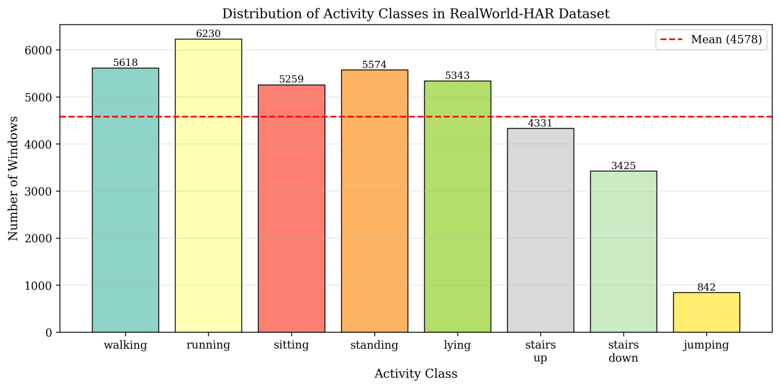
Figure 1 Distribution of Activity Classes in RealWorld Dateset
Figure 1 shows the distribution of activity classes in the preprocessed RealWorld-HAR dataset using the waist-mounted sensor data. The number of windows differs across activities, indicating a clear class imbalance. Common activities such as running, walking, standing, lying, and sitting contain more than 5,000 windows each, whereas stairs down contains 3,425 windows and jumping contains only 842 windows. This imbalance is important because models may learn more stable patterns for frequent classes but perform less reliably on under-represented activities. Therefore, macro-F1 was used as a key evaluation metric, as it gives equal importance to each class regardless of its sample size.

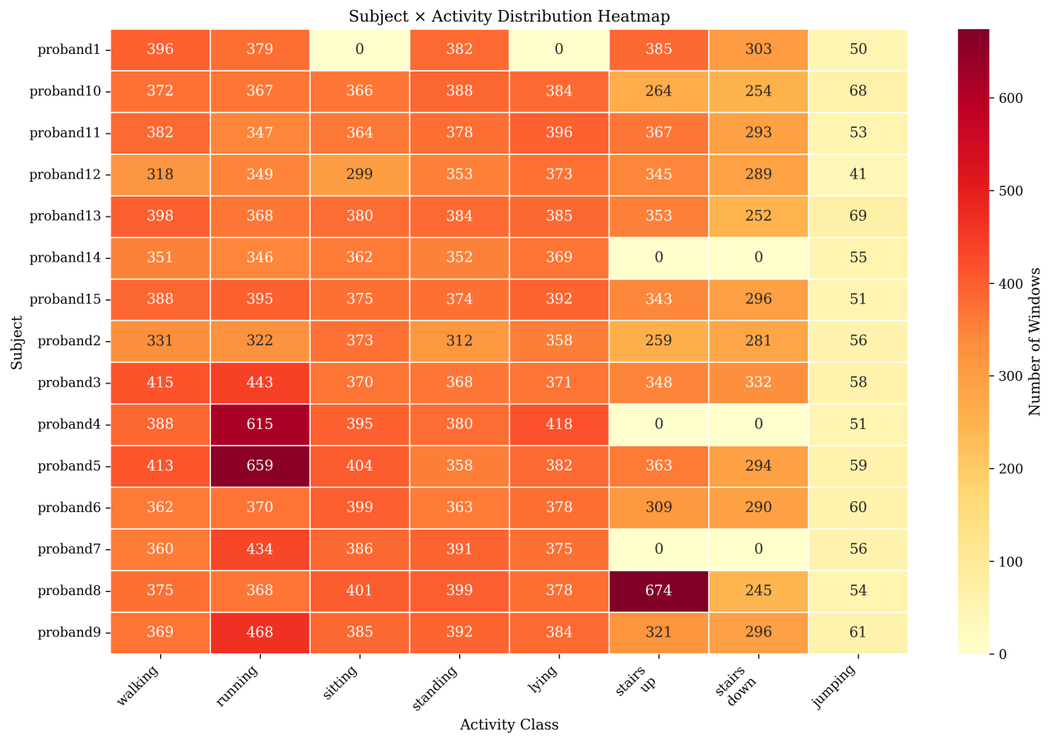
Figure 2 Subject × Activity Distribution Heatmap in RealWorld Dateset
Figure 2 shows the subject–activity window distribution of the preprocessed RealWorld-HAR dataset using the waist-mounted sensor data. The heatmap indicates that common activities such as walking, running, sitting, standing, and lying generally have relatively stable window counts across subjects. However, the distribution is not fully balanced. Jumping has consistently fewer windows for all subjects, and some subjects have missing samples for specific activities, such as sitting, lying, stairs up, or stairs down. This indicates both class imbalance and inter-subject variability in the dataset, which supports the use of the LOSO evaluation protocol to assess model generalisation to unseen subjects.

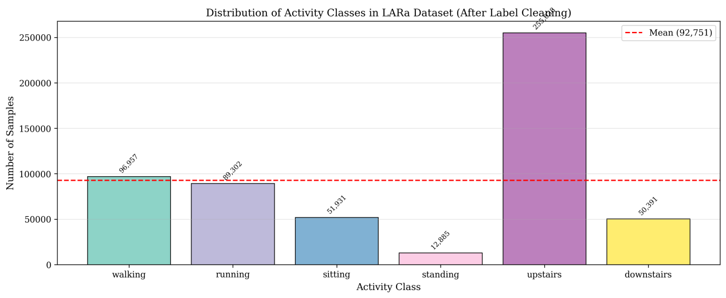
Figure 3 Distribution of Activity Classes in LARa Dateset
Figure 3 shows the distribution of activity classes in the LARa dataset after label cleaning. The dataset is clearly imbalanced across activities. The upstairs class contains the largest number of samples, with 255,638 samples, far above the class mean of 92,751. In contrast, standing is strongly under-represented, with only 12,885 samples. Sitting and downstairs also contain relatively fewer samples than walking and running. This clear imbalance caused by the experimental protocol is an inherent characteristic of the dataset itself, rather than a result of the data-cleaning process in this study.

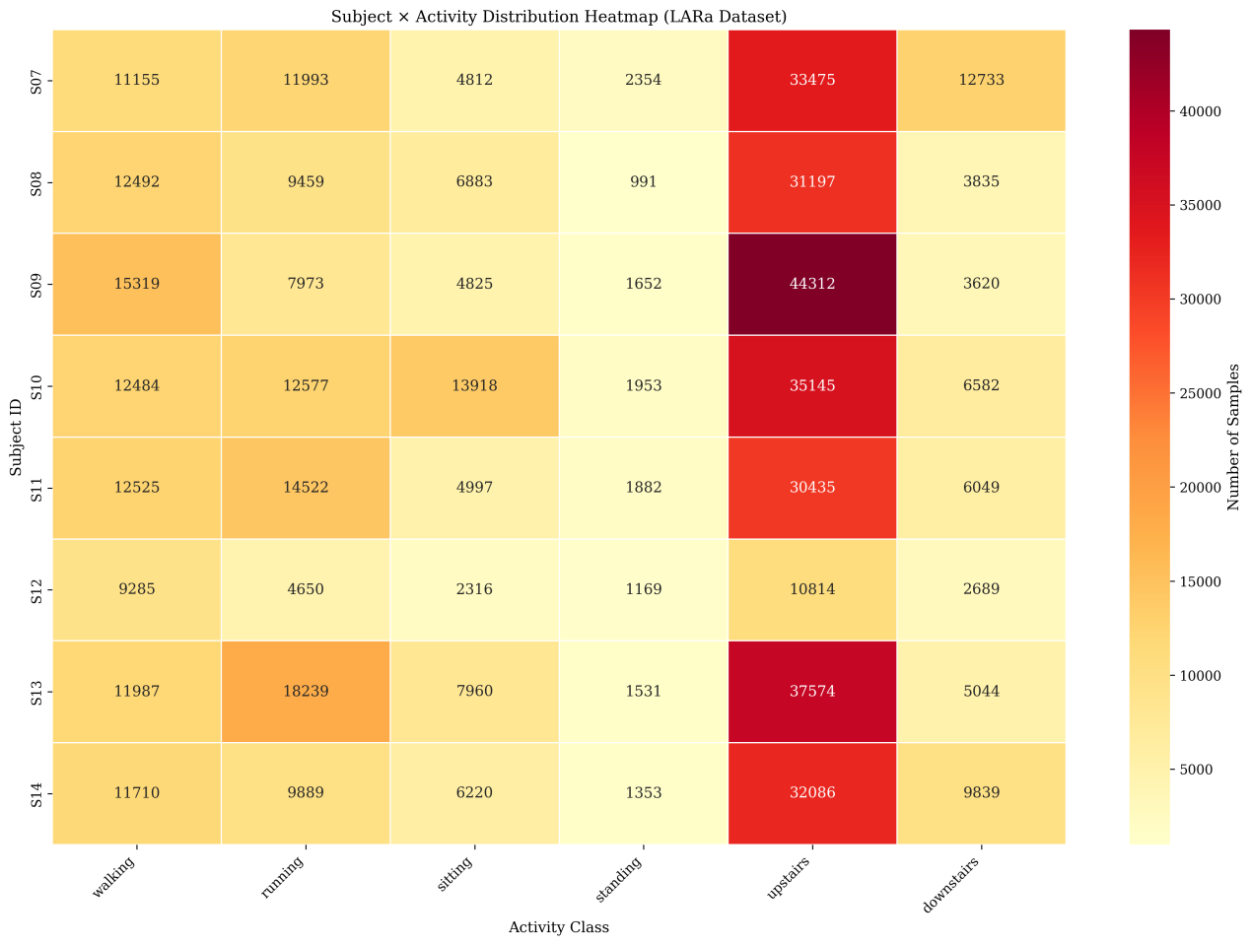
Figure 4 Subject × Activity Distribution Heatmap in LARa Dateset

Figure 4 presents the subject-level activity distribution in the LARa dataset. The heatmap shows that the data are not evenly distributed across either activities or subjects. The upstairs activity has the largest number of samples for all subjects, while standing is consistently under-represented. In addition, subject S12 contains substantially fewer samples than the other subjects. This indicates that the dataset contains both class imbalance and inter-subject variability.

5.2 Model-specific Input Construction, Hyperparameter Tuning and Training Protocol
After preprocessing, both RealWorld-HAR and LARa were represented as fixed-length, fold-aware time-series windows. Therefore, the modelling stage did not operate on raw sensor files directly. Instead, it used the standardised windows exported from the preprocessing pipeline and converted them into model-specific inputs. This separation was important because preprocessing ensured data quality and leakage prevention, while the modelling stage adapted the same cleaned windows to the requirements of different classifiers.

Different models require different input representations. Traditional machine-learning models, such as K-nearest neighbours (KNN) and Random Forest (RF), usually expect tabular feature vectors. A feature vector is a fixed-length list of numerical descriptors representing one sample. In contrast, deep learning models such as InceptionTime and Time Series Transformer (TST) can process multi-channel time-series tensors directly. A tensor is a multi-dimensional numerical array; in this project, one window can be represented as $C×L$, where $C$ is the number of sensor channels and $L$ is the number of time steps. With a 50 Hz sampling rate and a three-second window, $L=150$. For RealWorld-HAR, the input used six waist-mounted IMU channels: three accelerometer axes and three gyroscope axes. For LARa, the input used the selected right-wrist IMU placement, including accelerometer, gyroscope and, where configured, derived magnitude channels.

The first modelling route was based on hand-crafted features for KNN and RF. Hand-crafted features are manually defined numerical summaries derived from signal-processing knowledge. Instead of giving the full time-series waveform to the model, the code summarised each window using time-domain and frequency-domain descriptors. Time-domain features included mean, standard deviation, median, interquartile range, root mean square, energy, zero-crossing rate, skewness and kurtosis. These features describe the overall level, variability, intensity and shape of the signal. Frequency-domain features included spectral centroid, spectral entropy, roll-off frequency, peak frequency and bandpower in selected frequency bands. These features describe how the signal energy is distributed across different frequencies. This is useful because activities such as walking and running often show stronger periodic patterns than static activities such as sitting or standing.

This feature extraction step was necessary because KNN and RF do not automatically learn temporal patterns from raw sequences in the same way as convolutional or attention-based neural networks. A simple analogy is the difference between watching a full video and reading a summary table. Deep models can inspect the sequence directly, while traditional models need the movement to be summarised into measurable descriptors. For example, a running window may have higher energy and a clearer dominant frequency than a standing window. By extracting these properties, the pipeline converts motion patterns into a form that traditional classifiers can use.

For KNN, the model classifies a new window by finding the $K$ most similar training windows and using their labels to make a prediction. The main hyperparameter is therefore n_neighbors, which controls how many neighbours are considered. A small $K$ may be sensitive to noise, while a large $K$ may oversmooth class boundaries. The code searched several values of $K$, together with uniform and distance-based voting. Distance-based voting gives closer neighbours greater influence. Because KNN relies on distance calculations, feature scaling was fitted only on the training subjects of each fold and then applied to validation and test data.

Random Forest used the same hand-crafted features but a different learning mechanism. It is an ensemble model composed of many decision trees. Each tree learns threshold-based rules, and the forest combines the predictions of all trees to improve robustness. The code tuned parameters such as the number of trees, maximum tree depth, the number of features considered at each split and class weighting. Class weighting was used because HAR datasets are often imbalanced: some activities, such as walking, may have many more windows than short or rare activities. Without balancing, the model may favour majority classes and perform poorly on minority classes.

The second modelling route used InceptionTime, which received the standardised windows directly as multi-channel tensors. InceptionTime is a one-dimensional convolutional neural network designed for time-series classification. Its key idea is to apply multiple convolutional filters with different temporal lengths in parallel. Short filters can capture brief local changes, such as a sudden acceleration peak, while longer filters can capture broader movement cycles, such as repeated steps. This multi-scale structure is suitable for HAR because human activities contain both short events and longer rhythmic patterns. During training, validation subjects were selected only from the training fold, and early stopping was used to reduce overfitting. Early stopping means stopping training when validation performance no longer improves.

The third route used MiniROCKET and MultiROCKET. ROCKET-based methods transform time-series windows into high-dimensional convolutional features using many convolutional kernels. Unlike hand-crafted features, these features are generated automatically rather than manually specified one by one. MiniROCKET emphasises computational efficiency, while MultiROCKET produces a richer feature representation at a higher memory and computation cost. For each LOSO fold, the ROCKET transformer was fitted only on the training windows and then applied to both training and test windows. The test subject was never used when fitting the transformer.

After ROCKET transformation, the generated features were classified using a linear model such as RidgeClassifier. RidgeClassifier is a linear classifier with L2 regularisation. Regularisation penalises overly large weights and helps reduce overfitting, which is especially important when the feature dimension is very high. The regularisation strength, usually denoted as alpha, was selected using inner cross-validation on the training subjects. For large MultiROCKET feature matrices, the implementation also supported memory-aware processing such as float32 storage, batching, memory mapping and optional train-only feature selection.

The fourth route used the Time Series Transformer. TST also takes the standardised window tensor as input, but it models temporal relationships using self-attention. Self-attention allows the model to learn how different time points or temporal patches relate to one another. This is useful in HAR because an activity is usually defined by a sequence of movements rather than a single instant. For example, walking upstairs may involve foot lifting, body elevation and landing patterns that occur in a specific order. To reduce computational cost, the sequence can be divided into patches, where each patch is a short segment of the original window. The code tuned hyperparameters such as patch length, model dimension, number of attention heads, number of layers, dropout, learning rate and weight decay. Dropout and weight decay were used as regularisation methods to improve generalisation.

Across all model routes, hyperparameter tuning followed a nested subject-exclusive design. The outer LOSO split was reserved for final testing, while the inner GroupKFold split was performed only within the training subjects. GroupKFold keeps all windows from the same subject in the same split. This is necessary because windows from one subject are highly related and may share the same walking style, sensor orientation or movement amplitude. If windows were randomly split, the model could see part of a subject’s data during training and another part during validation, leading to overly optimistic results.

After the best hyperparameters were selected, the final model for each fold was retrained on all available training subjects and evaluated on the held-out test subject. The pipeline saved the trained model, selected hyperparameters, fitted scalers or transformers, training curves and window-level prediction outputs. Where available, logits and class probabilities were also saved. Logits are the raw model scores before conversion into probabilities, while probabilities represent the model’s confidence for each activity class. These outputs supported later calibration, uncertainty analysis and error inspection.

For the state-of-the-art models, including rTsfNet and the three DeepConvContext variants, as well as our proposed models, rTsfNet Lightweight, RCCMix Lightweight and RCCMix, the model-specific input construction procedures will be described in detail in Chapters 7 and 8.

Chapter 6

Baseline Models

6.1 KNN
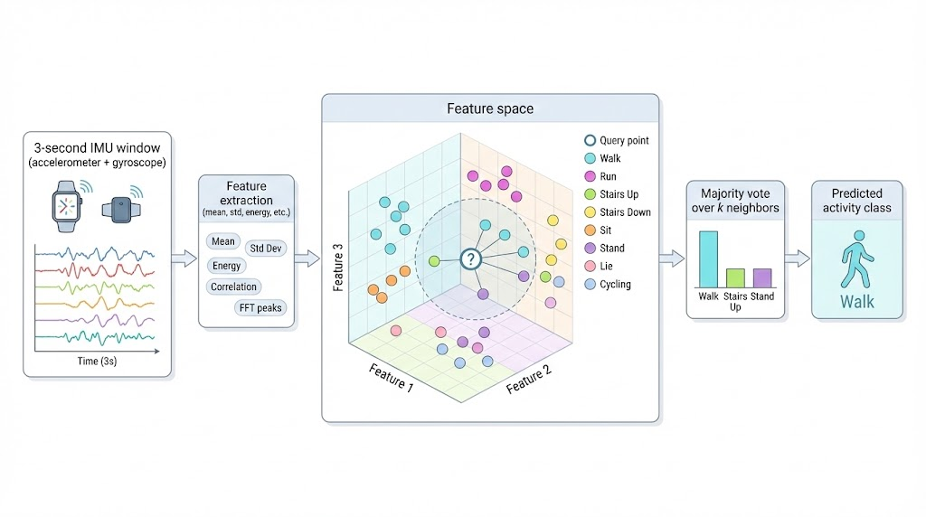
Figure 5 Knn
K-nearest neighbours (KNN) is a supervised and instance-based learning method that can be used for classification and regression. It is supervised because prediction relies on labelled examples, where each training sample has both input features and a known target label. It is also non-parametric, meaning that it does not learn a fixed set of parameters during training. Instead, KNN stores the training samples and performs classification by comparing a new sample with previously observed examples.

The central assumption of KNN is that samples with similar feature representations are likely to belong to the same class. For a test sample $x$, the algorithm calculates its distance to each training sample , commonly using Euclidean distance:
Where $p$ is the number of features, and and represent the value of feature $j$ in the test and training samples, respectively. The model then selects the $K$ closest training samples, known as nearest neighbours. For classification, the predicted label is assigned by majority voting:
$$\hat{y}=\arg{\max_{c}{}}\sum_{i∈N_{K}(x)}{1}(y_{i}=c)$$
Where is the set of $K$ nearest neighbours, $c$ is a candidate class, and is an indicator function.

In this study, each input sample can be interpreted as a feature vector extracted from a fixed-length IMU signal window, representing accelerometer and gyroscope movement patterns. The choice of $K$ controls the balance between local sensitivity and prediction stability. A small $K$ may capture fine-grained activity patterns but can be sensitive to noise, whereas a large $K$ produces smoother decisions but may weaken class boundaries. Feature scaling is necessary because distance-based methods are affected by feature magnitude; without standardisation, features with larger numerical ranges may dominate the distance calculation.

6.2 Random Forest
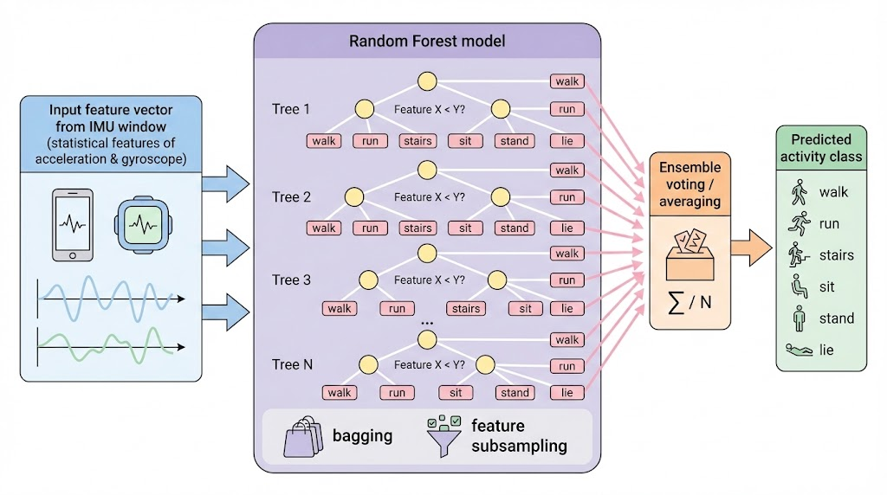
Figure 6 Random Forest
Random Forest is an ensemble learning method, meaning that it combines multiple individual models to produce a more reliable prediction than any single model alone. In Random Forest, the individual models are decision trees. A decision tree is a rule-based classifier that repeatedly splits the data according to feature values, for example, whether the mean acceleration in a time window is above or below a threshold. Each split is chosen to make the resulting groups more class-pure, commonly using criteria such as Gini impurity:
$$Gini=1-\sum_{c=1}^{C}{p_{c}^{2}}$$
Where is the proportion of samples belonging to class $c$ in a node.
The key idea of Random Forest is to reduce overfitting, which occurs when a model learns patterns that are too specific to the training data and performs poorly on unseen data. It does this in two ways. First, each tree is trained on a bootstrap sample, which is a random sample drawn from the training set with replacement. Second, at each split, the tree considers only a random subset of features rather than all available features. These two sources of randomness make the trees different from one another, so their errors are less likely to be identical.

For classification, the final prediction is usually made by majority voting:
$$\hat{y}=mode(h_{1}(x),h_{2}(x),…,h_{T}(x))$$
Where $h_{T}(x)$ is the prediction of the $T$-th tree. An intuitive example is asking many slightly different experts to classify an activity from sensor features; even if some experts are wrong, the majority decision is often robust. In human activity recognition, this makes Random Forest useful because IMU signals can be noisy, subject-dependent and affected by sensor placement. Its main strengths are robustness, interpretability and strong performance on structured feature representations, although it is less suited to learning complex temporal patterns directly from raw sequences.

6.3 Inceptiontime
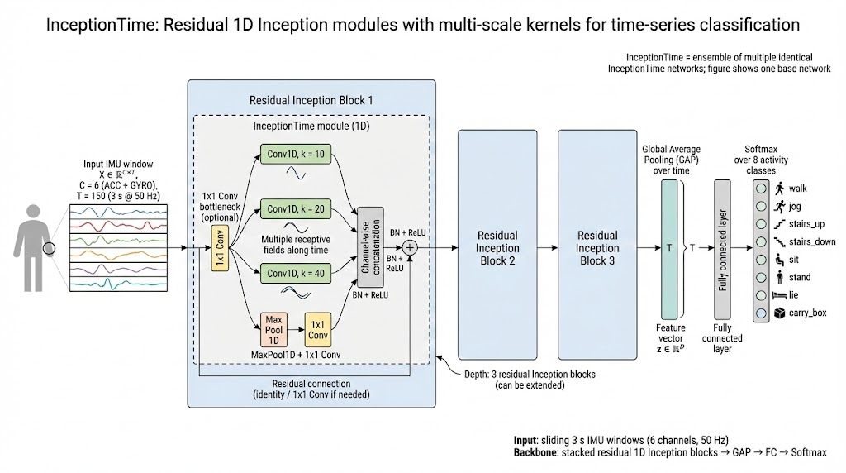
Figure 7 InceptionTime
InceptionTime is a deep learning architecture designed for time series classification, where the goal is to assign a label to an ordered sequence of measurements, such as an IMU window containing accelerometer and gyroscope values. It is based on one-dimensional convolutional neural networks (1D-CNNs), which learn temporal patterns by sliding small trainable filters along the time axis. For an input signal $x$ , a convolutional filter $w$ produces features such as $y_{t}=\sum_{i}{w_{i}}x_{t+i}$, meaning that the model learns which local signal shapes are useful for distinguishing classes. In human activity recognition, for example, a short repeated acceleration pattern may indicate walking, whereas a sharp high-amplitude pattern may indicate jumping.

The key component of InceptionTime is the Inception module. Instead of using only one convolution size, each module applies several parallel convolutions with different kernel lengths. A kernel is the temporal window observed by a filter; short kernels capture fine-grained changes, while long kernels capture slower movement patterns. This multi-scale design is necessary because time series often contain discriminative information at different temporal resolutions. For example, recognising “running” may require both short impacts from each step and a longer rhythm across several steps. The outputs of these parallel branches are concatenated, meaning they are combined along the feature dimension so that later layers can use all extracted patterns together.

To reduce computational cost, InceptionTime uses a bottleneck layer, usually a $1×1$ convolution, before longer convolutions. This operation compresses the number of channels while preserving temporal order, making the model cheaper without removing the main structure of the signal. It also includes a max-pooling branch, which summarises strong local activations and improves robustness to small temporal shifts. Residual connections are added between groups of modules; a residual connection passes earlier features directly to later layers, helping gradients flow during training and reducing the risk that deeper networks become difficult to optimise.

After several Inception modules, global average pooling converts each learned feature map into a single value by averaging over time. This avoids a large fully connected layer and makes the model less prone to overfitting. A final softmax layer then converts the output into class probabilities. The original InceptionTime method also uses an ensemble of multiple networks, which improves reliability by averaging predictions from independently trained models. Overall, InceptionTime is effective because it combines multi-scale temporal feature extraction, efficient convolutional design and stable deep training in a scalable architecture for time series classification.

6.4 Time series transformer
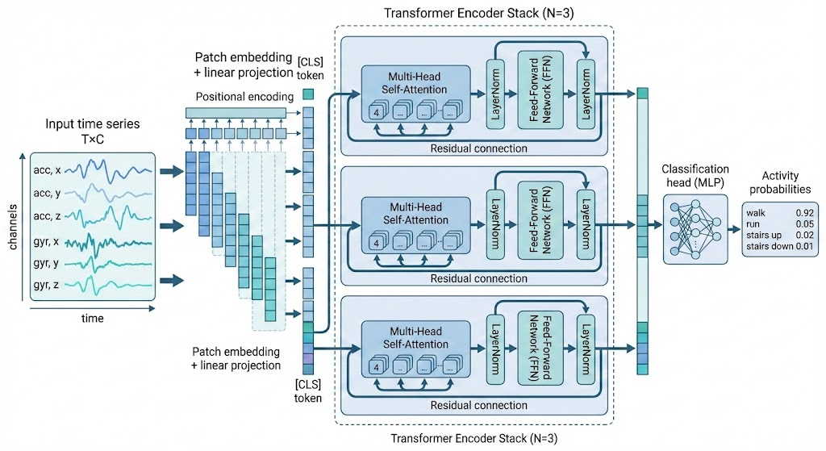
Figure 8 Time series transformer
A Time Series Transformer is a neural network model that adapts the Transformer architecture to sequential sensor data. A time series is an ordered sequence of observations, such as accelerometer and gyroscope readings collected over time. For a window of IMU data, the input can be represented as $X∈R^{T×C}$ , where $T$ is the number of time steps and $C$ is the number of sensor channels. In human activity recognition, each row may contain values such as acceleration and angular velocity at one moment, and the model predicts the activity label for the whole window.

The first step is to convert the raw time-series window into a sequence of embeddings. An embedding is a learned numerical representation that maps each time step, or sometimes each short patch of time steps, into a higher-dimensional feature vector. This projection is necessary because the Transformer does not directly operate on raw sensor values; it works on feature vectors with a fixed internal dimension. Since self-attention itself does not know the order of the sequence, positional encoding is added to the embeddings. Positional encoding provides information about whether a measurement occurs early or late in the window. This is important because the same sensor values can imply different motion patterns depending on their temporal position, just as the words “standing then walking” and “walking then standing” describe different transitions.

The core mechanism of the Time Series Transformer is self-attention. Self-attention allows each time step to compare itself with every other time step and decide which parts of the sequence are most relevant. For each embedded input, the model learns three representations: a query $Q$, a key $K$, and a value $V$. The attention operation is commonly written as:
$$Attention(Q,K,V)=softmax\left(\frac{QK^{T}}{\sqrt{d_{k}}}\right)V$$
Here, measures similarity between time steps, is the dimensionality of the key vectors, and the softmax function converts similarity scores into attention weights that sum to one. The division by prevents the similarity scores from becoming too large, which stabilises training. Intuitively, in a walking sequence, one footstep may attend strongly to previous and following footsteps because their repeated pattern helps distinguish walking from standing or random movement noise.

Most Time Series Transformers use multi-head attention, meaning that several attention mechanisms are applied in parallel. Each head can focus on a different type of temporal relationship, such as short-term changes, periodic patterns, or longer-range dependencies. The outputs are then passed through feed-forward layers, which are fully connected neural network layers applied to each time representation. Residual connections, which add the input of a layer back to its output, and layer normalisation, which stabilises the scale of activations, are used to make training deeper models more reliable.

For classification, the Transformer encoder produces contextualised representations of the sequence. These representations are then summarised, for example by average pooling or by using a special classification token, and passed to a final softmax classifier. Compared with convolutional models, which mainly capture local patterns through fixed-size filters, a Time Series Transformer can directly model relationships between distant time points. However, standard self-attention has $O(T^{2})$ computational cost, because every time step is compared with every other time step. Therefore, for long sensor windows, practical implementations often use shorter windows, patch-based inputs, or lightweight attention variants to reduce memory usage and inference latency.

6.5 Minirocket
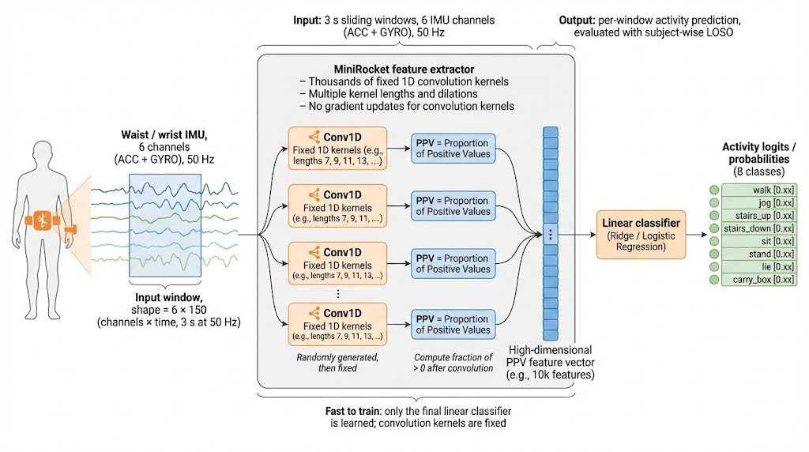
Figure 9 Minirocket
MiniROCKET is a highly efficient time series classification method derived from ROCKET, whose full name is Random Convolutional Kernel Transform. A time series classification task aims to assign a label to an ordered sequence of measurements, such as accelerometer and gyroscope readings collected from a wearable sensor. Instead of learning complex deep neural network parameters, MiniROCKET first transforms the raw time series into a large set of descriptive features using one-dimensional convolutional kernels, and then trains a simple linear classifier, such as ridge regression or logistic regression, on these features. A convolutional kernel is a small sliding pattern that is moved across the input signal to detect local temporal shapes. For example, in human activity recognition, one kernel may respond strongly to a short burst in acceleration that often appears during jumping or running.

For an input time series $x=(x_{1},x_{2},…,x_{T})$, a convolutional response can be written conceptually as
$$z_{t}=\sum_{j=0}^{L-1}{w_{j}}x_{t+jd}-b$$
Where are the kernel weights, $L$ is the kernel length, $d$ is the dilation, and $b$ is the bias. Dilation means that the kernel reads the signal with gaps between points, allowing it to capture both short- and long-range patterns without increasing the kernel length. The bias shifts the convolution output and changes the threshold used to decide whether a pattern is present.

The key idea of MiniROCKET is to reduce the randomness and computational cost of ROCKET while keeping its accuracy. It uses a fixed set of sparse kernels rather than generating many fully random kernels. In the original univariate version, the kernels have length nine and use a restricted weight pattern, which makes the convolution operation much faster. MiniROCKET mainly uses one pooling feature called PPV, or proportion of positive values. PPV measures the proportion of convolution outputs greater than zero:
$$PPV(z)=\frac{1}{T'}\sum_{t=1}^{T'}{I}(z_{t}>0)$$
Where $I(⋅)$ is an indicator function that returns 1 if the condition is true and 0 otherwise. Intuitively, PPV asks: “How often does this pattern appear in the signal?” This is useful because classification often depends not only on whether a local shape appears, but also on how frequently it appears. For example, walking may contain repeated rhythmic peaks, while sitting may produce very few positive responses for movement-related kernels. By combining many such PPV features across different kernels, dilations and biases, MiniROCKET creates a high-dimensional but efficient representation of the original time series. Its strength is therefore the combination of speed, scalability and strong classification performance, making it suitable for large benchmark datasets and deployment-oriented experiments where computational cost matters. MiniROCKET was introduced as an almost deterministic transform that is substantially faster than ROCKET while maintaining similar accuracy.

6.6 Multirocket
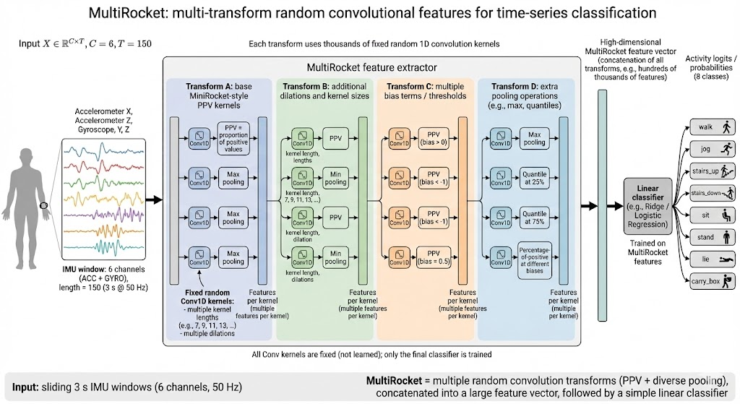
Figure 10 Multirocket
MultiROCKET extends MiniROCKET by increasing the diversity of the extracted features. Like MiniROCKET, it belongs to the ROCKET-based family of methods, where raw time series are transformed using many convolutional kernels and then classified using a linear model. However, MultiROCKET is based on the observation that MiniROCKET relies mainly on one type of summary statistic, PPV, and therefore may not capture all useful information contained in the convolution outputs. In other words, MiniROCKET mainly measures how often a pattern occurs, but not necessarily how strong, where, or how continuously that pattern appears.

To address this limitation, MultiROCKET introduces two main extensions. First, it applies the convolutional transform not only to the original time series but also to its first-order difference. The first-order difference is defined as
$$Δx_{t}=x_{t}-x_{t-1}$$
This transformation describes how quickly the signal changes between adjacent time steps. For wearable sensor data, this is important because many activities are characterised by motion dynamics rather than absolute sensor values. For example, standing and walking may have overlapping raw acceleration ranges, but walking usually produces repeated changes in acceleration. The first-order difference therefore helps the model capture movement transitions, slopes and sudden changes.

Second, MultiROCKET uses multiple pooling operators instead of relying only on PPV. A pooling operator is a function that summarises a sequence of convolution outputs into one or more fixed-length features. MultiROCKET uses four main pooling operators: PPV, MPV, MIPV and LSPV. PPV measures the proportion of positive convolution outputs. MPV, or mean of positive values, measures the average strength of positive responses, which indicates how strongly a pattern appears. MIPV, or mean index of positive values, captures where positive responses tend to occur in the sequence. LSPV, or longest stretch of positive values, measures the longest continuous region where the convolution output remains positive, which can reflect the duration of a detected pattern.

These operators are applied to convolution outputs from both the raw time series and the first-order difference representation. As a result, MultiROCKET describes each signal from multiple perspectives: pattern frequency, pattern strength, temporal location and temporal persistence. A simple analogy is analysing a heartbeat recording: MiniROCKET may mainly count how often a certain waveform appears, whereas MultiROCKET also considers how strong the waveform is, where it occurs, and how long it lasts. This richer feature representation usually improves classification accuracy, although it increases the number of generated features and computational cost compared with MiniROCKET. Overall, MultiROCKET can be understood as an enhanced version of MiniROCKET that trades some additional computation for more informative time series representations. The original MultiROCKET work reports that adding first-order differences and multiple pooling operators improves feature diversity and classification performance over MiniROCKET while remaining much faster than many complex ensemble-based alternatives.

Chapter 7

State Of The Art Baseline Models

7.1 rTsfNet
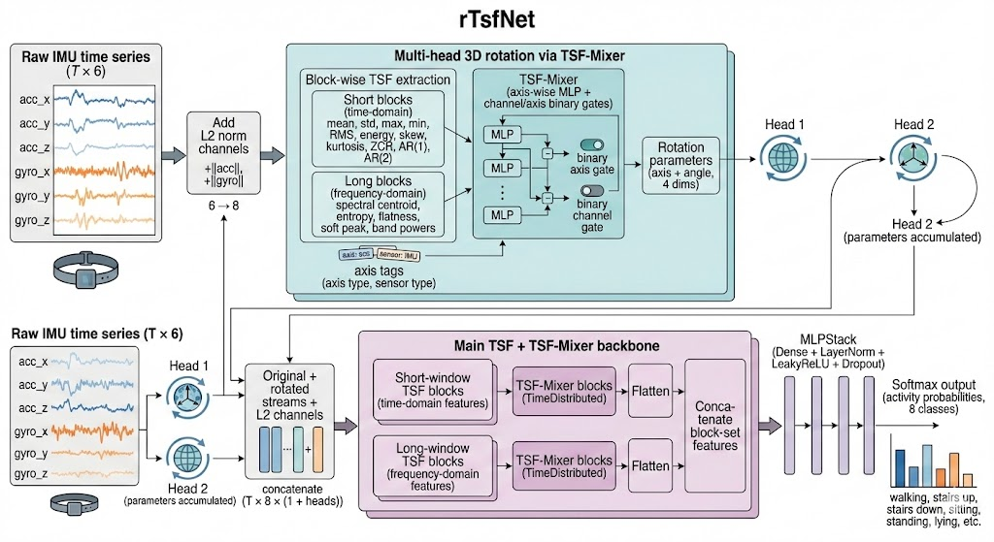
Figure 11 rTsfNet
rTsfNet is an IMU-based time-series classification model designed for human activity recognition under realistic wearable-sensing conditions. An inertial measurement unit (IMU) is a motion sensor package that usually contains an accelerometer and a gyroscope. The accelerometer measures linear acceleration along three spatial axes, while the gyroscope measures angular velocity around those axes. In this study, each input window is represented as a multivariate time series $X∈R^{T×6}$, where $T$ denotes the number of sampled time steps and the six channels correspond to three accelerometer axes $(a_{x},a_{y},a_{z})$ and three gyroscope axes $(g_{x},g_{y},g_{z})$. The purpose of rTsfNet is to learn activity-discriminative representations from these raw motion signals while reducing sensitivity to sensor orientation and body-placement variation.

A key challenge in wearable HAR is that the same physical activity can produce different axis-wise sensor readings when the device is rotated. For example, when a smartphone is worn at the waist, a slight change in its orientation may move part of the walking acceleration pattern from the $x$-axis to the $y$-axis, even though the user is performing the same activity. If a model learns only fixed axis-specific patterns, it may incorrectly treat this orientation change as a different movement pattern. rTsfNet addresses this problem through a multi-head three-dimensional rotation module. The term “multi-head” means that the model learns several rotated views of the same IMU signal, rather than relying only on the original coordinate system. Each head produces an alternative orientation of the accelerometer and gyroscope streams, allowing the classifier to observe the same motion from multiple coordinate perspectives.

The rotation operation is based on an axis-angle representation. In this representation, a three-dimensional rotation is described by a unit vector $u=(u_{x},u_{y},u_{z})$, which specifies the axis of rotation, and an angle $θ$, which specifies how far the signal is rotated around that axis. The corresponding rotation matrix $R∈R^{3×3}$ can be written using Rodrigues’ formula:
$$R=\cos{(}θ)I+(1-\cos{(}θ))uu^{T}+\sin{(}θ)K$$
Where $I$ is the identity matrix and $K$ is the skew-symmetric matrix constructed from $u$. This matrix is applied to the accelerometer and gyroscope vectors at each time step. Importantly, this transformation does not change the underlying activity; it changes the coordinate view from which the activity is represented. A simple analogy is rotating a camera around a person who is walking: the walking action remains the same, but the visual projection changes. In the same way, rTsfNet uses learned rotations to make the classifier less dependent on a single sensor orientation.

In the full rTsfNet architecture, the rotation parameters are estimated using time-series feature representations rather than only a simple global summary. Time-series features, abbreviated as TSF, are manually defined statistical descriptors that summarise important properties of a signal. Before TSF extraction, the model augments the original six IMU channels with two magnitude channels: one for acceleration and one for angular velocity. These are computed using the Euclidean norm:
$${\left\|a\right\|}_{2}=\sqrt{a_{x}^{2}+a_{y}^{2}+a_{z}^{2}}, {\left\|g\right\|}_{2}=\sqrt{g_{x}^{2}+g_{y}^{2}+g_{z}^{2}}$$
These magnitude channels are useful because they capture total movement intensity regardless of direction. For example, running usually produces a larger acceleration magnitude than standing, even if the device is rotated. Therefore, the L2-norm channels provide a direction-independent signal that complements the raw axis-specific measurements.

rTsfNet extracts both time-domain and frequency-domain features. Time-domain features describe the signal directly over time. They include mean, standard deviation, maximum, minimum, peak-to-peak range, root mean square, energy, skewness, kurtosis, zero-crossing rate, and autoregressive correlations. These features capture different aspects of motion, such as average intensity, variability, sudden changes, and temporal smoothness. Frequency-domain features are obtained by transforming the signal from the time domain into the frequency domain using the fast Fourier transform (FFT). The FFT decomposes a signal into oscillatory components at different frequencies. This is important for HAR because many activities differ in rhythm. Walking, running, and climbing stairs may all involve repeated motion, but their dominant frequencies and energy distributions are different. rTsfNet therefore computes spectral descriptors such as frequency centroid, spectral entropy, spectral flatness, soft peak frequency, and bandpower over selected frequency ranges. These descriptors help the model distinguish activities not only by how strong the movement is, but also by how regularly and how quickly it repeats.

Another important component is block-wise multi-scale TSF extraction. Instead of computing features only over the whole window, rTsfNet divides the signal into blocks and extracts features from different temporal scales. Short blocks focus on local changes, such as a sharp acceleration peak caused by a foot strike, while longer blocks capture global patterns, such as the overall rhythm of walking or running across the full window. This is necessary because human activities contain both short-term and long-term information. A useful analogy is analysing a song: individual beats provide local information, but the full phrase reveals the tempo and rhythm. Similarly, rTsfNet combines local and global descriptions of IMU motion.

The extracted block-wise features are processed by a TSF-Mixer. In this context, a mixer is a neural module that learns interactions among feature dimensions, sensor axes, and temporal blocks. First, an axis-shared multilayer perceptron (MLP) is applied to the axis-level features. An MLP is a feed-forward neural network composed of dense layers and nonlinear activation functions. “Axis-shared” means that the same transformation is applied to different sensor axes, which encourages the model to learn reusable feature-processing rules rather than completely separate rules for each axis. After axis-wise processing, the resulting representations are concatenated and passed through additional dense layers to form a block-level representation. Layer normalisation stabilises the scale of hidden activations, LeakyReLU introduces nonlinearity while reducing the risk of inactive neurons, and dropout randomly suppresses hidden units during training to reduce overfitting.

The full rTsfNet also includes axis and channel selection. Axis selection determines which sensor axes are useful for a given representation, while channel selection determines which extracted TSF descriptors should be retained. This is implemented through binary gates, which approximate hard keep-or-discard decisions. Since exact binary decisions are not directly differentiable, a straight-through estimator is used: the forward pass behaves like a binary selection operation, while the backward pass still allows gradients to update the gate parameters. This mechanism is useful because different activities may rely on different sensor components. For example, vertical acceleration may be important for jumping, while gyroscope features may be more informative for turning or wrist rotation.

Finally, rTsfNet combines the original IMU stream with the rotated streams generated by the rotation heads. Each stream is enriched with magnitude channels and transformed into TSF representations before classification. The final classifier outputs a probability distribution over activity classes using the softmax function:
$$p(y=c∣X)=\frac{exp(z_{c})}{\sum_{j=1}^{C}{exp}(z_{j})}$$
Where is the logit for class $c$, and $C$ is the number of activity classes. The model is trained using categorical cross-entropy, which penalises low predicted probability for the correct class. Overall, rTsfNet combines orientation-aware signal transformation, interpretable statistical feature extraction, multi-scale temporal modelling, and learned feature selection. This makes it a strong reference architecture for IMU-based human activity recognition, especially when sensor orientation and activity rhythm are both important.

7.2 DeepConvContext (three variants)
This project evaluates three DeepConvContext variants for wearable human activity recognition: a unidirectional LSTM variant, a bidirectional LSTM variant, and a bidirectional attention-based variant.
The three models follow the same high-level idea: they first learn local motion patterns inside short windows and then model temporal context across neighbouring windows. This two-stage structure is important because human activities contain information at different time scales. For example, a single three-second window may capture one or two walking steps, but a longer sequence of windows can reveal whether the person is continuously walking, changing activity, or transitioning from standing to walking. Therefore, the model needs both local feature extraction and contextual reasoning.

In the implemented pipeline, each input window contains 150 samples, corresponding to three seconds of data at 50 Hz. Adjacent windows overlap by 50%, giving a stride of 75 samples. For the LSTM-based variants, consecutive windows are explicitly concatenated into context sequences of length 100. The input can be represented as:
$$X∈R^{B×S×C×T}$$
Where $B$ is the number of sequences in a batch, $S=100$ is the number of consecutive windows in each sequence, $C=6$ is the number of sensor channels, and $T=150$ is the number of samples per window. This representation means that the model does not treat each window as an isolated example. Instead, each prediction is made while considering a longer temporal context.

All three variants use a similar intra-window feature extractor. The term “intra-window” refers to operations applied within one window before information from neighbouring windows is considered. This component consists of four one-dimensional convolutional layers followed by a one-layer LSTM with 128 hidden units. A one-dimensional convolution (Conv1D) is a neural operation that slides a learnable filter along the time axis of the signal. A simplified convolution can be expressed as:
$$y_{t}=\sum_{i=0}^{k-1}{w_{i}}x_{t+i}+b$$
Where $x$ is the input signal, are learnable filter weights, $b$ is a bias term, $k$ is the kernel size, and is the output at time position $t$. In this project, the kernel size is 9, allowing the model to detect short local movement patterns, such as acceleration peaks, oscillations, or changes in rotational velocity. This is necessary because many HAR cues are local and repetitive. For example, walking often produces repeated acceleration patterns, while sitting or standing produces more stable signals.

After the convolutional layers, an intra-window LSTM summarises the temporal structure inside each window. LSTM stands for long short-term memory. It is a recurrent neural network module designed to process sequential data. Unlike a basic recurrent network, an LSTM uses learned gates to control what information should be stored, updated, or discarded. These gates are useful because not every sensor fluctuation is equally informative. A sudden spike may be noise if it occurs alone, but it may become meaningful if it forms part of a repeated movement pattern. The intra-window LSTM therefore converts each processed window into a compact feature vector that represents the movement pattern within that window.

7.2.1 DeepConvContext-LSTM (unidirectional, 1-layer)
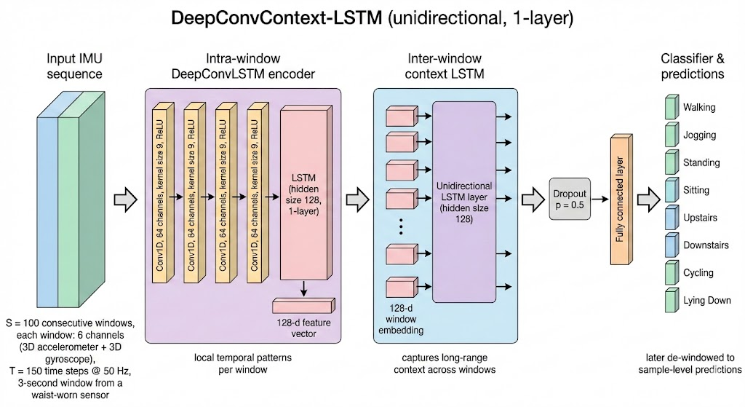
Figure 12 DeepConvContext-LSTM (unidirectional, 1-layer)
The first variant is the unidirectional DeepConvContext-LSTM. After each window has been converted into a feature vector by the intra-window Conv-LSTM block, the sequence of window-level vectors is passed to an inter-window LSTM. The term “inter-window” means that the model now learns relationships between consecutive windows rather than relationships between samples inside one window. This inter-window LSTM is unidirectional, so it processes the sequence from past to future. At a given time step , the hidden representation depends on the current window and previous windows, but not on future windows.

This design is suitable for online or near-real-time HAR. In a wearable system, future measurements are normally unavailable at the moment when a prediction must be made. For example, if a smartwatch is classifying the user’s current activity, it can use the current and previous motion windows, but it cannot rely on sensor data that will only arrive several seconds later. The unidirectional LSTM is therefore causally valid and deployment-friendly. Its limitation is that it may struggle with ambiguous transition windows, because it cannot use future context to confirm what activity follows.

7.2.2 DeepConvContext-LSTM (bidirectional, 1-layer)
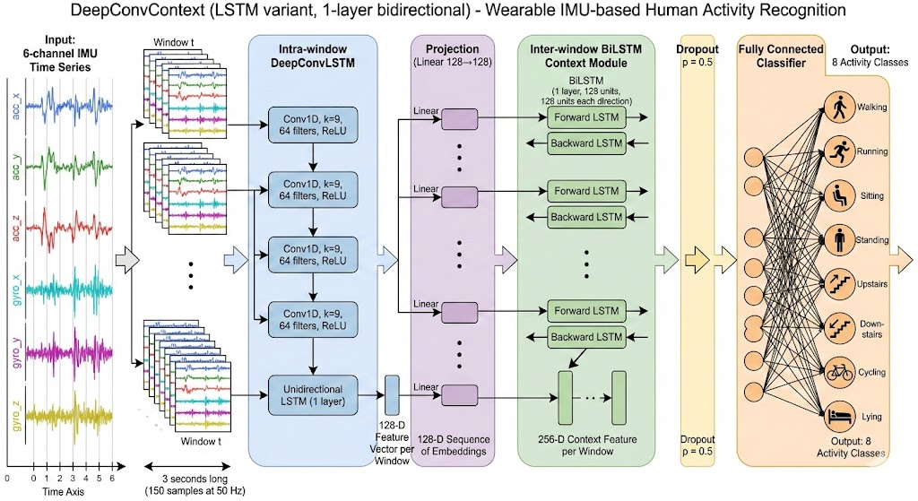
Figure 13 DeepConvContext-LSTM (bidirectional, 1-layer, A100 version)
The second variant is the bidirectional DeepConvContext-LSTM. It keeps the same intra-window Conv-LSTM feature extractor but replaces the unidirectional inter-window LSTM with a bidirectional LSTM. A bidirectional LSTM contains two recurrent directions: one processes the sequence from past to future, and the other processes it from future to past. The two hidden states are then combined:
$$h_{t}=[\vec{h_{t}};\overset{⃖}{h_{t}}]$$
where $\vec{h_{t}}$ is the forward hidden state, $\overset{⃖}{h_{t}}$ is the backward hidden state, and $[ ; ]$ denotes concatenation. This means that the prediction for a window can use both earlier and later windows.

The motivation for this design is that activity labels are often easier to infer when surrounding context is available. For example, the first window of walking after standing may still look similar to standing because the motion has only just begun. If later windows clearly show a stable walking rhythm, the model can use that future evidence to classify the transition more accurately. A simple analogy is reading a sentence: sometimes the meaning of a word becomes clear only after reading the following words. Similarly, the meaning of a sensor window can become clearer after observing subsequent movement.

In the implemented bidirectional variant, a projection layer is inserted between the intra-window feature extractor and the inter-window BiLSTM. A projection layer is a fully connected transformation that maps the extracted feature vector into a controlled feature space, here 128 dimensions. This helps standardise the representation before bidirectional context modelling. However, the main conceptual difference from the unidirectional variant is not the projection layer, but the use of future as well as past context. This gives the BiLSTM stronger contextual modelling ability, but makes it less suitable for strictly real-time deployment.

7.2.3 DeepConvContext Bi-Attention
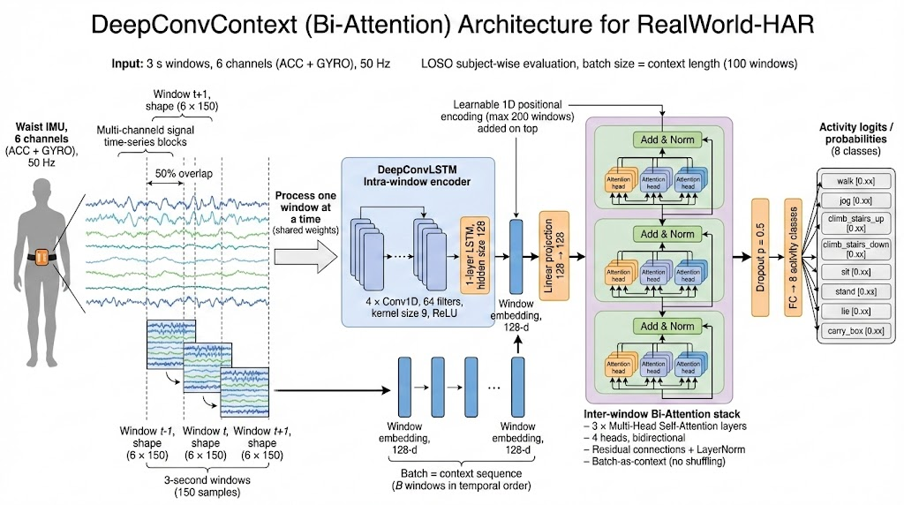
Figure 14 DeepConvContext Bi-Attention
The third variant is DeepConvContext Bi-Attention. This model retains the same intra-window Conv-LSTM feature extractor, but replaces the inter-window LSTM with multi-head self-attention. In this implementation, the attention module uses three attention layers and four attention heads. Unlike the two LSTM variants, which explicitly construct sequences with shape $(B,S,C,T)$, the Bi-Attention implementation preserves the window order and treats an ordered batch of windows as the context sequence. In other words, the batch itself is used as a sequence of temporally ordered windows for attention-based context modelling.

Self-attention allows each window to directly compare itself with other windows in the context and decide which windows are most relevant. A standard attention operation is defined as:
$$Attention(Q,K,V)=softmax\left(\frac{QK^{T}}{\sqrt{d_{k}}}\right)V$$
Where $Q$, $K$, and $V$ are query, key and value representations. The matrix $QK^{⊤}$ measures similarity between windows, stabilises the scale of the similarity scores, and the softmax function converts the scores into attention weights. The output is a weighted combination of value vectors. In practical terms, this means that when the model classifies one window, it can directly focus on other relevant windows rather than passing information step by step through a recurrent chain.

The term “multi-head” means that several attention operations are performed in parallel. Different heads can learn different types of relationships. For example, one head may focus on nearby windows to capture local continuity, while another may attend to more distant windows to detect longer activity patterns. This is useful in HAR because some activities are identified by short-term motion cues, whereas others require broader temporal context.

Because attention does not inherently encode temporal order, positional encoding is added before the attention layers. Positional encoding assigns a learnable position vector to each window, allowing the model to distinguish earlier windows from later windows. This is necessary because order matters in activity recognition: standing followed by walking is different from walking followed by standing, even if both sequences contain similar individual windows.

The Bi-Attention variant is bidirectional, meaning that no causal mask is applied and each window can attend to both past and future windows. Compared with LSTM-based context modelling, attention can capture long-range dependencies more directly because distant windows can interact in a single attention layer. However, this greater contextual flexibility also makes the model less naturally suited to real-time inference unless future windows are available or a prediction delay is acceptable.

After context modelling, all three variants apply dropout and a fully connected classifier. Dropout is a regularisation method that randomly disables part of the representation during training, reducing overfitting by preventing the model from relying too heavily on a small set of features. The final fully connected layer maps the contextual representation to class scores, one for each activity class.

Overall, these three models form a controlled comparison of context-modelling strategies within the same DeepConvContext family. The unidirectional LSTM tests how well the model performs when only past context is available. The bidirectional LSTM tests whether adding future context improves recognition, especially around ambiguous activity transitions. The Bi-Attention variant tests whether replacing recurrent context modelling with attention-based modelling improves the ability to capture longer-range relationships between windows. Therefore, the main difference among the three models lies not in their local motion feature extractor, which is largely shared, but in how they model temporal context across windows.

Chapter 8

Self-developed Models

8.1 rTsfNet Lightweight
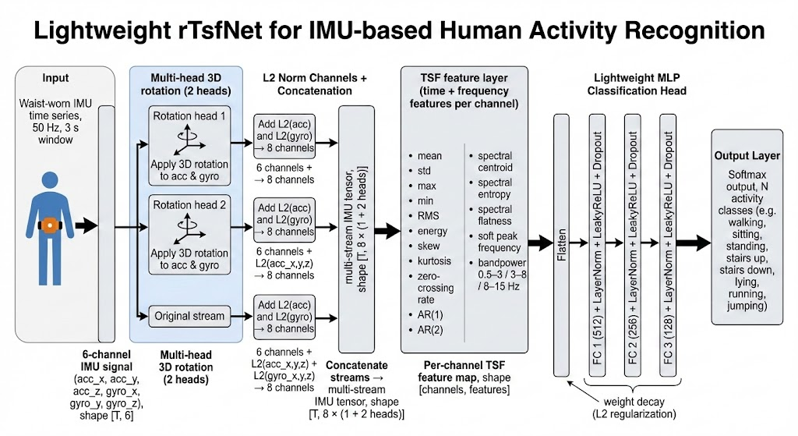
Figure 15 rTsfNet Lightweight
rTsfNet Lightweight is a deployment-oriented adaptation of rTsfNet developed to reduce computational cost while preserving the core modelling principles of the original architecture. The full rTsfNet is expressive because it estimates rotation parameters through block-wise TSF extraction, TSF-Mixer processing, axis tags, and binary axis/channel selection. However, these components also increase model complexity, inference latency, and memory usage. In wearable HAR, this trade-off is important because recognition systems may need to run continuously on devices with limited battery capacity and processing power. The lightweight version therefore keeps the main useful ideas of rTsfNet—orientation-aware rotation, magnitude augmentation, explicit TSF extraction, and neural classification—but removes several expensive intermediate mechanisms.

The input to rTsfNet Lightweight is the same six-channel IMU window $X∈R^{T×6}$, consisting of tri-axial acceleration and tri-axial angular velocity. Like the full model, it uses multiple rotation heads to generate alternative coordinate views of the input signal. The main difference lies in how the rotation parameters are estimated. Instead of using block-wise TSF-Mixer features to predict the rotation, the lightweight model summarises the input sequence using global average pooling. Global average pooling compresses each sensor channel across the temporal dimension by computing its average value over the input window. This produces a compact representation of the whole sequence. A small MLP then maps this global representation to the axis-angle rotation parameters for each head.

This design substantially simplifies the rotation-estimation pathway. The full rTsfNet asks a more detailed question: which temporal blocks, sensor axes, and TSF channels should guide the rotation? By contrast, the lightweight version asks a simpler question: which overall rotated views of this input window are useful for classification? This simplification removes the cost of constructing multiple block-wise feature tensors and applying mixer-based axis/channel selection. The trade-off is that the lightweight model may capture less fine-grained local structure when estimating rotations. However, it still retains the most important orientation-aware mechanism, because the classifier receives both the original signal and multiple learned rotated versions of the signal.

After the rotation stage, rTsfNet Lightweight applies the same magnitude augmentation principle as the full model. For each stream, including the original stream and the rotated streams, it computes the accelerometer magnitude and gyroscope magnitude and concatenates them with the six directional channels. With two rotation heads and the original stream retained, the model obtains three streams in total. Since each stream contains six raw or rotated channels plus two magnitude channels, the concatenated representation contains $8×3=248$ channels. This design allows the classifier to compare three types of information: the original coordinate representation, the learned orientation-transformed representations, and the direction-independent movement magnitudes.

The next stage is TSF extraction. Unlike the full rTsfNet, which performs block-wise multi-scale TSF extraction, rTsfNet Lightweight computes one global set of time- and frequency-domain descriptors from the concatenated multi-stream representation. This reduces complexity because the model does not need to maintain separate short-block and long-block feature pathways. The extracted time-domain descriptors summarise statistical properties such as central tendency, variability, signal energy, asymmetry, and temporal correlation. The frequency-domain descriptors summarise rhythmic properties such as dominant frequency, spectral concentration, and energy distribution across frequency bands. These features remain useful because they provide interpretable information about both movement intensity and movement rhythm. For example, sitting and standing may have low energy and weak periodicity, while walking and running are usually more periodic and have stronger frequency-domain patterns.

The classification head of rTsfNet Lightweight is also simplified. Instead of using a TSF-Mixer with explicit axis and channel selection, the lightweight model flattens the extracted TSF tensor into a single feature vector and feeds it into a standard MLP classifier. Flattening means converting the structured channel-by-feature representation into one continuous vector. The MLP then learns nonlinear combinations of the extracted descriptors. For instance, the model can learn that high acceleration energy, a strong spectral peak, and increased gyroscope variation together indicate a dynamic activity such as running, whereas low energy and low frequency variation are more consistent with static activities such as sitting or standing. Dense layers provide feature interaction, layer normalisation improves training stability, LeakyReLU adds nonlinearity, and dropout reduces overfitting.

The main advantage of rTsfNet Lightweight is that it preserves the conceptual strengths of rTsfNet while reducing the computational burden. It keeps orientation-aware augmentation through multi-head rotation, keeps magnitude channels for direction-independent motion intensity, and keeps TSF descriptors for interpretable time- and frequency-domain representation. At the same time, it removes the most expensive components of the full model, including block-wise TSF-Mixer processing, label or axis-tag injection, and binary axis/channel selection. As a result, the lightweight model is less expressive than the full rTsfNet, but it is more suitable for practical wearable deployment where low latency, smaller memory footprint, and reduced energy consumption are important. This makes rTsfNet Lightweight an appropriate proposed variant for evaluating whether the key benefits of rTsfNet can be retained in a more efficient architecture.

Comparison between rTsfNet and rTsfNet Lightweight
The relationship between the two models can be understood as a trade-off between representational richness and deployment efficiency. rTsfNet is the more expressive reference architecture: it uses block-wise multi-scale TSF extraction, TSF-Mixer processing, learned axis/channel selection, and rotation estimation based on detailed time-series descriptors. This allows the model to capture fine-grained relationships among temporal blocks, sensor axes, and statistical features. rTsfNet Lightweight is a simplified adaptation that keeps the core ideas but removes several costly mechanisms. It estimates rotations from a compact global representation, extracts TSF descriptors globally rather than block-wise, and uses a direct MLP classifier instead of a TSF-Mixer. Therefore, the full model is better suited for maximum representational capacity, while the lightweight version is better suited for deployment-oriented HAR, where the model must balance accuracy with latency, memory, and energy consumption.

8.2 RCCMix Lightweight and RCCMix
RCCMix Lightweight and RCCMix are two proposed neural architectures for wearable human activity recognition using six-axis inertial measurement unit (IMU) signals. An IMU window contains three accelerometer channels $(a_{x},a_{y},a_{z})$, which measure linear acceleration, and three gyroscope channels $(g_{x},g_{y},g_{z})$, which measure angular velocity. For both models, the input can be represented as $X∈R^{B×L×C×T}$, where $B$ is the batch size, $L$ is the number of consecutive windows, $C=6$ is the number of sensor channels, and $T$ is the number of time samples in each window. Instead of classifying each window independently, the models construct short sequences of neighbouring windows and use the centre window as the supervised target. This design is necessary because many activities are defined by temporal continuity rather than by a single instant. For example, one acceleration peak may occur in walking, running, or a sudden body adjustment, but a sequence of repeated peaks over several windows provides stronger evidence that the person is walking or running.

The two models share the same central idea: local motion patterns are first extracted within each window using convolutional encoders, and then relationships across consecutive windows are modelled using a rotation-conditioned Transformer. A convolutional encoder is suitable for detecting short-term temporal patterns, such as peaks, oscillations, or changes in direction. A Transformer is then used to model longer contextual dependencies between windows. This combination is useful because wearable activity recognition requires both fine-grained signal analysis and short-term contextual reasoning. In simple terms, the convolutional part answers “what movement pattern appears inside this window?”, while the Transformer answers “how does this window relate to the surrounding movement sequence?”

A key feature of both models is the use of geometry-aware input augmentation. Although the raw input has six channels, the models dynamically append two additional norm channels: accelerometer magnitude and gyroscope magnitude. These are computed as
$$a_{norm}(t)=\sqrt{a_{x}(t)^{2}+a_{y}(t)^{2}+a_{z}(t)^{2}+ϵ}$$
$$g_{norm}(t)=\sqrt{g_{x}(t)^{2}+g_{y}(t)^{2}+g_{z}(t)^{2}+ϵ}$$
Where $ϵ$ is a small constant used to avoid numerical instability. These magnitude channels do not replace the original axes; instead, they provide complementary information about the overall strength of movement and rotation. This is important because wearable sensors may be placed or rotated slightly differently across users or recording sessions. If a phone or wearable device rotates, the values of $x$, $y$, and $z$ may change individually, but the total magnitude is usually more stable. Therefore, the norm channels provide a simple but effective proxy for improving robustness to orientation-related variation.

8.2.1 RCCMix Lightweight

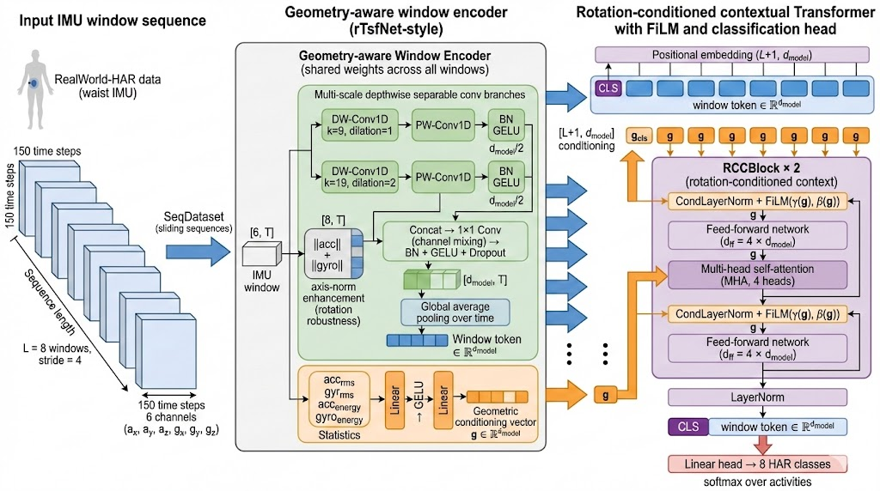
Figure 16 RCCMix Lightweight
RCCMix Lightweight is the deployment-oriented version of the proposed model. Its purpose is to preserve the main modelling advantages of RCCMix while reducing computational complexity, parameter count, and inference cost. After the six raw IMU channels are augmented with accelerometer and gyroscope norm channels, each window is processed by a compact window encoder. The encoder uses two multi-scale depthwise separable convolution branches with different temporal receptive fields. A receptive field refers to the range of time samples that a convolutional filter can observe when producing one output feature. Using multiple receptive fields allows the model to detect movement patterns at different temporal scales. Shorter filters are more sensitive to rapid local changes, while longer or dilated filters can capture broader motion patterns.

Depthwise separable convolution is used to make the model efficient. A standard one-dimensional convolution jointly learns temporal filters and channel mixing at the same time, which can be computationally expensive. In contrast, a depthwise separable convolution first applies a separate temporal filter to each channel and then uses a pointwise $1×1$ convolution to mix information across channels. This separation reduces the number of operations while still allowing the model to learn both channel-specific and cross-channel features. This is particularly suitable for wearable HAR, where edge deployment may require fast inference and low energy consumption.

In RCCMix Lightweight, the two convolution branches use different kernel and dilation settings, allowing the model to observe movement at two temporal scales. Dilation means that the convolutional filter skips over input positions at a fixed interval, increasing the receptive field without proportionally increasing the number of parameters. The outputs of the two branches are concatenated and then fused using a $1×1$ convolution. Batch normalisation and GELU activation are applied to stabilise and non-linearly transform the features. Batch normalisation standardises intermediate feature distributions during training, while GELU is a smooth activation function that helps the network model complex non-linear relationships. Finally, global average pooling is applied along the time dimension to produce a fixed-length window token. A token is a learned vector representation that summarises the information in one window. In this model, the token dimension is , which keeps the representation compact.

In parallel with token extraction, RCCMix Lightweight constructs a geometric conditioning vector $g$ from summary statistics of the accelerometer and gyroscope signals. These statistics include root mean square and energy-related measures. Root mean square describes the typical magnitude of a signal, while energy-related statistics describe the overall intensity of movement within a window. The role of this vector is not to classify the activity directly, but to condition the contextual model on the physical characteristics of the current motion. For example, two windows may have similar temporal shapes but different movement intensities; conditioning helps the model interpret these patterns differently.

The sequence of window tokens is then processed by a rotation-conditioned Transformer encoder. A learnable CLS token is added to the beginning of the sequence. The CLS token acts as a global summary position: after self-attention has processed the full sequence, this token is used as the final representation for classification. Self-attention is a mechanism that allows each token to compare itself with other tokens in the sequence and assign different importance weights to them. This is useful for activities whose evidence is distributed across several neighbouring windows.

The “rotation-conditioned” part is implemented through FiLM-style conditional Layer Normalisation. Layer Normalisation stabilises hidden representations by normalising them within each token. FiLM, or feature-wise linear modulation, adjusts features using learned scale and shift terms. In this model, the operation can be written as
$$CondLN(z,g)=LN(z)⊙(1+γ(g))+β(g)$$
Where $z$ is a token representation, $g$ is the geometric conditioning vector, and $γ(g)$ and $β(g)$ are learned functions that generate feature-wise scaling and shifting parameters. This mechanism is necessary because the same temporal pattern may have a different meaning under different movement geometries. For instance, a burst of gyroscope activity may indicate a wrist rotation in one activity, but a body turn or device orientation change in another. By conditioning the Transformer on geometric statistics, RCCMix Lightweight adapts its contextual reasoning to the physical properties of the sensor signal.

8.2.2 RCCMix

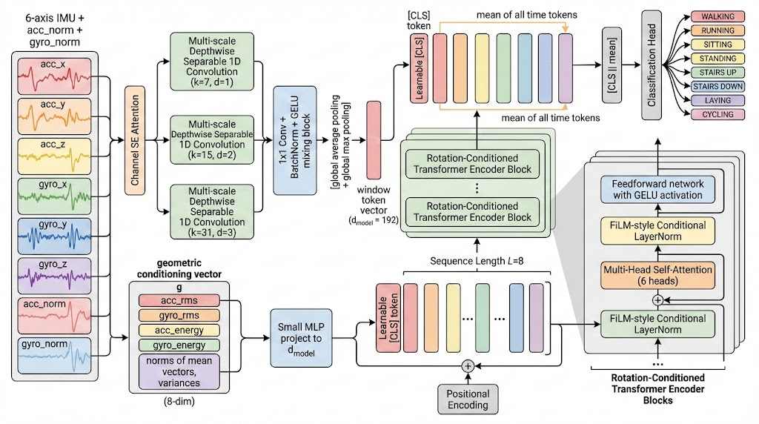 Figure 17 RCCMix
RCCMix is the accuracy-oriented version of the architecture. It retains the same overall pipeline as RCCMix Lightweight but increases the representational capacity of the encoder and Transformer. The main purpose of RCCMix is to learn richer local and contextual features when higher computational cost is acceptable. Compared with the lightweight variant, it uses a larger hidden dimension, more attention heads, more Transformer layers, channel attention, more convolution branches, dual pooling, and a richer geometric conditioning vector.

The first major enhancement is the squeeze-and-excitation channel attention block. Channel attention is a mechanism that learns how important each input channel is for a particular window. The squeeze step summarises each channel over time, and the excitation step uses a small neural network to generate a weight for each channel. The input channels are then rescaled by these learned weights. This is useful because different activities may rely on different sensor channels. For example, walking may be strongly represented by periodic acceleration, whereas turning or twisting may depend more heavily on gyroscope information. Channel attention allows the model to emphasise informative channels and suppress less relevant ones dynamically.

The second enhancement is the use of three multi-scale depthwise separable convolution branches rather than two. The branches use kernel sizes $7$, $15$, and $31$, with dilation rates $1$, $2$, and $3$, respectively. This gives the encoder three temporal “lenses”: a short-range lens for local peaks, a medium-range lens for movement rhythm, and a longer-range dilated lens for broader temporal structure. For example, a brief hand movement may be captured by the short branch, while a repeated walking cycle may require the medium or long branch. The outputs of the three branches are concatenated and mixed into a unified representation with , giving RCCMix more capacity to represent complex motion patterns than the lightweight version.

RCCMix also replaces simple average pooling with dual temporal pooling. Average pooling summarises the overall tendency of the feature map, while max pooling preserves the strongest detected response. Combining them is useful because activities may contain both sustained patterns and short discriminative events. For instance, walking may be characterised by a stable repeated rhythm, whereas a sudden transition or impact-like motion may appear only briefly. By concatenating average-pooled and max-pooled features and projecting them back to the model dimension, RCCMix forms a window token that captures both global and peak-based information.

The geometric conditioning vector is also expanded from four statistics to eight statistics. In addition to RMS and energy-related measures, RCCMix includes mean-norm and variance-related statistics for both accelerometer and gyroscope signals. Mean-norm captures the average directional magnitude of the signal, while variance measures how strongly the signal fluctuates over time. These features provide a richer description of the movement geometry and intensity within each window. As in the lightweight model, this conditioning vector is projected to the same hidden dimension as the token and used in conditional Layer Normalisation inside the Transformer. These additional statistics allow the model to represent not only motion intensity but also motion stability and variability. For example, standing and walking may both contain acceleration due to gravity, but walking usually has higher variance because the signal changes rhythmically over time.

The contextual module in RCCMix is larger than in RCCMix Lightweight. It uses a Transformer with , six attention heads, and three encoder layers. Multi-head attention means that several attention mechanisms operate in parallel, allowing different heads to focus on different temporal relationships. One head may focus on periodic movement, another on transitions between activities, and another on short abnormal changes. Positional embeddings are added to the tokens so that the model knows the order of windows in the sequence, because self-attention alone does not inherently encode temporal order.

The final classification representation is also strengthened. Instead of relying only on the CLS token, RCCMix concatenates the final CLS representation with the mean representation of all contextualised window tokens:
$$h_{final}=[h_{CLS} ‖ mean(h_{1},…,h_{L})]$$
Here, $‖$ denotes concatenation. This design combines two complementary summaries. The CLS token provides a learned global representation that can focus on the most discriminative evidence, while the mean representation preserves information distributed across all windows. The combined representation is passed through dropout and a linear classification head to produce the final class logits.

Overall, RCCMix Lightweight and RCCMix represent two points on the same design spectrum. RCCMix Lightweight prioritises efficiency by using a smaller embedding dimension, fewer Transformer layers, fewer attention heads, two convolution branches, average pooling, and a compact geometric conditioning vector. RCCMix prioritises recognition performance by using channel attention, three convolution scales, dual pooling, a richer conditioning vector, and a deeper Transformer. Both models are based on the same principle: robust wearable activity recognition should not rely only on raw axis-specific patterns, but should combine local temporal feature extraction, geometry-aware conditioning, and contextual reasoning across neighbouring windows.

Chapter 9

Evaluation Methodology

9.1 Accuracy
LOSO Macro F1 combines a subject-independent validation protocol with a class-balanced performance metric. LOSO stands for Leave-One-Subject-Out cross-validation. In this protocol, if a dataset contains $N$ participants, the experiment is repeated $N$ times. In each fold, all data from one participant are held out as the test set, while the data from the remaining $N-1$ participants are used for training. The held-out participant is therefore completely unseen during training. This is important in wearable human activity recognition because sensor signals are strongly subject-dependent: two people may perform the same activity with different speed, posture, limb length, device placement, or movement intensity. A random train-test split may place windows from the same person in both training and testing sets, allowing the model to exploit person-specific patterns rather than learning activity-related patterns. LOSO reduces this risk and evaluates whether the model can generalise to a new user.

The second component, Macro F1, measures classification quality while treating all activity classes equally. For each class, precision, recall, and F1-score are first calculated. Precision measures how many samples predicted as a given class are correct:
$${Precision}_{c}=\frac{TP_{c}}{TP_{c}+FP_{c}}$$
Where $TP_{c}$ is the number of true positives for class $c$, and $FP_{c}$ is the number of false positives. Recall measures how many true samples of that class are successfully detected:
$${Recall}_{c}=\frac{TP_{c}}{TP_{c}+FN_{c}}$$
Where $FN_{c}$ is the number of false negatives. The F1-score is the harmonic mean of precision and recall:
$$F1_{c}=\frac{2⋅{Precision}_{c}⋅{Recall}_{c}}{{Precision}_{c}+{Recall}_{c}}$$
The harmonic mean is used because it penalises models that perform well on only one side of the trade-off. For example, a model that predicts “walking” only when it is very certain may have high precision but low recall because it misses many walking samples. Conversely, a model that labels too many samples as “walking” may have high recall but low precision. F1 rewards a better balance between the two.

Macro F1 is then computed by averaging the F1-scores across all $C$ classes:
$$Macro F1=\frac{1}{C}\sum_{c=1}^{C}{F}1_{c}$$
Unlike accuracy, Macro F1 does not allow frequent classes to dominate the final score. This is particularly relevant for human activity recognition datasets, where common activities such as walking or standing may appear much more often than transitional or short-duration activities. For example, if 70% of the dataset is walking, a model can obtain high accuracy by mainly recognising walking, while still performing poorly on rarer activities such as sitting down or climbing stairs. Macro F1 exposes this weakness because each activity contributes equally to the final metric.

In a LOSO Macro F1 evaluation, Macro F1 is usually computed for each held-out subject and then averaged across all subjects. This reports both class-level robustness and subject-level generalisation. Therefore, a high LOSO Macro F1 score indicates that the model is not only accurate on average, but also able to recognise different activity classes consistently when applied to people whose data were not seen during training.

9.2 Inference Latency (per window, HAR window, 3 s @ 50 Hz)
Inference latency was measured to evaluate the practical deployment efficiency of each model, rather than only its classification accuracy. Inference latency refers to the elapsed time required for a trained model to produce an output prediction for a given input sample. In this project, the reported latency measures the pure forward-pass time, meaning the time taken by the model computation itself, excluding data loading, file I/O, training, backpropagation, and metric calculation. This is important because wearable human activity recognition systems often need to run on resource-constrained devices, where a model must classify sensor windows quickly enough for near-real-time use.

To make the comparison fair and reproducible, all models were benchmarked on the CPU rather than on a GPU. CPU measurement is relevant because many wearable or mobile deployment scenarios rely on general-purpose processors rather than powerful accelerators. To improve reproducibility, the number of computational threads was fixed to one by setting CPU-related thread controls, including PyTorch thread usage. A thread is an independent stream of execution used by the processor. Restricting the benchmark to a single thread reduces variability caused by automatic parallelisation and makes the comparison between models fairer. The model was placed in evaluation mode using model.eval(). Evaluation mode disables training-specific behaviours, such as dropout randomness and batch-normalisation updates, so that the measured time reflects deterministic inference behaviour. Gradient computation was also disabled, because gradients are only needed during training when model parameters are updated. During inference, storing gradients would add unnecessary memory and computational overhead.

For each model, a fixed input tensor with the same shape as the expected sensor input was used. For sequence-level HAR models, the input shape was represented as $B×L×C×T$, where $B$ is the batch size, $L$ is the number of consecutive windows, $C$ is the number of sensor channels, and $T$ is the number of time samples per window. In the benchmark, $B=1$ was used to simulate single-sample prediction, which is closer to real deployment than large-batch offline processing. For example, an input of $1×8×6×150$ represents one sequence containing eight windows, six inertial channels, and 150 samples per window.

Before timing, several warm-up forward passes were executed. Warm-up runs are necessary because the first few executions may include one-off overheads, such as memory allocation or internal library initialisation. These runs were not included in the final statistics. The model was then executed repeatedly for 100 timed runs. For each run, latency was computed as
$$t_{i}=\left(t_{end,i}-t_{start,i}\right)×1000$$
Where $t_{i}$ is the latency in milliseconds. The final report included the mean, standard deviation, median latency (p50), and 90th-percentile latency (p90). The p50 value represents typical inference speed, while p90 shows a more conservative estimate of slower cases. For sequence-based models, per-window latency was approximated by dividing the sequence latency by the number of windows, allowing fairer comparison with models that operate on individual HAR windows.

9.3 Model size (Example: RCCMix-HAR lightweight version size.ipynb)
Model size was measured using a parameter-based storage estimate. In this context, model size refers to the memory required to store the model parameters, such as weights, biases, normalization parameters, and learnable embeddings. It does not represent the full runtime memory consumption during inference, because runtime memory also depends on input batch size, intermediate activations, framework overhead, and hardware-specific execution details. Therefore, parameter size provides a cleaner and more comparable measure of the storage cost of different models.

For each model, the architecture was first reconstructed using the same configuration as in the corresponding experiment, including the number of input channels, hidden dimension, number of layers, attention heads, sequence length, dropout rate, and number of output classes. This step is necessary because parameter count is determined by the exact architecture. For example, if a linear layer maps a 128-dimensional representation to another 128-dimensional representation, it contains 128 × 128 weights, before counting any bias terms. Increasing the hidden dimension would therefore increase the model size even if the general model design remained unchanged.

After instantiating the model, the total number of parameters was computed by summing the number of scalar values in all tensors returned by model.parameters(). In PyTorch, a tensor is a multi-dimensional array used to store model values, and numel() returns the number of scalar elements in that tensor. Trainable parameters were also reported separately by counting only tensors with requires_grad=True, which indicates that they are updated during training.

The theoretical storage size was then estimated from the numerical precision. A 32-bit floating-point value, or FP32, uses 4 bytes per parameter, while a 16-bit floating-point value, or FP16, uses 2 bytes per parameter. Thus, model size was calculated as:

Model size = number of parameters × bytes per parameter.

As a simple analogy, this is similar to estimating the size of a book by counting how many characters it contains and how many bytes are needed to store each character. Finally, a randomly initialized PyTorch state_dict was saved to disk to check the actual .pt file size. This file may be slightly larger than the theoretical estimate because it can include serialization metadata and buffers, so it was used as a practical reference rather than the main fairness criterion.

9.4 Model Energy Consumption
The We employed two complementary approaches to measure model energy consumption. The primary experiments and comparative results are based on the first method (Hardware-based Direct Measurement), which was used for all models. The second method (Calibrated Complexity-based Proxy Model) serves as a supplementary analysis and was applied only to six models: KNN, Random Forest, InceptionTime, Time Series Transformer, MiniRocket, and MultiRocket.

Method 1: Hardware-based Direct Measurement
Core Logic: Leveraging GPU driver interfaces (NVML) to read real-time power and integrate it over time.
To obtain the ground-truth energy consumption, we employed a hardware-based direct measurement approach. We utilized the NVIDIA Management Library (NVML) to sample the instantaneous power draw $P(t)$ of the GPU at a high frequency (interval $Δt≈20ms$). The total dynamic energy $E_{dynamic}$ per inference window is calculated by integrating the power over the inference latency $T$ and subtracting the baseline idle power $P_{idle}$:
$$E_{dynamic}=\int_{0}^{T}{P}(t)dt-P_{idle}×T$$

This method captures the full system-level overhead, including data transfer, driver latency, and hardware power state transitions.
Use Case:
To serve as the Ground Truth for evaluating actual model performance on specific hardware.
To serve as the calibration baseline for the proxy model (Method 2).

Method 2: Calibrated Complexity-based Proxy Model
Core Logic: Statistical regression of theoretical computational complexity (FLOPs) and memory access (Bytes) against measured energy to derive a formula.
To enable rapid estimation of energy costs across different hyperparameters without repeated physical measurements, we developed a complexity-based proxy model. We decomposed the inference cost into two primary theoretical factors: computational complexity (measured in MACs/FLOPs) and memory access cost (measured in Bytes).
Using a Weighted Least Squares (WLS) regression on a calibration set of models, we derived a linear energy model:
$$E_{proxy}=α⋅N_{FLOPs}+β⋅N_{Bytes}+γ$$

Where $α$ represents the energy cost per floating-point operation, $β$ represents the cost per byte of memory access, and $γ$ accounts for the constant hardware overhead (intercept). This allows us to decouple the algorithmic efficiency from the specific hardware implementation.
Use Case:
When extensive hyperparameter search is required (e.g., varying window sizes or channels) and physical measurement for every configuration is infeasible.
To analyze whether a model is "compute-bound" or "memory-bound."

9.4.1 Method 1: Hardware-based Direct Measurement
Energy consumption was measured as GPU inference energy per 3-second input window, reported in millijoules (mJ). In this context, a 3-second window refers to one fixed-length segment of wearable sensor data used as the model input. Reporting energy per window makes the results comparable across models, because each value represents the cost of processing the same amount of sensor information. It is important to note that this measurement captures GPU inference energy rather than the total energy of the whole computer system; therefore, it excludes components such as the CPU, memory, storage, display, and cooling system.

The measurement was based on GPU power readings obtained through NVML, the NVIDIA Management Library. NVML is a low-level interface that allows software to query hardware information from NVIDIA GPUs, including instantaneous power draw. Power was sampled every 0.02 seconds in a separate background process while the model performed inference. Power, measured in milliwatts (mW), represents the rate at which energy is being consumed. Energy, measured in millijoules, is the accumulated power over time. A simple analogy is water flow: power is like the flow rate from a tap, while energy is the total amount of water collected in a container.

Before measuring active inference, the GPU idle power was recorded for 20 seconds. Idle power is the baseline power consumed when the GPU is powered on but not executing the tested model. This baseline must be removed because a GPU consumes energy even when no inference is running, for example to maintain device readiness and memory state. Without idle subtraction, part of the reported energy would reflect the hardware platform rather than the model itself. The model-specific per-window energy was therefore computed as:
$$E_{window}=\frac{E_{total}-P_{idle}T}{N_{windows}}$$
Where $E_{total}$ is the total measured energy during active inference, $P_{idle}$ is the average idle power, $T$ is the active measurement duration, and $N_{windows}$ is the total number of processed input windows.

To obtain $E_{total}$ , the sampled power-time curve was integrated using the trapezoidal rule. Trapezoidal integration estimates the area under a curve by connecting neighbouring power samples with straight lines and summing the resulting trapezoids. Since power multiplied by time gives energy, integrating mW over seconds gives mJ. This approach is more reliable than using a single power reading because GPU power fluctuates during inference depending on kernel execution, memory access, and scheduling.

Several steps were used to improve measurement reliability. First, warm-up inference passes were performed before recording energy. This reduces one-off overheads such as CUDA kernel initialization, memory allocation, and caching effects, which would otherwise make the first run unusually expensive. Second, the number of repeats was calibrated so that each active measurement lasted approximately eight seconds. This is necessary because very short measurements are more sensitive to sampling noise and timing overhead. Third, CUDA synchronization was applied after inference. GPU execution is often asynchronous, meaning that the CPU may continue before all GPU operations have finished. Synchronization ensures that the measured time and energy cover the complete inference workload.

Finally, the measurement was repeated five times, and bootstrap resampling with 1000 samples was used to estimate a 95% confidence interval. Bootstrapping repeatedly resamples the observed runs to estimate how much the mean energy value may vary. Reporting both the mean energy and confidence interval provides a more transparent result than a single number, because it indicates not only the estimated inference cost but also the stability of the measurement.

9.4.2 Method 2: Calibrated Complexity-based Proxy Model (Github: proxy energy final.ipynb)
This experiment used a proxy-based energy estimation procedure to compare the computational efficiency of different human activity recognition models under a controlled and repeatable setting. The purpose was not to directly measure battery drain on a wearable device, but to build a calibrated framework for relative energy comparison. Direct energy measurement on every possible edge-device configuration is difficult because the result depends on the processor, memory system, driver, power management policy, and runtime implementation. Therefore, the experiment first measured GPU energy under a fixed software and hardware environment, then fitted a proxy model that related measured energy to two interpretable model-level variables: floating-point operations and memory traffic. This allowed the models to be compared using a consistent methodology.

Step 0: Environment Recording and Reproducibility Control

The first step recorded the experimental environment before any measurement was performed. The experiment stored the Python version, operating system, PyTorch and NumPy versions, installed packages, NVIDIA driver version, CUDA availability, GPU name, memory status, power limit, and GPU performance state. This step was necessary because energy consumption is strongly hardware- and software-dependent. The same model can produce different latency and energy values on different GPUs, or even on the same GPU if the driver, CUDA version, or power limit changes.

The experiment also checked whether the NVIDIA Management Library (NVML) supported direct cumulative energy readings. NVML is NVIDIA’s low-level interface for querying GPU status, including power, memory, and sometimes total energy consumption. If direct energy counters were available, energy could be read in millijoules. If they were not available, the procedure used power sampling instead, where instantaneous power is sampled repeatedly and integrated over time. To improve reproducibility, random seeds were fixed for Python, NumPy, and PyTorch, and deterministic CUDA settings were enabled where possible.

Step 1: Dataset Preparation and Window Configuration

The second step prepared the UCI HAR raw inertial signal dataset. Each input sample was a fixed time window containing nine sensor channels: body acceleration, body gyroscope, and total acceleration along the x, y, and z axes. The input shape was therefore expressed as (samples, time steps, channels). The dataset uses windows of 128 samples at 50 Hz, corresponding to 2.56 seconds of sensor data. A window is a short segment of continuous sensor readings used as one model input; for example, instead of classifying a single accelerometer value, the model classifies a 2.56-second movement pattern.

The data was split using subject-level grouping. This means that windows from the same participant were not mixed randomly across training and validation sets. This is important in human activity recognition because random window-level splitting can overestimate performance by allowing the model to learn person-specific movement patterns. Standardization was then applied per channel using statistics fitted only on the training set. This avoids data leakage, because validation and test data should not influence preprocessing parameters.

Step 2: Model Training and Naming Consistency

The third step trained six comparison models: KNN, Random Forest, Time Series Transformer, MiniROCKET, MultiROCKET, and InceptionTime. In the implementation, KNN and Random Forest were trained using GPU-accelerated cuML and were sometimes labelled as KNN_GPU and RandomForest_GPU; in the analysis and discussion, these correspond to KNN and Random Forest respectively. This naming convention keeps the model identity consistent while acknowledging the GPU implementation used for measurement.

KNN and Random Forest used flattened input windows, while the deep learning models retained the temporal input structure. The Time Series Transformer used self-attention to model relationships between time steps. MiniROCKET and MultiROCKET transformed time-series signals using many convolutional kernels. InceptionTime used multi-scale one-dimensional convolutions to capture short- and medium-range temporal patterns. Each model was evaluated using accuracy and macro-F1, and the trained models were then used in the energy proxy pipeline.

Step 3: Unified Inference Interface

The fourth step implemented a unified inference interface for all models. This was necessary because different models required different input formats and runtime libraries. KNN and Random Forest used CuPy/cuML arrays, while the neural models used PyTorch tensors. Each model adapter loaded the trained model, validated the input shape, converted the input to the required format, ran inference, synchronized the GPU, and returned class probabilities.

GPU synchronization was essential because CUDA operations are asynchronous: the CPU may continue executing before the GPU has finished its computation. Without synchronization, latency or energy measurement could end too early and underestimate the true cost. As a simple example, it would be like timing a delivery task by stopping the clock when the order is placed, rather than when the delivery actually arrives. Warm-up inference was also performed to reduce one-time overheads such as CUDA kernel initialization, memory allocation, and caching.

Step 4: Estimating Computational Cost with MACs and FLOPs

The fifth step estimated the computational workload of each model. The primary unit was MACs, or multiply-accumulate operations. One MAC consists of one multiplication and one addition. MACs are commonly used to approximate the arithmetic work performed by neural networks. The experiment converted MACs into FLOPs using:

$$FLOPs=2×MACs$$

where FLOPs means floating-point operations. It is important to note that FLOPs are a proxy for computation, not a direct measurement of energy. A model with more FLOPs often requires more computation, but actual energy also depends on memory movement, hardware utilization, and implementation efficiency.

For neural models, the experiment used forward hooks to count operations during real inference. A forward hook is a function attached to a model layer that records information when the layer executes. The procedure counted operations for convolutional layers, linear layers, normalization layers, transformer attention, and custom ROCKET-style convolutional modules. For KNN and Random Forest, analytical estimates were used. KNN was modelled as brute-force nearest-neighbour search, where each test window is compared with all training windows. Random Forest was estimated from the number of trees and an approximate average tree depth. Although tree models mainly use comparisons rather than multiplications, their operations were converted into a common operation-equivalent scale for cross-model comparison.

Step 5: Estimating Memory Traffic in Bytes

The sixth step estimated memory traffic per inference. This was included because energy is not determined by arithmetic operations alone. Moving data between memory and compute units can also consume substantial energy. In this experiment, memory traffic was represented by bytes read and written during inference. The estimate assumed FP32 precision, where each floating-point value occupies 4 bytes.

The memory estimate separated input reads, parameter reads, activation reads, activation writes, and output writes. Activations are intermediate tensors produced inside a model. For example, in a convolutional network, the output of one convolutional layer becomes the input activation for the next layer. For the Transformer, the estimate included embedding outputs, query/key/value projections, attention score matrices, feed-forward layers, residual operations, and normalization layers. For MiniROCKET and MultiROCKET, it included convolution kernel reads, convolution outputs, pooled features, and classifier inputs. For KNN, the dominant memory cost came from reading the stored training data during inference, because KNN compares each new sample with many stored examples instead of using a compact learned parameter set.

This distinction between FLOPs and bytes is important. As an intuitive analogy, FLOPs are like the amount of mechanical work an engine performs, while bytes are like the amount of cargo moved around. Both can consume fuel. Therefore, estimating energy from FLOPs alone would be incomplete, because it would ignore the cost of moving data.

Step 6: Measuring GPU Energy for Calibration

The seventh step measured actual GPU energy for each model using NVML. These measurements formed the calibration data for the proxy model. When the GPU supported cumulative energy counters, the experiment recorded the energy value before and after repeated inference. When direct energy counters were unavailable, the experiment sampled power over time and integrated it:
$$E=\int{P}(t) dt$$

Where $P(t)$ is power and $E$ is energy.
Before each model was measured, warm-up inference was performed. The experiment also measured GPU baseline energy before and after each model’s inference run. Baseline energy is the energy consumed by the GPU even when the target model is not actively running. This includes idle power and background overhead. The net energy per inference was computed as:

$$E_{net}=\frac{E_{total}-E_{baseline}×duration}{N_{inferences}}$$

This baseline subtraction was necessary because otherwise the reported energy would include unrelated GPU idle consumption. Each model was measured over multiple rounds, and the number of repeated inferences was adjusted to make each measurement interval sufficiently long. The experiment then reported mean energy, latency, standard deviation, and 95% confidence intervals.

Step 7: Calibration Coverage Check

The eighth step combined FLOPs, bytes, measured energy, and latency for all models. The experiment also calculated the FLOPs-to-bytes ratio for each model. This ratio indicates whether a model is more compute-dominant or memory-dominant. The coverage check was necessary because the proxy model needs examples from different computational profiles. If all calibration models had similar FLOPs-to-bytes ratios, the regression could not reliably separate the energy contribution of computation from the energy contribution of memory traffic. Therefore, the experiment checked that the calibration set covered both lower and higher FLOPs-to-bytes regions. All six models were used in the calibration set.

Step 8: Fitting the Proxy Energy Model

The ninth step fitted the calibrated energy model:

$$E=α×FLOPs+β×Bytes+γ$$

Where $E$ is estimated energy per inference in millijoules, $α$ is the coefficient for computational work, $β$ is the coefficient for memory traffic, and $γ$ captures fixed overhead not explained by FLOPs or bytes.

The model was fitted using weighted least squares. Least squares is a regression method that chooses coefficients by minimizing prediction error. Weighted least squares extends this by assigning larger weights to more reliable measurements. In this experiment, the weights were based on the standard error derived from the 95% confidence interval of each energy measurement. This was preferable to ordinary linear regression because not all measured energy values had the same uncertainty. A stable measurement should influence the fitted model more than a noisy measurement.

The experiment also fitted a non-negative constrained version as a diagnostic check, because negative energy contributions are physically difficult to interpret. Model quality was assessed using weighted , unweighted , RMSE, and residual diagnostics. To avoid overconfidence in a single point estimate, the experiment also calculated a conservative 95% upper estimate:

$$E_{upper}=E_{point}+Δ_{95}$$

This upper bound accounts for both measurement uncertainty and proxy model fitting error.

Step 9: Deriving Energy, Power, Latency, and Schedulability Metrics

The tenth step applied the fitted proxy model to generate final estimates. The experiment clearly separated three categories of quantities. First, the directly measured quantities were GPU energy and latency from NVML-based calibration. Second, the proxy variables were FLOPs and bytes per inference. Third, the derived metrics were estimated energy, upper-bound energy, average power, energy-delay product, and schedulability.

Average power was derived from energy per inference and refresh rate:

$$Power=E_{inference}×refresh rate$$

Because $1mJ/s=1mW$, this gives power directly in milliwatts. For example, if one inference consumes 2 mJ and the model runs twice per second, the average power is 4 mW.

The experiment also calculated utilization:

$$Utilization=\frac{refresh rate×latency_{ms}}{1000}$$

This checks whether the model can run fast enough for a given refresh rate. A utilization value below 1 means the model can complete inference within the available time budget. A value above 1 means the model is not schedulable under that refresh rate.

Step 10: Visualizing Efficiency Trade-offs and Stating Limitations

The final step visualized the trade-offs between accuracy, energy, latency, and refresh rate. The generated figures included accuracy versus energy, energy versus latency, energy-delay product versus window duration, and power versus refresh rate. The energy-delay product was defined as:

$$EDP=E×D$$

Where $E$ is energy and $D$ is delay. A lower EDP indicates a better balance between energy efficiency and speed.

A key limitation is that these values are proxy estimates calibrated from GPU measurements, not direct measurements from a wearable edge device. The byte estimates represent model-level memory traffic approximations, not exact hardware-level DRAM transactions from a profiler. Similarly, FLOPs represent arithmetic workload rather than direct energy. Therefore, the results should be interpreted mainly as relative comparisons under a controlled experimental protocol. This is still useful for model selection because all models were evaluated using the same dataset, preprocessing, measurement procedure, proxy variables, and calibration method.

9.5 Statistical Verification Methods for Algorithm Performance Evaluation (Friedman ，Nemenyi ，Wilcoxon and Cliff’s δ)
In this project, statistical verification was used to assess whether the observed differences between algorithms were reliable rather than simply caused by random variation across subjects, folds, or datasets. This is necessary because mean performance alone can be misleading. For example, a model may obtain a higher average Macro-F1 because it performs very well on a few easier subjects, even if it is not consistently better across most subjects. Therefore, the statistical tests were applied to subject-level, fold-level, or dataset-level scores rather than to individual sliding windows, because neighbouring windows from time-series data are highly correlated and should not be treated as fully independent samples.

9.5.1 Friedman Test
The Friedman test was used as the global test when more than two algorithms were compared under the same evaluation conditions. It is a non-parametric test, meaning that it does not assume the performance scores follow a normal distribution. This is appropriate for wearable human activity recognition, where subject-to-subject variation can be large. The Friedman test is rank-based: within each evaluation condition, the algorithms are ranked according to their performance, with rank 1 assigned to the best algorithm. The average rank of each algorithm is then computed across all conditions. Its null hypothesis, , is that all algorithms perform equivalently, so their average ranks should not differ systematically. This step is important because directly running many pairwise tests among several models increases the risk of a Type I error, which means incorrectly reporting a difference as significant when it may have occurred by chance.

9.5.2 Nemenyi Test
When the Friedman test indicated a statistically significant overall difference, the Nemenyi post-hoc test was used to identify which specific algorithms differed from each other. A post-hoc test is a follow-up test performed after a significant global test. The Nemenyi test compares the difference between two algorithms’ average ranks with a threshold called the critical difference (CD). If the rank gap is larger than the CD, the two algorithms are considered significantly different. In simple terms, the Friedman test answers the question “Are all models roughly similar overall?”, while the Nemenyi test answers “Which particular models are reliably different?” A useful analogy is comparing several athletes across multiple races: Friedman checks whether their rankings differ overall, while Nemenyi identifies which athletes are consistently separated in rank.

9.5.3 Wilcoxon Signed-Rank Test
For targeted pairwise comparisons, the Wilcoxon signed-rank test was used. This is also a non-parametric test, but it is designed for paired comparisons between two algorithms. “Paired” means that both algorithms are evaluated under exactly the same conditions, such as the same LOSO subject or the same cross-validation fold. The test examines the signed differences between the two models’ scores and evaluates whether these differences are consistently above or below zero. This is more appropriate than comparing unrelated score sets, because both models face the same difficult and easy subjects. It is also more robust than a paired t-test when the distribution of differences is not normal.

9.5.4 Cliff’s $δ$ (Cliff’s Delta)
Finally, Cliff’s delta was used to report effect size. An effect size measures the practical magnitude of a difference, while a p-value only indicates whether the difference is statistically unlikely under . Cliff’s delta is non-parametric and can be interpreted as the degree to which one algorithm tends to outperform another. Its value ranges from -1 to 1: values close to 0 indicate little practical difference, while values closer to 1 or -1 indicate that one model consistently outperforms the other. This is important because a very small improvement, such as a 0.002 increase in Macro-F1, may be statistically detectable but not meaningful for real deployment.

Overall, these methods provide a rigorous basis for comparing algorithm performance. Friedman and Nemenyi evaluate differences among multiple algorithms, Wilcoxon supports focused pairwise comparisons, and Cliff’s delta adds practical interpretation. This ensures that model superiority is judged not only by average scores, but also by statistical reliability and real-world relevance.

9.6 Model Calibration: NLL, Brier, ECE, and Temperature Scaling
In addition to predictive performance, this study evaluates model calibration, which refers to the reliability of a model’s predicted probabilities. In a multi-class classification problem such as wearable human activity recognition (HAR), the model does not only output a class label, but usually produces a probability distribution over all possible activity classes through the softmax function. For example, a model may predict walking with confidence 0.90, standing with confidence 0.06, and other classes with smaller probabilities. Accuracy measures whether the top predicted class is correct, whereas calibration measures whether the confidence value is statistically meaningful. A well-calibrated model that predicts 0.90 confidence should be correct approximately 90% of the time among similar predictions. Therefore, calibration complements accuracy: accuracy tells us whether the model is often correct, while calibration tells us whether the model knows how uncertain it is.

This distinction is important in HAR because model predictions may support downstream decisions in health monitoring, assisted living, or safety-related systems. For instance, if a wearable system predicts falling with 0.95 confidence when the true activity is only sitting down, an overconfident prediction may trigger unnecessary intervention. Conversely, if the model is underconfident even when it is usually correct, useful predictions may be ignored. Calibration analysis therefore helps assess not only whether a model predicts the correct activity, but also whether its confidence can be trusted.

9.6.1 Negative Log-Likelihood, NLL
The first probabilistic metric used in this study is Negative Log-Likelihood (NLL). NLL measures how much probability the model assigns to the true class. For a dataset with $N$ samples, if $p_{i,y_{i}}$ is the predicted probability assigned to the correct class $y_{i}$, NLL is defined as:
$$NLL=-\frac{1}{N}\sum_{i=1}^{N}{\log{}}(p_{i,y_{i}})$$
A lower NLL indicates better probabilistic prediction. NLL is especially sensitive to confident errors. For example, if the true activity is standing but the model assigns only 0.01 probability to standing, the penalty is large because $-log(0.01)$ is high. This is necessary because two models may have similar accuracy, but the model that gives more realistic probabilities to the correct classes is more reliable.

9.6.2 Brier Score
The Brier Score is another measure of probabilistic quality. It computes the mean squared difference between the predicted probability vector and the true label represented as a one-hot vector, where the correct class is encoded as 1 and all other classes as 0. For $K$ classes, it is:
$$Brier=\frac{1}{N}\sum_{i=1}^{N}{\sum_{k=1}^{K}{}}(p_{i,k}-y_{i,k})^{2}$$
Where $p_{i,k}$ is the predicted probability for class $k$, and $y_{i,k}$ is the corresponding one-hot target. A lower Brier Score is better. Compared with NLL, the Brier Score gives a smoother squared-error view of the whole probability distribution, rather than focusing mainly on the probability assigned to the true class.

9.6.3 Expected Calibration Error (ECE)
This study also reports Expected Calibration Error (ECE), which directly estimates the mismatch between confidence and observed accuracy. Predictions are divided into confidence bins, such as 0.0-0.1, 0.1-0.2, and so on. For each bin, the average confidence is compared with the actual accuracy:
$$ECE=\sum_{m=1}^{M}{\frac{\left|B_{m}\right|}{N}}\left|acc(B_{m})-conf(B_{m})\right|$$
Where $B_{m}$ is bin $m$, $acc(B_{m})$ is the accuracy in that bin, and $conf(B_{m})$ is the mean confidence. For example, if predictions in the 0.80 confidence bin are correct only 65% of the time, the model is overconfident in that region.

9.6.4 Temperature Scaling
Finally, Temperature Scaling is used as a post-hoc calibration method, meaning it adjusts confidence after training without changing the model architecture. It divides the model’s logits, the raw outputs before softmax, by a learned scalar temperature $T$:
$$p_{k}=\frac{exp(z_{k}/T)}{\sum_{j}{exp}(z_{j}/T)}$$
Where $z_{k}$ is the logit for class $k$. When $T>1$, the probability distribution becomes softer and less overconfident; when $T<1$, it becomes sharper. The temperature is learned on a validation set by minimising NLL, because using the test set would bias the final evaluation. Since Temperature Scaling usually preserves the ranking of logits, it typically does not change the predicted class, but improves the reliability of the reported confidence. Thus, NLL, Brier Score, ECE, and Temperature Scaling together provide a more complete evaluation of both classification correctness and confidence reliability.

9.7 Error analysis and diagnostic metrics(Confusion Matrix，Top-K Confusion Pairs，Subject Error Rate)
Aggregate evaluation metrics, such as accuracy, macro-F1, and weighted-F1, are useful for summarising overall classifier performance, but they do not fully explain how errors are distributed. This limitation is important in human activity recognition (HAR), where several activities can produce similar sensor patterns. For example, “walking upstairs” and “walking downstairs” may both generate rhythmic acceleration signals, even though they represent different physical actions. To support a more detailed root cause analysis, this study uses three complementary error analysis metrics: the confusion matrix, Top-K confusion pairs, and subject error rate. These metrics form a hierarchical framework: the confusion matrix describes the full class-level error distribution, Top-K confusion pairs identify the dominant failure modes, and subject error rate evaluates whether errors are concentrated in particular individuals.

9.7.1 Confusion Matrix
A confusion matrix is a table that compares the ground-truth labels, meaning the correct activity classes, with the labels predicted by the model. For a classification task with $C$ classes, the confusion matrix has size $C×C$. Each row represents the true class and each column represents the predicted class. Values on the diagonal correspond to correct predictions, while values outside the diagonal, called off-diagonal entries, correspond to misclassifications. For instance, if 50 true “sitting” windows are predicted as “sitting”, this contributes to the diagonal entry for “sitting”. If 15 true “standing” windows are predicted as “sitting”, this appears as an off-diagonal entry in the “standing” row and “sitting” column.

This analysis is necessary because a single performance score can hide important differences between classes. A model may achieve high accuracy by performing well on frequent or easy activities while still failing on rare or ambiguous activities. In HAR, this is particularly relevant because datasets are often imbalanced, meaning that some activities have more samples than others. The confusion matrix exposes whether errors are spread evenly across classes or concentrated in a small number of problematic classes. It also shows whether confusion is symmetric or asymmetric. Symmetric confusion occurs when class A is often mistaken for class B and class B is also often mistaken for class A, which may indicate genuinely similar movement patterns. Asymmetric confusion occurs when class A is often predicted as class B, but not the reverse, which may suggest class imbalance, biased decision boundaries, or insufficient training examples for one class.

9.7.2 Top-K Confusion Pairs
Although the confusion matrix provides a complete overview, it can become difficult to interpret when many classes are involved. Therefore, this study also reports Top-K confusion pairs. A confusion pair is an ordered pair $(i,j)$, where $i$ is the true class and $j$ is the predicted class, with $i≠j$. Each pair is associated with an error count, usually taken from the corresponding off-diagonal cell of the confusion matrix. The Top-K confusion pairs are obtained by ranking all off-diagonal entries from largest to smallest and selecting the $K$ most frequent misclassification patterns. For example, if “walking upstairs” is predicted as “walking downstairs” 35 times, and this is one of the largest off-diagonal values, it becomes one of the Top-K confusion pairs.

This step is useful because it converts a large matrix into a focused diagnostic list. Not all errors are equally important: if a few class pairs account for a large proportion of the total mistakes, they represent the main failure modes of the model. A simple analogy is an exam result. Knowing that a student scored 75% is informative, but knowing that most mistakes came from algebra rather than geometry is more useful for improvement. Similarly, Top-K confusion pairs show which activity boundaries require the most attention. In HAR, these pairs can often be interpreted through physical similarity, sensor placement, or temporal context. For example, confusion between “sitting” and “standing” may occur because both are relatively static postures, especially when the sensor is placed on the waist or wrist and does not capture clear posture transitions.

9.7.3 Subject Error Rate
The third metric, subject error rate, evaluates performance at the participant level. A subject is an individual person who contributes sensor data to the dataset. For each subject $s$, the subject error rate is calculated as:

This metric is necessary because HAR models should generalise not only across activity classes but also across people. Different subjects may perform the same activity in different ways due to walking speed, body shape, sensor attachment, movement habits, or device orientation. For example, two users may both perform “walking”, but one may have strong arm movement while another walks with smaller and smoother motion. A model may perform well on average but still produce a high error rate for the second user if their movement pattern differs from the training distribution.

Subject error rate is especially important in subject-independent evaluation, such as leave-one-subject-out validation, where the test subject is not seen during training. A high subject error rate indicates weak individual robustness, meaning that the model may be sensitive to person-specific variation. In contrast, consistently low subject error rates across participants suggest that the model has learned activity patterns that transfer well to unseen users. This is important for real-world wearable systems, because a deployed HAR model should not only work for an average participant; it should remain reliable for users with different movement styles.

In summary, these three metrics provide a more interpretable evaluation framework than aggregate scores alone. The confusion matrix shows the complete class-level distribution of predictions, Top-K confusion pairs highlight the most severe class-to-class failures, and subject error rate reveals whether errors are concentrated in specific individuals. This combination supports a more detailed understanding of both model strengths and model limitations.

Chapter 10

Experimental setup
Experimental platform: Google Colab
All experiments in this study were conducted using Google Colab. Google Colab is a cloud-based interactive computing platform that supports Jupyter Notebooks, Python, and widely used machine learning and deep learning libraries such as NumPy, Pandas, Matplotlib, PyTorch, and TensorFlow. It allows experiments to be run directly through a web browser without requiring complex local environment configuration.

Colab provides access to cloud-based CPU, GPU, and TPU resources, making it suitable for training and evaluating computationally demanding machine learning models. Its integration with Google Drive also supports the storage of notebooks, datasets, and experimental outputs, which improves reproducibility and facilitates experiment management.

10.1 Preprocessing of the two datasets (Realworld and LaRa)
The detailed preprocessing pipelines for the RealWorld and LaRa datasets are described in Chapter 5. All models in this study were trained and evaluated using the same preprocessing procedures. Since the experiments follow a subject-exclusive leave-one-subject-out (LOSO) evaluation protocol, and key factors such as window length, overlap ratio, sampling rate, and class mapping were harmonised across datasets, the performance results of different models can be compared fairly.

For the RealWorld dataset, the complete preprocessing pipeline is implemented in RealWorld_preprocessing.ipynb, which can be executed in Google Colab using the “Run All” function. For the LaRa dataset, the main additional requirement is that the IMU data (annotated)_MbientLab file must be manually downloaded and uploaded to Colab before preprocessing. After that, the remaining steps follow the same workflow. This study uses the all-folds version of the LaRa preprocessing notebook, because it automatically processes all folds and is therefore suitable for full model evaluation. The single-fold version allows the user to specify which fold to run each time, making it suitable for quickly testing model performance.

10.2 Training and evaluation all models models, Comparison of all models in terms of accuracy, model size, inference latency, and energy consumption
This study evaluates three groups of models.

The first group consists of six baseline models: KNN, Random Forest, InceptionTime, MiniRocket, MultiRocket, and Time Series Transformer. The second group consists of state-of-the-art models, including rTsfNet and three DeepConvContext variants: a unidirectional LSTM model, a bidirectional LSTM model, and a bidirectional attention-based model. The third group contains the proposed models: rTsfNet Lightweight, RCCMix, and RCCMix Lightweight.

In terms of hardware configuration, the one-layer bidirectional DeepConvContext LSTM model was trained on an A100 80 GB GPU, while the remaining models were mainly trained on an L4 GPU. Measurements of model size, inference latency, and energy consumption were conducted within the same Google Colab session using the same hardware conditions, in order to improve consistency across comparisons.

Due to memory and runtime limitations in Colab, the six baseline models were divided into two notebooks. Group 1 includes KNN, Random Forest, and InceptionTime, which are relatively lightweight and faster to train. Group 2 includes MiniRocket, MultiRocket, and Time Series Transformer, which involve more computationally demanding time-series feature extraction or Transformer-based modelling. This separation reduces the risk of out-of-memory errors and forced session restarts, while also making dependency management and experiment reproduction more stable.

Importantly, this grouping is only an engineering decision. All six baseline models use the same preprocessed data, follow the same LOSO evaluation protocol, and are reported using the same metrics. Therefore, the grouping does not affect the fairness or comparability of the results.

Implementation of State-of-the-Art Models

The rTsfNet and DeepConvContext models were manually reimplemented based on two sources: the architectural descriptions in the original papers and the official GitHub source code. This was done to place all models within a unified experimental framework, ensuring that they share the same preprocessing pipeline, data splits, training loop, and evaluation metrics.

The official GitHub implementations were not directly reused for several reasons. Different repositories often contain their own preprocessing methods, training strategies, early stopping rules, and data partitioning schemes, which makes strict comparison difficult. Some implementations also depend on outdated software environments, while others provide only the model architecture without complete training scripts, hyperparameters, or split configurations. Manual reimplementation therefore reduces dependency-related uncertainty and improves reproducibility.

Chapter 7 provides architectural diagrams and detailed descriptions of the reimplemented rTsfNet and DeepConvContext models, showing that their structures are aligned with the official versions.

10.3 In-depth analysis of 6 baseline models
The six baseline models are further analysed in two groups: KNN, Random Forest, and InceptionTime in Group 1; MiniRocket, MultiRocket, and Time Series Transformer in Group 2.

For MiniRocket, additional sensitivity and robustness experiments were conducted by varying the window length (2, 3, and 5 seconds), overlap ratio (0% and 50%), and input channels (accelerometer only versus accelerometer plus gyroscope). These experiments were performed only within the training subjects to avoid information leakage from the test subjects.

The MiniRocket sensitivity and robustness experiments were conducted using a v6e-1 TPU, while the other experiments were mainly conducted on an L4 GPU. The analysis includes Friedman, Nemenyi, and Wilcoxon tests, Cliff’s δ, as well as calibration-related metrics and methods including NLL, Brier score, ECE, and temperature scaling.

10.4 Energy proxy for 6 baseline models
The energy proxy method described in Section 9.4.2 was applied to the six baseline models: KNN, Random Forest, InceptionTime, MiniRocket, MultiRocket, and Time Series Transformer. This analysis estimates the relative energy cost of each model and supports comparison from a deployment-oriented perspective.

10.5 In-depth Analysis and Interpretability of RCCMix Lightweight
To analyse the interpretability of RCCMix Lightweight, this study uses both visual and quantitative methods. These include visual analysis of the FiLM modulation mechanism, quantitative verification of rotation invariance, mining of multi-head attention patterns, and contribution decomposition of the multi-scale branches. These analyses help explain how RCCMix Lightweight uses contextual information, direction-invariant features, and multi-scale temporal patterns to achieve a balance between accuracy, efficiency, and interpretability.

Chapter 11

Testing and adjustment

11.1 Gradient explosion in rTsfNet
On the RealWorld dataset, rTsfNet achieved strong performance, with a LOSO macro-F1 of 0.8139. However, when the same model configuration was directly transferred to the LARa dataset without modifying the architecture or optimisation settings, training became unstable in most LOSO folds. After approximately 30–40 epochs, both training and validation losses suddenly became NaN (“Not a Number”), while validation accuracy dropped to 0 and remained there. This indicates a severe numerical instability during backpropagation, preventing the network from continuing meaningful learning.
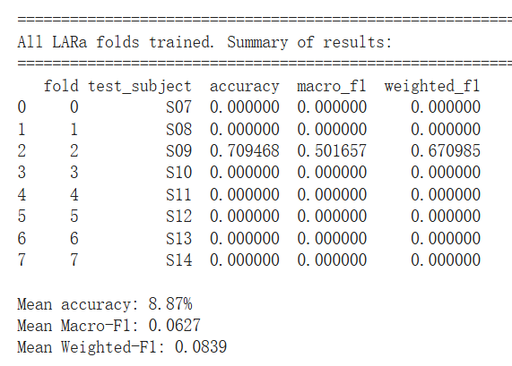
Figure 18 Gradient explosion in rTsfNet

Gradient explosion is a common optimisation problem in deep neural networks. During backpropagation, gradients are passed backward through multiple layers. If the network is deep, the learning rate is too high, input features vary strongly, or intermediate activations have large magnitudes, gradients may be repeatedly amplified across layers. Once gradients become excessively large, a single parameter update can push weights into extreme values, causing numerical overflow and producing inf or NaN loss values.

In this study, rTsfNet uses a relatively deep geometry-aware feature extraction structure and computes many time-domain and frequency-domain statistics, such as higher-order moments and band energies. On the smaller and noisier LARa dataset, these operations may generate intermediate features with large numerical values. In addition, the optimisation configuration that was stable on RealWorld-HAR used a relatively high learning rate, many training epochs, and no gradient clipping. Combined with the higher variance and smaller scale of LARa, this increased the risk of gradient explosion. Therefore, the observed NaN losses and failed folds are best interpreted as optimisation failures rather than evidence that rTsfNet is inherently unsuitable for LARa.

11.1.1 Solution to the gradient explosion problem
To address this issue, only the optimisation configuration of rTsfNet on LARa was modified, while the preprocessing pipeline and network architecture were kept unchanged. This ensures that any performance change mainly reflects improved training stability rather than a different model design.

First, the learning rate was reduced so that each parameter update became smaller and less likely to push the model outside a stable optimisation region. Second, gradient clipping was enabled in the Adam optimiser, for example by setting clipnorm = 1.0. Gradient clipping rescales gradients when they exceed a predefined threshold, preventing individual updates from becoming excessively large. Third, Adam was replaced with its AMSGrad variant, which provides a more stable adaptive learning-rate mechanism when gradients fluctuate strongly. This is especially useful for small, heterogeneous datasets such as LARa. Finally, defensive training callbacks were added, including early stopping, learning-rate reduction on validation-loss plateau, and TerminateOnNaN. The best model checkpoint was restored according to validation accuracy, ensuring that late-stage instability did not affect the final evaluated model.

After applying these stabilisation measures, all eight LOSO folds on LARa trained without producing NaN losses. The previous collapse, where seven folds failed with 0% accuracy, disappeared. The final cross-subject performance stabilised at approximately 65.2% accuracy and 0.466 macro-F1. This confirms that the original failure was mainly caused by numerical and optimisation instability, not by a fundamental limitation of the rTsfNet architecture.
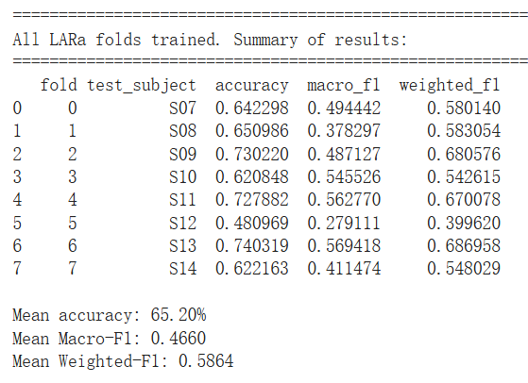
Figure 19 Solution to the gradient explosion

11.2 Solution to the poor performance of RCCMix lightweight on the LaRa dataset
Two versions of RCCMix lightweight were evaluated on the LARa wrist-worn dataset under the same protocol: 13 activity classes, Leave-One-Subject-Out validation, 3-second windows, sequences of eight consecutive windows, and centre-window labels. Accuracy and macro-F1 were used as evaluation metrics.

Under this setting, the original waist-oriented RCCMix lightweight reached only 0.4049 macro-F1. The wrist-optimised version improved performance to 0.4663 macro-F1. Because the training schedule, optimiser, and evaluation protocol were kept identical, this improvement mainly reflects better architectural suitability for wrist-worn HAR on LARa.

The original model performed poorly for three main reasons. First, it was prone to learning subject-specific patterns rather than activity-specific patterns. In LARa, wrist motion varies strongly across individuals because of personal movement style, wrist-band tightness, and sensor orientation. Without per-window normalisation, raw IMU amplitudes and offsets can become strong identity cues. As a result, the model may perform well on seen training subjects but generalise poorly to unseen subjects in LOSO testing.

Second, the original Transformer head used a standard [CLS] token to summarise the whole eight-window sequence. However, in the LARa setup, the label of each sequence is taken only from the centre window, while the surrounding windows provide context. Since a 24-second sequence may contain several micro-actions, a global [CLS] summary can mix information from multiple activities. This creates a mismatch between the model representation and the target label, making optimisation harder and increasing effective label noise.

Third, the original two-branch window encoder was not rich enough for wrist dynamics. Wrist movements often include fast micro-movements, medium-scale actions such as reaching or lifting, and slower posture changes. A limited two-branch encoder may fail to capture this full range of temporal patterns, especially for classes that depend on subtle timing differences.

The wrist-optimised RCCMix lightweight directly addresses these limitations. First, instance normalisation is applied to each IMU channel before convolution by subtracting the window mean and dividing by the standard deviation. This reduces subject-specific amplitude and offset differences while preserving the shape and rhythm of the movement. Second, the window encoder is expanded into a four-branch multi-scale structure with residual connections. Short kernels capture rapid wrist micro-movements, while larger or dilated kernels capture longer motion patterns. The residual pathway helps preserve fine-grained waveform details.

Third, the geometry vector is improved by adding an explicit estimate of gravity direction from the mean accelerometer vector. For wrist-worn sensors, gravity direction provides useful information about hand orientation, such as whether the palm is facing up or down, which can help distinguish similar activities. Fourth, FiLM conditioning combines local window-level geometry with global sequence-level geometry, allowing the Transformer to adjust its internal processing according to both the current window and the broader motion context. Finally, the [CLS] token is removed, and classification is performed using only the centre-window token. This aligns the model head with the labelling rule while still allowing neighbouring windows to provide contextual information through self-attention.

Overall, the original RCCMix lightweight struggled on LARa because it was designed for waist-mounted data and did not fully address cross-subject variability, centre-window labelling, or fine-grained wrist dynamics. The wrist-optimised version introduces targeted changes that directly match these challenges, leading to more stable and higher macro-F1 and accuracy under the same LOSO protocol.

The wrist-optimized RCCMix Lightweight model is not considered a separate architecture, but a modality-specific instantiation of the same RCCMix Lightweight framework, adapted for right-wrist IMU signals in the LARa dataset.

11.3 The issue of MultiRocket training very slowly on the RealWorld dataset
On the RealWorld dataset, MultiROCKET produced extremely high-dimensional features and required substantial computation. Even after engineering optimisation, including memmap-based storage, two-stage feature selection, and dynamic parallelism, training one LOSO fold still took approximately seven hours. Since RealWorld contains 15 folds, full training would require about 105 hours, or nearly four days of continuous computation.

This was also impractical on Google Colab, where a single session is typically limited to 24 hours. In addition, experiments on LARa showed that MultiROCKET did not clearly outperform MiniRocket in overall performance. Since both methods belong to the ROCKET family and use similar random convolutional feature transformations, this study excluded MultiROCKET as a full RealWorld baseline. Instead, only fold 0 was trained on RealWorld, and its result is reported in later chapters as a limited but informative reference.

Chapter 12

Final Results and Evaluation
Models | Accuracy(Realworld) | Accuracy(LaRa) | Size (mb) | Inference latency (ms) | Energy consumption(mj per 3-s window)
knn | 0.7551 | 0.4481 | 27.39 | 46.9475 | 0.115
Random forest | 0.7830 | 0.4255 | 219.85 | 6.8383 | 0.010
inceptiontime | 0.6241 | 0.5199 | 1.78 | 10.5010 | 1.902
minirocket | 0.7879 | 0.4981 | 0.44 | 49.1377 | 0.0208
multirocket | 0.6417(fold 0) | 0.4892 | 2.60 | 10.2868 | 0.0879
TST | 0.7452 | 0.4389 | 2.04 | 5.6155 | 0.262
rTsfNet | 0.8139 | 0.4660 | 3.66 | 439.6153 | 2.020
rTsfNet Lightweight | 0.7815 | 0.4236 | 1.55 | 58.9771 | 0.447
DeepConvContext–LSTM (1-layer, bidirectional) | 0.7982 | 0.3903 | 1.89 | 2.0239 | 0.561
DeepConvContext–LSTM (1-layer, unidirectional) | 0.8066 | 0.4115 | 1.32 | 2.0109 | 1.068
DeepConvContext Bi‑Attention | 0.6301 | 0.3424 | 1.74 | 2.0235 | 1.318
RCCMix lightweight | 0.8114 | 0.4663 | 2.16 | 0.6885 | 0.277
RCCMix | 0.8570 | 0.4954 | 7.39 | 1.5329 | 0.400

12.1 Accuracy, model size, inference latency, and energy consumption of all models
Table 1 Summary of model results

12.1.1 Performance comparison across datasets
Table 1 summarises the performance of all 13 models on the two datasets. On the waist-worn RealWorld-HAR dataset, modern geometry- and context-aware architectures generally outperform the classical baselines. Among the external baselines, rTsfNet achieves the highest macro-F1 (0.8139), followed by the unidirectional DeepConvContext-LSTM (0.8066), the bidirectional DeepConvContext-LSTM (0.7982), MiniRocket (0.7879), Random Forest (0.7830), and KNN (0.7551). InceptionTime and MultiRocket perform noticeably worse on RealWorld-HAR (0.6241 and 0.6417, respectively, with the latter reported for fold 0 only). Our proposed models further improve this performance: RCCMix achieves the best overall score of 0.8570, while RCCMix-Lightweight reaches 0.8114, comparable to rTsfNet and DeepConvContext with substantially lower computational cost.

The ranking changes on the wrist-worn LARa dataset. InceptionTime achieves the highest macro-F1 (0.5199), followed by MiniRocket (0.4981) and RCCMix (0.4954). MultiRocket also remains competitive at 0.4892, while RCCMix-Lightweight and rTsfNet achieve almost identical performance (0.4663 and 0.4660). KNN and TST obtain 0.4481 and 0.4389, respectively. The DeepConvContext variants degrade more substantially, with the two LSTM versions achieving 0.3903–0.4115 and the Bi-Attention model performing worst overall at 0.3424. Overall, these results show that model rankings are dataset-dependent. Although RCCMix does not outperform InceptionTime on LARa, it remains among the strongest models across both datasets, suggesting that its advantages are not limited to the waist-mounted RealWorld-HAR setting.

12.1.2 Accuracy–efficiency trade-offs
A central goal of this work is to evaluate not only predictive performance but also the accuracy–efficiency trade-off relevant to wearable deployment. On RealWorld-HAR, rTsfNet provides strong accuracy (0.8139) but at a high computational cost, with a mean inference latency of 439.6 ms per 3-second window and measured energy consumption of 2.020. By comparison, RCCMix increases macro-F1 to 0.8570 while reducing latency to 1.53 ms and energy consumption to 0.400, with a model size of 7.39 MB. RCCMix therefore provides a substantially better overall operating point than rTsfNet across the four evaluated dimensions.

RCCMix-Lightweight offers an even more deployment-oriented configuration. On RealWorld-HAR it achieves 0.8114 macro-F1, comparable to the unidirectional DeepConvContext-LSTM (0.8066), while reducing latency from 2.01 ms to 0.69 ms and energy consumption from 1.068 to 0.277, at the cost of a modest increase in model size from 1.32 MB to 2.16 MB. On LARa, RCCMix-Lightweight similarly matches rTsfNet (0.4663 vs 0.4660) while remaining much faster and more energy-efficient. The full RCCMix model achieves a higher LARa score of 0.4954 with a latency of only 1.53 ms, providing a strong compromise between predictive performance and computational efficiency.

The results also reveal several Pareto-style operating points. MiniRocket combines competitive performance with the smallest model size (0.44 MB) and very low energy consumption (0.0208), making it attractive for memory- or energy-constrained settings. Random Forest also consumes very little measured energy, although its model size is substantially larger. TST and the DeepConvContext variants occupy an intermediate region, with relatively small models and low inference latency. These results confirm that no single architecture is optimal for every deployment scenario, and model selection should depend on the relative importance of accuracy, latency, model size, and energy consumption.

12.1.3 Design insights for wearable HAR models
The comparison between rTsfNet, DeepConvContext, and the RCCMix family provides several design insights. First, geometry-aware representations appear particularly useful on waist-worn RealWorld-HAR. Both rTsfNet and RCCMix explicitly model relationships between inertial sensor axes and outperform architectures relying primarily on conventional temporal representations. This suggests that incorporating domain knowledge about three-dimensional sensor geometry can improve recognition when sensor placement is relatively stable and activities involve complex whole-body movements.

Second, contextual modelling should be introduced with controlled complexity. The unidirectional DeepConvContext-LSTM performs better than the bidirectional version on both datasets, while adding bi-attention further reduces performance and increases energy consumption. RCCMix instead combines geometric information with a relatively lightweight rotation-conditioned Transformer and FiLM-style modulation. Its results suggest that useful contextual dependencies can be captured without relying on deeper recurrent or attention-based architectures.

Finally, the cross-dataset results highlight the importance of robustness to sensing configuration. Architecture rankings change substantially between waist-worn RealWorld-HAR and wrist-worn LARa. InceptionTime performs best on LARa, while MiniRocket and RCCMix achieve closely matched results of 0.4981 and 0.4954. Importantly, RCCMix remains competitive despite the change in sensor placement, whereas rTsfNet and the DeepConvContext variants experience larger performance reductions. This suggests that the effectiveness of geometric and contextual inductive biases depends on how they are integrated into the architecture, and motivates future work on adaptive or placement-aware models that can generalise more consistently across sensing locations.

12.2 The significance testing of KNN, Random Forest, and InceptionTime on the RealWorld dataset

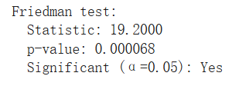
Figure 20 Friedman test
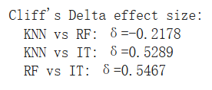
Figure 21 Cliff's Delta effect size

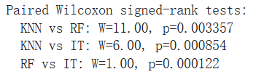
Figure 22 Paired Wilcoxon signed-rank tests

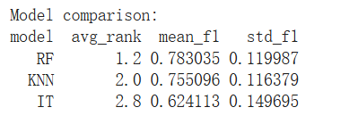
Figure 23 Model comparison

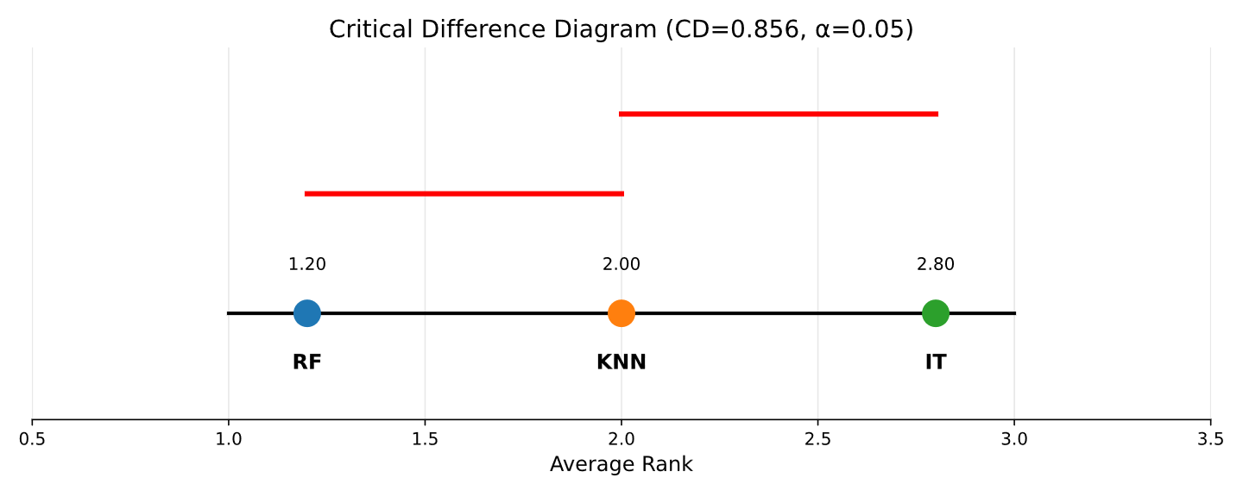
Figure 24 critical_difference

For the 15 subjects (using LOSO cross-validation), we calculated the macro-F1 scores for KNN, Random Forest (RF), and InceptionTime (IT), aiming to answer a fundamental question: are the observed differences between these models large enough to be unlikely attributable merely to chance? To address this, we first employed the Friedman test, a non-parametric omnibus test designed for repeated measures on the same subjects. The test yielded $χ_{F}^{2}(2)=19.2withp=6.8×10^{-5}$, implying that the probability of the null hypothesis—that "all three models perform equally well", being true is far below 1%. In other words, there is strong statistical evidence suggesting that on the RealWorld-HAR dataset, the true performance of at least one model differs from the others, rather than being a result of random fluctuation.

Subsequently, to identify exactly which model pairs differ, we conducted pairwise Wilcoxon signed-rank tests on the per-subject macro-F1 scores. All three pairwise comparisons were statistically significant (KNN vs. RF: $p=0.0034;KNNvs.IT:p=8.5×10^{-4};RFvs.IT:p=1.2×10^{-4}$), and remained significant after applying the Holm correction for multiple comparisons. Effect sizes calculated using Cliff’s $\delta$ indicate that RF holds a "small but consistent advantage" over KNN ($δ=-0.22$, favoring RF), whereas both RF and KNN demonstrate a "large advantage" over IT (KNN vs. IT:$δ=0.53$; RF vs. IT: $δ=0.55$).
The Nemenyi Critical Difference (CD) diagram, based on average ranks, yields the same qualitative conclusion: RF achieved the best average rank (1.20), followed by KNN (2.00), with IT significantly lagging behind (2.80). Notably, the rank difference between RF and IT far exceeds the critical difference $(CD≈0.86)$. Combining these findings with the raw scores (mean macro-F1 $±std:RF0.783±0.120,KNN0.755±0.116,IT0.624±0.150$), we conclude that Random Forest is the strongest overall model among the three classic baselines on the RealWorld-HAR dataset; KNN is slightly inferior but remains competitive; whereas InceptionTime performs significantly worse than the former two.

12.3 Sensitivity and robustness experiments for MiniRocket

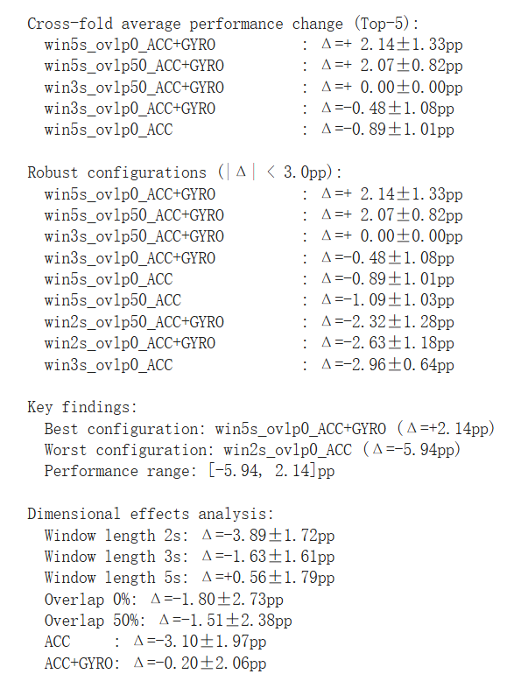
Figure 25 Sensitivity and robustness experiments for MiniRocket

We systematically varied the window length (2 s, 3 s, 5 s), overlap ratio (0 % vs. 50 %), and sensor modality (ACC vs. ACC+GYRO) around the baseline setting of 3 s windows with 50 % overlap and both accelerometer and gyroscope channels. Across all 12 configurations, the cross-fold change in LOSO macro-F1 remained modest, with a performance range of only [−5.94,+2.14] percentage points (pp). Eight out of twelve configurations fall within ±3 pp of the baseline, indicating that the model is reasonably robust to moderate changes in the segmentation hyper-parameters.
Effect of window length.
Window length is the main driver of performance differences. Short 2 s windows consistently hurt performance (average Δ= −3.89 ± 1.72 pp), which is consistent with the intuition that very short segments do not provide enough temporal context to distinguish between similar activities. In contrast, 5 s windows yield a small but systematic improvement (average Δ = +0.56 ± 1.79 pp), and the best configuration overall (5 s, 0 % overlap, ACC+GYRO) improves macro-F1 by +2.14 pp compared to the baseline.
Effect of overlap and sensor modality.
The choice of overlap has a comparatively minor influence: moving between 0 % and 50 % overlap changes performance by less than 2 pp on average (Δ = −1.80 ± 2.73 pp vs. −1.51 ± 2.38 pp), which is small relative to the fold-to-fold variability. Sensor modality is more consequential: removing the gyroscope and using accelerometer-only inputs leads to a clear degradation (Δ = −3.10 ± 1.97 pp), whereas using both accelerometer and gyroscope essentially recovers baseline performance (Δ = −0.20 ± 2.06 pp).
Design implication.
Taken together, these results show that the baseline segmentation setup (3 s, 50 % overlap, ACC+GYRO) lies well inside a robust region of the design space: it delivers near-optimal accuracy while keeping computational cost and decision latency moderate, and it remains stable across subjects. Although 5 s windows with ACC+GYRO can yield an additional ~2 pp of macro-F1, this comes at the price of higher latency and memory usage. We therefore retain the canonical 3 s / 50 % / ACC+GYRO configuration for all main experiments and treat the sensitivity analysis as evidence that our conclusions are not an artefact of a brittle segmentation choice.

12.4 Energy proxy for 6 baseline models
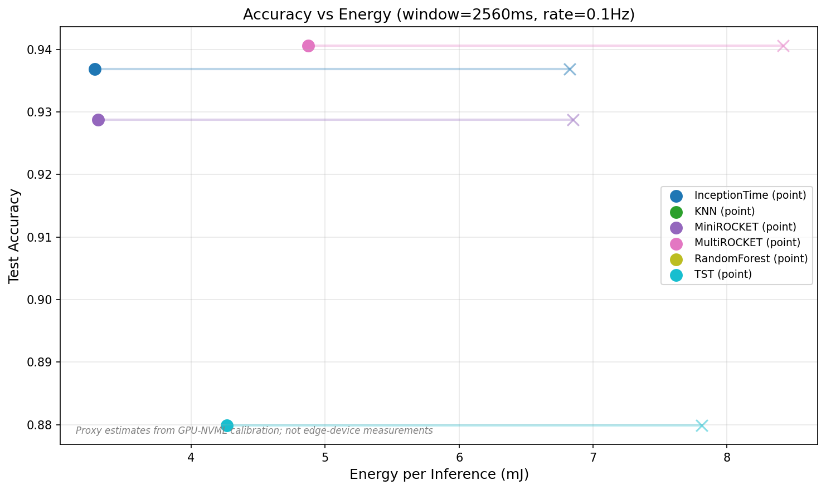
Figure 26 Accuracy vs Energy
artefact As shown in Figure 26, the evaluated models exhibit a clear trade-off between test accuracy and energy per inference. Overall, MiniROCKET and InceptionTime achieve near-maximal test accuracy while consuming substantially less energy per inference than KNN and TST, yielding a more favourable accuracy–energy trade-off.

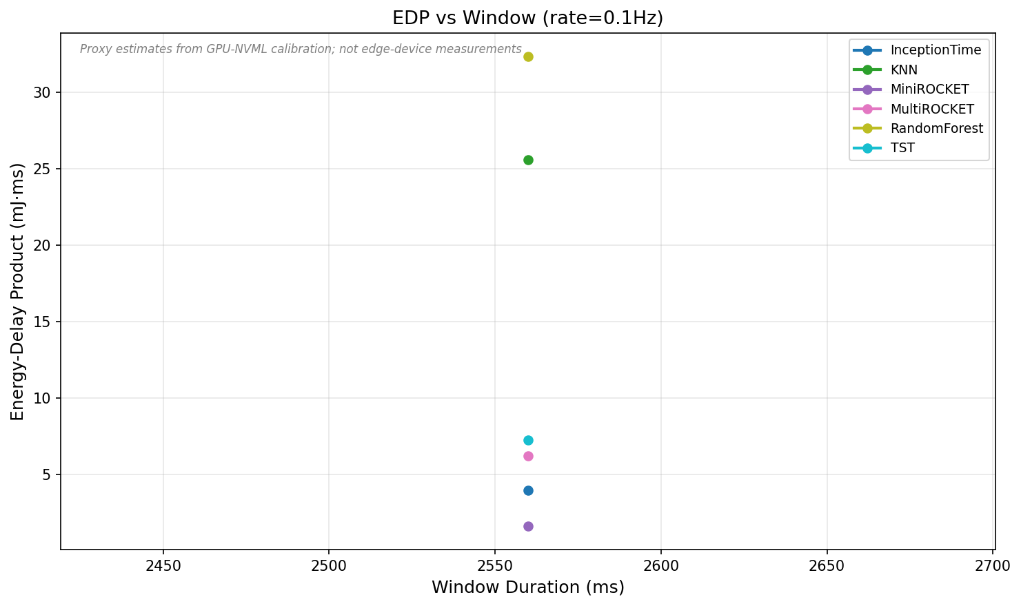
Figure 27 EDP vs Window
Comparison of the energy–delay product (EDP) across the baseline models for window durations around 2560 ms at a refresh rate of 0.1 Hz. The x-axis shows the window duration (ms), and the y-axis reports the EDP (mJ·ms), defined as the product of the energy per inference and the inference latency. This metric jointly captures energy consumption and responsiveness, with lower values indicating better overall efficiency. Each coloured marker corresponds to a different model, and EDP values are derived from GPU-NVML–calibrated estimates of energy and latency.
As illustrated in Figure 27, the models exhibit substantial differences in EDP under the same window configuration. MiniROCKET and InceptionTime achieve the lowest EDP values, indicating that they are efficient in terms of both energy consumption and inference latency. TST and MultiROCKET occupy an intermediate regime, whereas KNN and RandomForest show considerably higher EDP, driven by their higher energy usage and/or longer latency. Overall, the EDP analysis reinforces that MiniROCKET and InceptionTime provide the most favourable performance–efficiency trade-off in this experimental setting.

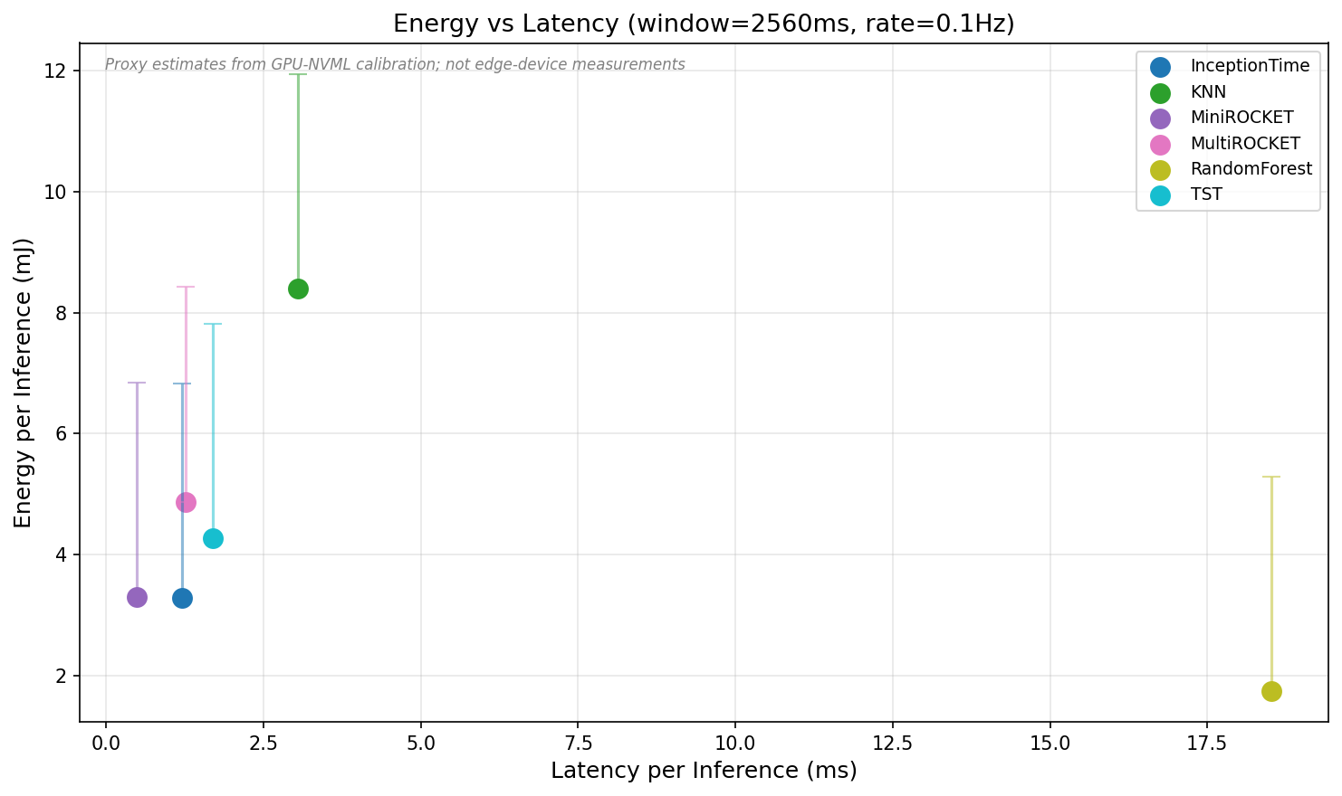
Figure 28 Energy vs Latency
Energy per inference versus inference latency for the baseline models with a window length of 2560 ms and a refresh rate of 0.1 Hz. The x-axis shows the latency per inference (ms), where smaller values indicate faster predictions, and the y-axis shows the energy required to process a single window (mJ), where smaller values indicate lower energy consumption. Filled circles denote NVML-calibrated estimates of the single-inference energy, and the vertical error bars indicate the variation observed across repeated runs. Points in the lower-left region correspond to the desirable regime of low energy and low latency.
As shown in Figure 28, the models exhibit a characteristic trade-off in the energy–latency plane. InceptionTime and MiniROCKET lie towards the lower-left region, combining relatively short inference latency with moderate energy per inference, and thus offer a balanced compromise between responsiveness and efficiency. TST and MultiROCKET show slightly higher latency and energy, occupying an intermediate regime. By contrast, KNN attains the highest energy consumption without being particularly fast, whereas RandomForest achieves the lowest energy per inference at the cost of substantially longer latency. Overall, this figure highlights the practical design trade-offs that arise in deployment: models must balance energy usage against responsiveness rather than optimising either in isolation.
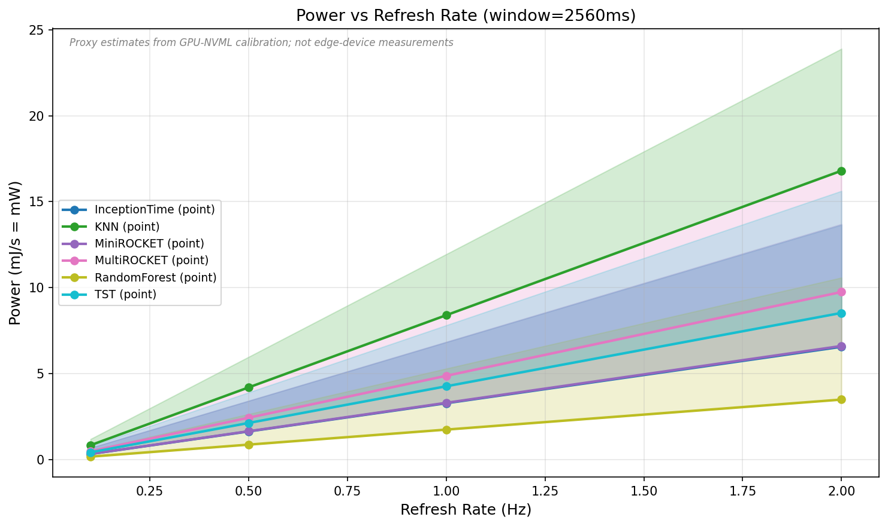
Figure 29 Power vs Refresh Rate
Estimated inference power as a function of refresh rate for the baseline models with a window length of 2560 ms. The x-axis denotes the number of activity-recognition inferences per second (refresh rate, Hz), and the y-axis shows the corresponding average power consumption (mJ/s ≈ mW). Each coloured line represents the power obtained by multiplying the measured energy per inference by the refresh rate, under the simplifying assumption that the energy cost of a single inference is approximately independent of the refresh rate; the shaded bands reflect the propagation of uncertainty from the underlying energy estimates. All values are derived from GPU–NVML–based calibration rather than direct measurements on embedded or wearable hardware.
As illustrated in Figure 29, under the present configuration the power consumption of all models increases approximately linearly with the refresh rate: raising the frequency from one inference every 10 seconds (0.1 Hz) to two inferences per second (2 Hz) increases the required sustained power by roughly an order of magnitude. The power curves for KNN and MultiROCKET lie near the top of the plot, indicating that these methods are particularly demanding in high-refresh-rate settings, whereas RandomForest remains the most power-efficient and least sensitive to changes in refresh rate. InceptionTime, MiniROCKET, and TST occupy an intermediate regime, offering acceptable power levels at moderate to high refresh rates. Taken together, this figure highlights that, in practical deployments, the choice of refresh rate is as critical as the choice of model in determining overall energy efficiency and battery lifetime.

12.5 In-depth Analysis and Interpretability of RCCMix Lightweight

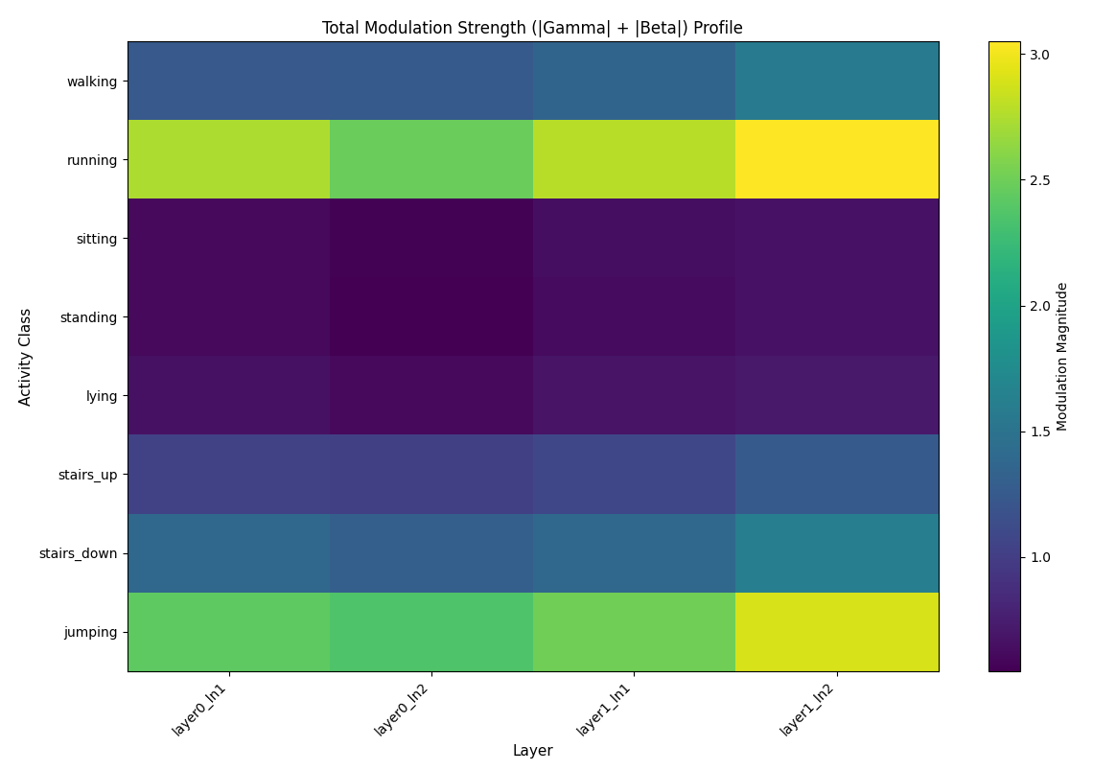
Figure 30 Total Modulation Strength
Fig 30 summarises how strongly the FiLM layers in RCCMix-HAR modulate the internal representation for each activity class. For every conditional LayerNorm in the two RCC blocks (layer0_ln1, layer0_ln2, layer1_ln1, layer1_ln2), we extract the FiLM scaling and shifting vectors γ(g) and β(g) for all test sequences, take their absolute values, and average over feature dimensions, windows and LOSO folds. Each cell therefore corresponds to the mean total modulation strength E[∣γ∣+∣β∣] for a given (activity, layer) pair, with brighter colours indicating that the layer relies more heavily on FiLM to adapt its features to that activity.
Two consistent patterns emerge. First, dynamic activities such as running and jumping exhibit substantially larger modulation magnitudes than static activities such as sitting, standing and lying across all layers. Transition activities (stairs_up and stairs_down) fall between these two extremes. This indicates that the network has learned to use the geometric conditioning pathway to a much greater extent when the underlying motion is strong or rapidly changing, whereas low-energy postures require only mild adjustments to the base representation. Second, modulation strengths tend to increase towards the deeper FiLM layers (particularly layer1_ln2), suggesting that later blocks integrate the geometric summary more aggressively when forming the final sequence representation.
Overall, Fig. 30 provides direct evidence that FiLM is not acting as a redundant auxiliary branch but is systematically activity-dependent: the same backbone representation is reweighted and shifted to different degrees depending on the movement regime. Coupled with the sensitivity experiments in Sec. Y (where perturbing accelerometer/gyroscope energy significantly alters predictions for the same set of dynamic classes), this supports our claim that RCCMix-HAR has learned a meaningful, geometry-aware conditioning mechanism rather than merely fitting a black-box classifier.

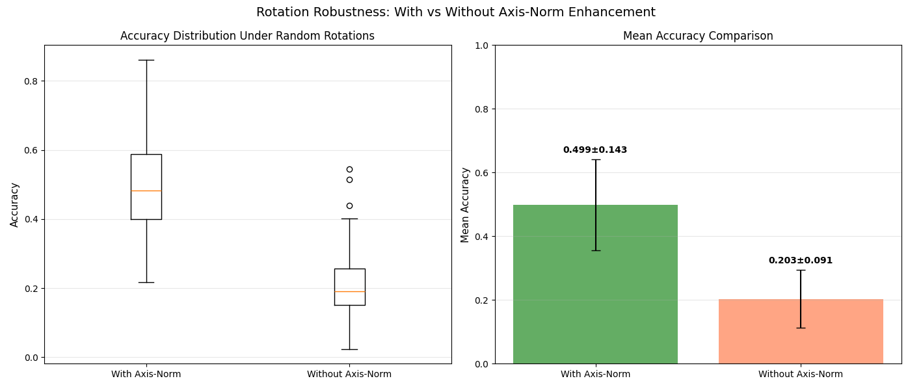
Figure 31 Axis-Norm Enhancement
To quantify the contribution of the axis-norm branch in the window encoder, we evaluate RCCMix-HAR under a set of randomly sampled 3-D rotations of the raw IMU axes. Fig. 31 compares the distribution of test accuracy with and without axis-norm enhancement. With axis-norm, the model maintains a mean accuracy of 0.499±0.143 across rotations, whereas the variant that operates only on the raw Cartesian axes collapses to 0.203±0.091. In other words, random misalignment of the sensor orientation degrades the baseline by more than a factor of two, but the axis-norm formulation recovers a large fraction of this loss and yields substantially more stable performance across different rotation matrices. This result supports our design choice: aggregating axis-wise magnitudes and energies provides a rotation-aware summary that allows the downstream Transformer to form activity-specific representations that are much less sensitive to how the device is mounted in practice.

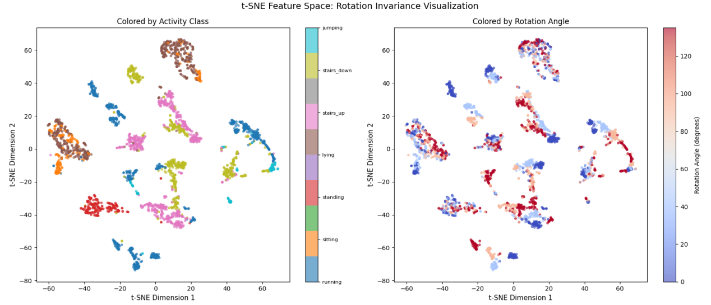
Figure 32 Rotation Invariance Visualization
While Fig. 31 measures robustness at the prediction level, Fig. 32 examines how rotation information is encoded in the latent space. We collect the final CLS-token embeddings for a subset of rotated test sequences and project them to two dimensions using t-SNE. When points are coloured by activity label (Fig. 32-left), the embedding forms eight well-separated clusters, confirming that the representation is strongly class-discriminative.

When we recolour the same points by the applied rotation angle (Fig. 32-right), no clear angular structure emerges: samples with very different rotation angles are intermingled within each activity cluster, and there are no systematic gradients or sub-clusters that correlate with orientation. If the network had retained a strong dependence on sensor orientation, we would expect rotated versions of the same activity to split into distinct sub-manifolds, or to arrange along continuous trajectories in the embedding space. Instead, the t-SNE plots suggest that RCCMix-HAR has largely factored out the rotation nuisance, mapping different orientations of the same movement pattern to nearby points. Together with the quantitative robustness in Fig. 32, this provides converging evidence that the proposed axis-norm and geometric conditioning mechanisms have successfully induced an approximately rotation-invariant
feature space.

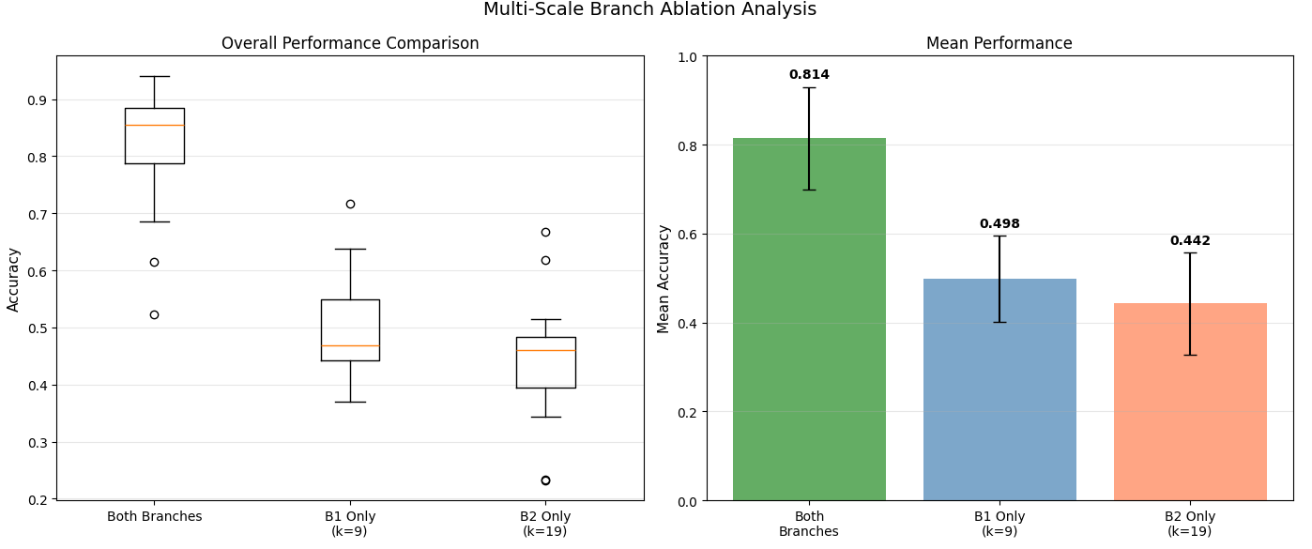
Figure 33 Multi-Scale Branch Ablation Analysis
The window encoder in RCCMix-HAR uses two parallel depthwise convolutional branches with kernel sizes 𝑘=9 (B1) and 𝑘=19 (B2) to capture short-range and longer-range temporal patterns within each IMU window. To test whether both branches are actually needed, we perform an ablation study where we retrain the model with only B1 or only B2, keeping all other components and hyper-parameters fixed. Fig. 33 summarises the resulting LOSO test accuracies.

When both branches are present, the model reaches a mean accuracy of 0.814, whereas the single-branch variants drop to 0.498 (B1-only) and 0.442 (B2-only). The boxplots also show that the full model is not only more accurate but also markedly more stable across folds. Importantly, each single-branch model still performs well above chance, which indicates that both branches learn useful features; however, their combination recovers an additional ~30 percentage points of accuracy. This pattern suggests that the two convolutional paths are complementary rather than redundant: the network benefits from simultaneously observing fine-grained, short-range motion cues and slower, longer-range trends within the same window, which justifies the added complexity of the multi-scale encoder.

12.6 In-depth Analysis and Interpretability of RCCMix
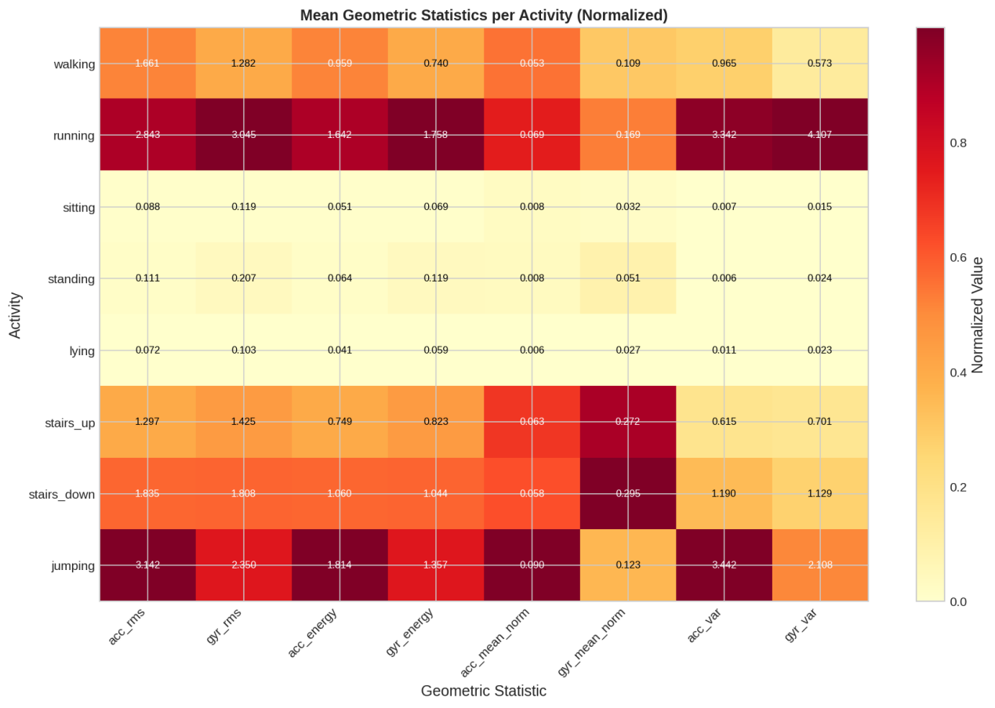
Figure 34 Mean Geometric Statistics per Activity
Normalised mean geometric statistics per activity. Each row corresponds to one activity and each column to one component of the geometric conditioning vector (RMS, energy, mean norm and variance for acceleration and gyroscope). Darker colours indicate larger average values. Running and jumping show clearly higher intensity-related values than static activities, while stair climbing/descending lie in between.

Fig. 34 visualises the average value of each geometric feature for the eight activities. We can see that running and jumping appear in dark red across almost all acceleration and gyroscope statistics, meaning that these features capture strong, high-intensity motion. Sitting, standing and lying are almost entirely light-coloured, indicating values close to zero. Stair climbing and descending lie between walking and running.
In other words, the 8-dimensional geometric vector already separates “high-intensity dynamic activities”, “medium-intensity gait and stairs” and “low-intensity postures” in a physically meaningful way. This supports using g as a compact and interpretable summary of the subject’s motion state.

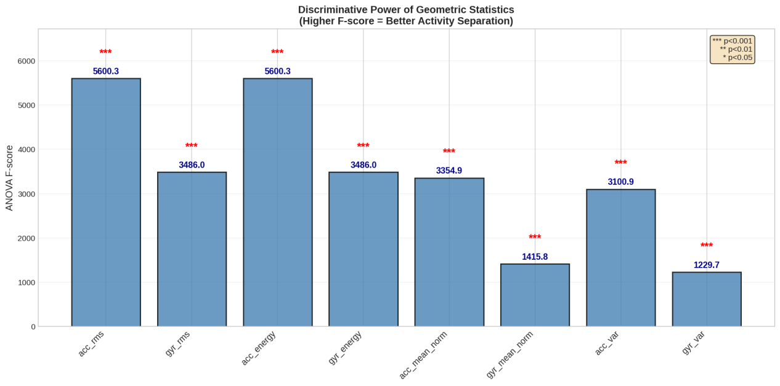
Figure 35 Discriminative Power of Geometric Statistics
Discriminative power of each geometric statistic measured by one-way ANOVA F-scores. A higher F-score means that the feature shows larger mean differences across the eight activities and thus has stronger discriminative ability. Acceleration RMS and energy achieve the highest F-scores, followed by acceleration variance and mean norm, while gyroscope-based features have slightly lower but still highly significant values (p < 0.001).

To quantify how useful each geometric component is for separating activities, we perform a one-way ANOVA over the eight classes; the resulting F-scores are shown in Fig. 35. All features have p-values far below 0.001, indicating highly significant differences in their means across activities. Acceleration RMS and energy achieve the largest F-scores, followed by acceleration variance and mean norm, while gyroscope-based features are slightly weaker but still clearly discriminative.
This confirms that the geometric conditioning vector is not just an auxiliary side feature: its components are statistically very sensitive to the underlying activity classes.

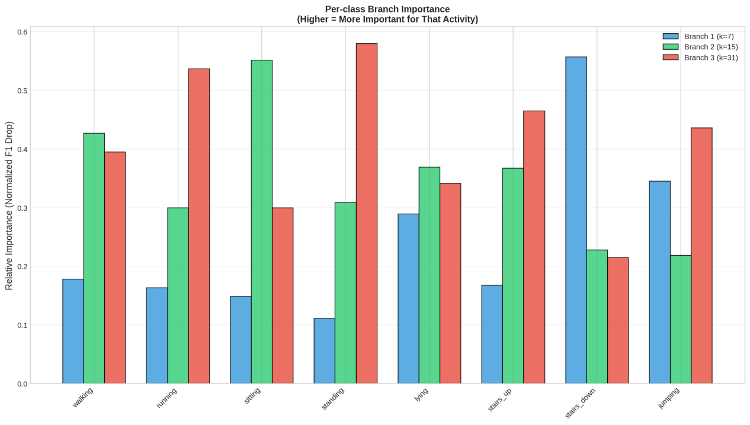
Figure 36 Per-class Branch Importance
Fig. 36 Relative importance of the three temporal branches for each activity (values are normalised drops in F1-score when the branch is ablated; higher means more important for that class). Branch 1 (k=7) captures the shortest time scale (high-frequency), Branch 2 (k=15) a medium time scale, and Branch 3 (k=31) the longest time scale (low-frequency). Static postures (sitting, standing) rely most on the long-term branch (Branch 3), while stair descent (stairs_down) and jumping depend strongly on the short-term branch (Branch 1). Walking and running are mainly supported by the medium and long time-scale branches.

To understand what each branch is actually doing, we perform a simple “switch-off” experiment at test time. We disable one branch at a time and measure how much the F1-score drops for each class. After normalisation, these drops give the relative importance values shown in Fig. 36.
The figure shows that sitting and standing rely most on the longest time-scale branch (Branch 3), suggesting that the model mainly uses low-frequency information about whether the body posture stays stable over a longer period. In contrast, stair descent (stairs_down) and jumping depend strongly on the short time-scale branch (Branch 1), which is consistent with these activities containing sharp, high-frequency changes such as impacts and rapid step transitions. Walking and running are supported primarily by the medium and long time-scale branches, matching our intuition that they are dominated by relatively regular gait cycles.
Overall, these results indicate that the three multi-scale convolution branches are not redundant. Instead, they specialise into “short-term shocks, mid-term gait and long-term posture”, providing empirical support for the multi-time-scale design of RCCMix.

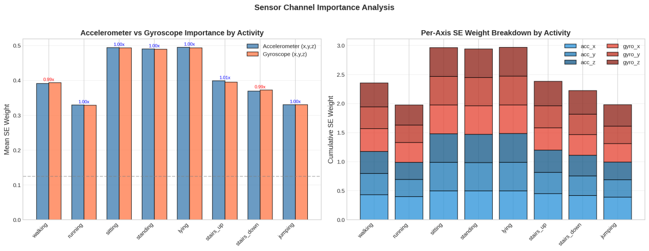
Figure 37 Sensor Channel Importance Analysis
Fig. 37 Sensor channel importance analysis. The left panel shows the mean SE attention weight assigned to the accelerometer (x,y,z) and gyroscope (x,y,z) for each activity, which can be interpreted as how much the model relies on each sensor type; the dashed line indicates the baseline for a uniform allocation. The right panel breaks down the cumulative SE weights into the six individual axes (acc_x, acc_y, acc_z, gyro_x, gyro_y, gyro_z), revealing which directions are emphasised for different activities.

Fig. 37 shows what the model is actually looking at at the sensor level. In the left panel, we compare the mean SE attention weights assigned to the accelerometer and gyroscope for each activity. Overall, the two sensor types receive very similar weights for most activities, which suggests that RCCMix does not rely on a single sensor but combines linear acceleration and angular velocity information when making decisions.
The right panel breaks the weights down by axis. For activities such as stair climbing/descending and jumping, the vertical axes (e.g. acc_z and gyro_y/gyro_z) contribute more, while for static postures (sitting, standing, lying) the weights are more evenly spread across axes.
These patterns indicate that the SE channel attention learns intuitive “sensor selection”: for movements with strong vertical or rotational components, it automatically up-weights the corresponding channels; for static postures, it does not over-emphasise any single axis. This also supports the design choice of keeping both accelerometer and gyroscope on a waist-worn IMU, as both are actively used by the model.

12.7 Error Analysis of the Random Forest Baseline
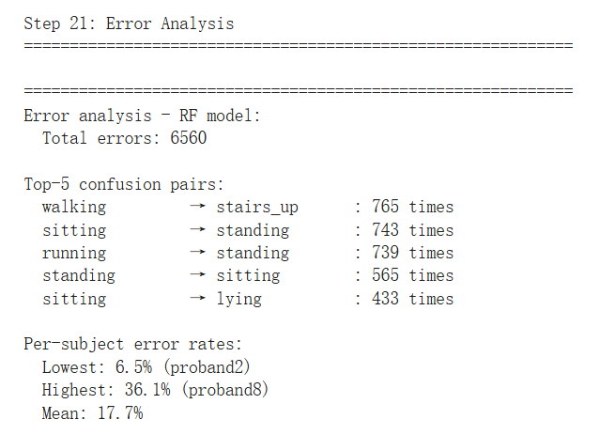
Figure 38 Misclassification Patterns and Subject-level Error Rates of the Random Forest Baseline

The error analysis of the Random Forest (RF) baseline shows that the model produced 6,560 incorrect window-level predictions. The most frequent confusion was between walking and stairs_up, with 765 walking windows incorrectly classified as stairs_up. This suggests that RF struggled to distinguish locomotion activities with similar periodic acceleration patterns. Static postures were also frequently confused, particularly sitting and standing, and sitting and lying. This is expected because these activities involve limited body movement and mainly differ in sensor orientation rather than strong dynamic motion.

A notable error was the misclassification of running as standing 739 times. Since these two activities are physically distinct, this may indicate subject-specific variation, transitional windows, or limitations of RF in capturing temporal movement patterns. The per-subject error rates further confirm this issue. The lowest error rate was 6.5% for proband2, while the highest reached 36.1% for proband8, with a mean error rate of 17.7%. This wide gap suggests that the RF model is sensitive to inter-subject variability under the LOSO evaluation protocol. Overall, although RF achieved reasonable performance, its errors were concentrated in similar activity pairs and in specific subjects, indicating limited robustness when generalising to unseen users.

12.8 Self developed models calibration results
Model | Setting | NLL ↓ | Brier ↓ | ECE ↓ | Adaptive ECE ↓ | Classwise ECE ↓
rTsfNet Lightweight | Raw | 0.6422 | 0.2782 | 0.0716 | 0.0715 | 0.0194
rTsfNet Lightweight | Calibrated | 0.6627 | 0.2806 | 0.0769 | 0.0769 | 0.0207
RCCMix Lightweight | Raw | 0.6521 | 0.2994 | 0.0447 | 0.0526 | 0.0171
RCCMix Lightweight | Calibrated | 0.6898 | 0.3058 | 0.0785 | 0.0750 | 0.0227
RCCMix | Raw | 0.5479 | 0.2225 | 0.0660 | 0.0658 | 0.0191
RCCMix | Calibrated | 0.6376 | 0.2327 | 0.0995 | 0.0993 | 0.0258
Table 2 Pooled calibration results before and after temperature scaling

To further assess whether the proposed models produced reliable probability estimates, a post-hoc calibration analysis was performed on the pooled LOSO test predictions. This analysis is complementary to the main classification evaluation. Macro-F1 measures whether the predicted activity labels are correct, whereas calibration metrics evaluate whether the confidence values assigned to those predictions are trustworthy. For example, if a model assigns approximately 80% confidence to a group of predictions, a well-calibrated model should be correct for roughly 80% of those cases.

Temperature scaling was used as a lightweight post-hoc calibration method. It rescales the logits before the softmax function using a single positive temperature parameter, thereby adjusting the sharpness of the predicted probability distribution. Since this transformation normally preserves the class with the highest probability, it is expected to affect confidence-based metrics such as negative log-likelihood (NLL), Brier score and expected calibration error (ECE), rather than the predicted labels themselves.

The pooled calibration results are shown in Table 2. Overall, temperature scaling did not improve calibration for the three evaluated models. For rTsfNet Lightweight, NLL increased from 0.6422 to 0.6627, Brier score increased from 0.2782 to 0.2806, and ECE increased from 0.0716 to 0.0769 after calibration. The Macro-F1 remained unchanged at 0.8298, confirming that temperature scaling modified the predicted confidence values but not the predicted class labels. A similar pattern was observed for RCCMix Lightweight, where NLL increased from 0.6521 to 0.6898, Brier score from 0.2994 to 0.3058, and ECE from 0.0447 to 0.0785. For the full RCCMix model, the raw predictions also showed better calibration than the calibrated predictions: NLL increased from 0.5479 to 0.6376, Brier score from 0.2225 to 0.2327, and ECE from 0.0660 to 0.0995.

These results indicate that the uncalibrated models were already reasonably calibrated under the pooled LOSO evaluation, and that the validation-derived temperature parameters did not transfer beneficially to the pooled test predictions. Therefore, the raw probability outputs were retained for the final uncertainty and calibration interpretation. This finding also highlights that temperature scaling is not guaranteed to improve calibration in every setting, particularly when the validation split used to estimate the temperature differs from the distribution of the held-out test subjects. In subject-independent HAR, this issue is especially relevant because each LOSO fold evaluates a previously unseen participant, and differences in movement style, sensor placement and activity execution can affect both classification accuracy and confidence calibration.

Chapter 13

Discussion and Reflection

13.1 Discussion of Main Findings
This dissertation investigated how accurate and computationally efficient human activity recognition models can be designed for wearable IMU settings. The main finding is that wearable HAR should not be evaluated as a pure classification problem. Instead, it should be treated as a deployment-oriented time-series recognition problem, where predictive performance, cross-subject generalisation, latency, model size, approximate energy consumption and reliability all matter.

On the RealWorld-HAR waist-mounted setting, RCCMix achieved the strongest overall result, with a LOSO macro-F1 of 0.8570. This suggests that combining geometry-aware modelling with contextual temporal representation learning is effective when the sensor is placed close to the body centre and the activities involve clear whole-body movement patterns. Waist-mounted IMU signals capture posture, gait and locomotion more consistently than wrist-mounted signals. Therefore, modelling the three-dimensional structure of accelerometer and gyroscope signals, together with temporal context, can help distinguish activities such as walking, running, stair ascent and stair descent.

However, the results on LARa show that this advantage is not universal. In the right-wrist logistics setting, InceptionTime achieved the highest macro-F1, while RCCMix remained competitive but did not outperform all baselines. This indicates that a model that works very well for waist-mounted daily activity recognition may not transfer equally well to wrist-mounted industrial activity recognition. Wrist IMU signals are more affected by hand movement, object manipulation, working style and incidental arm motion. In LARa, several activities are fine-grained and locally similar, so stable global body geometry is less informative than in RealWorld-HAR. This helps explain why a multi-scale convolutional model such as InceptionTime performs particularly well in that setting.

The findings therefore suggest that future HAR research should avoid drawing conclusions from a single dataset or sensor placement. Sensor placement is not only an implementation detail; it changes the nature of the recognition problem. A waist sensor is better suited to global posture and locomotion, while a wrist sensor is more sensitive to local manipulation and task-dependent movement. As a result, model design should be matched to the target deployment scenario.

13.2 Deployment Implications
The results also show that the model with the highest macro-F1 is not always the most suitable model for wearable deployment. In practical HAR systems, a slightly lower macro-F1 may be acceptable if the model is substantially faster, smaller and more energy-efficient.

The comparison between rTsfNet and rTsfNet-Lightweight illustrates this point clearly. rTsfNet achieved strong recognition performance, but it required relatively high latency and approximate energy consumption. rTsfNet-Lightweight reduced the model size from 3.66 MB to 1.55 MB, reduced inference latency from 439.62 ms to 58.98 ms, and reduced approximate energy consumption from 2.020 mJ to 0.447 mJ per three-second window. Its RealWorld-HAR macro-F1 decreased from 0.8139 to 0.7815. This represents a clear accuracy-efficiency trade-off: some predictive performance was lost, but the model became much more suitable for resource-constrained deployment.

RCCMix and RCCMix-Lightweight provide another example of this trade-off. RCCMix prioritises recognition performance and achieves the best RealWorld-HAR result. RCCMix-Lightweight provides a more deployment-friendly operating point. On RealWorld-HAR, it achieved a macro-F1 of 0.8114, close to rTsfNet’s 0.8139, while reducing inference latency to 0.69 ms and approximate energy consumption to 0.277 mJ per window. On LARa, RCCMix-Lightweight also slightly exceeded the original rTsfNet. These results suggest that simplified geometry- and context-aware designs can retain much of the benefit of more complex architectures while becoming more practical for continuous inference.

Overall, the study supports a multi-objective view of HAR evaluation. Macro-F1, model size, latency and approximate energy consumption should be interpreted together. For offline analysis, a larger and more accurate model may be acceptable. For real-time or on-device recognition, a lightweight model with slightly lower macro-F1 may be preferable. This is especially important for wearable systems, where battery life, responsiveness and memory constraints directly affect usability.

13.3 Reliability, Robustness and Limitations
The strict Leave-One-Subject-Out protocol is one of the most important parts of this dissertation. Since each fold evaluates a previously unseen subject, the results provide a more realistic estimate of generalisation than random window-level splitting. In wearable HAR, this is essential because users differ in gait, posture, movement intensity and device wearing style. A model that performs well under LOSO is more likely to learn generalisable activity representations rather than subject-specific patterns.

The additional analyses also show that average macro-F1 alone is insufficient. Statistical testing, calibration analysis, robustness checks and error analysis provide a more complete understanding of model behaviour. Confusion matrices and top-confusion pairs help identify which activities are systematically difficult to separate. Subject-level analysis reveals whether a model performs consistently across users or fails on particular participants. Calibration metrics such as NLL, Brier score and ECE examine whether model confidence is reliable, not only whether the predicted label is correct.

Several limitations remain. First, the study uses two datasets: RealWorld-HAR and LARa MbientLab. Although they represent two different HAR scenarios, they do not cover all possible wearable applications, such as rehabilitation, elderly monitoring, fall detection, sports analytics or long-term free-living monitoring. Therefore, the conclusions should be interpreted as evidence from two representative settings rather than universal claims about all HAR tasks.

Second, only one main sensor placement is used for each dataset: waist for RealWorld-HAR and right wrist for LARa. This reflects realistic single-device deployment, but it does not fully test cross-placement generalisation. In real-world use, users may carry a phone in different pockets or wear a device at slightly different wrist positions. These placement shifts may affect model performance.

Third, the experiments use a fixed preprocessing configuration: 50 Hz sampling, three-second windows and 50% overlap. This ensures consistency across models, but different deployment scenarios may require shorter windows, lower sampling rates or different overlap ratios. These choices could change both accuracy and computational cost.

Fourth, the reported energy values are approximate and hardware-dependent. They are useful for relative comparison under a controlled setup, but they should not be interpreted as exact battery consumption on all wearable devices. Direct measurement on smartphones, smartwatches or embedded hardware would be needed to make stronger deployment claims.

Finally, some complex models showed training instability or weaker generalisation, especially in the LARa wrist setting. This suggests that increasing architectural complexity does not automatically improve HAR performance. Geometry-aware and context-aware modelling can be valuable, but their effectiveness depends on the dataset, sensor placement and activity structure.

13.4 Reflection
This project shows that building a reliable HAR benchmark requires substantial engineering work beyond training models. The preprocessing pipeline, subject-wise splitting, metric calculation, latency measurement, energy estimation and debugging steps were all necessary to make the comparison meaningful. Without these steps, the results could have been affected by data leakage, inconsistent preprocessing or unfair evaluation.

A key lesson from this dissertation is that model design and evaluation should be developed together. A new HAR model should not only report a high accuracy or macro-F1 score. It should also be tested against strong baselines, evaluated under subject-independent conditions, measured for computational cost and analysed for reliability. This broader evaluation perspective is one of the main contributions of the project.

Chapter 14

Conclusion and future work

14.1 Conclusion
This dissertation addressed the problem of designing accurate and computationally efficient wearable IMU-based human activity recognition models. The work focused on two practical single-sensor settings: waist-mounted daily activity recognition using RealWorld-HAR and right-wrist logistics activity recognition using LARa MbientLab.

A unified experimental framework was developed to evaluate classical baselines, general time-series models, recent HAR-specific architectures and three proposed models under the same LOSO protocol. The evaluated models included KNN, Random Forest, InceptionTime, MiniRocket, MultiRocket, Time Series Transformer, rTsfNet, DeepConvContext variants, RCCMix, RCCMix-Lightweight and rTsfNet-Lightweight. The evaluation considered not only macro-F1, but also model size, inference latency, approximate energy consumption, calibration, robustness and error behaviour.

The main research question asked how accurate and computationally efficient HAR models can be designed for waist- and wrist-mounted IMU settings. The results suggest that effective HAR model design requires three elements: strong temporal representation learning, strict subject-independent evaluation and explicit consideration of deployment cost. RCCMix shows that geometry-aware and contextual modelling can improve performance in waist-mounted daily activity recognition. RCCMix-Lightweight shows that these ideas can be simplified into a much faster and more energy-efficient model while retaining competitive performance. rTsfNet-Lightweight shows that a recent geometry-aware architecture can be compressed substantially with only a moderate reduction in macro-F1.

For RQ1, the results show that model rankings differ across datasets. RCCMix performs best on RealWorld-HAR, while InceptionTime performs best on LARa. This confirms that no single model family dominates all HAR settings.

For RQ2, the results reveal clear trade-offs between macro-F1, model size, latency and approximate energy consumption. Models with strong predictive performance are not always the most deployable, while lightweight models may sacrifice some accuracy in exchange for major efficiency gains.

For RQ3, the results support the value of combining geometry-aware and contextual modelling, especially when the IMU signal contains stable body-level movement patterns. However, the benefit is less consistent in the noisier wrist-based logistics setting, where fine-grained local hand motion plays a larger role.

For RQ4, the results show that rTsfNet can be simplified substantially. rTsfNet-Lightweight greatly reduces model size, inference latency and approximate energy consumption while preserving much of the original model’s recognition ability.

Overall, this dissertation makes four contributions. First, it provides a reproducible and leakage-safe evaluation pipeline for wearable IMU-HAR. Second, it offers a broad comparison of representative model families under the same LOSO protocol. Third, it introduces RCCMix, RCCMix-Lightweight and rTsfNet-Lightweight. Fourth, it evaluates HAR models from a multi-objective deployment perspective rather than relying only on accuracy or macro-F1.

14.2 Future Work
Future work should first evaluate the proposed models on more datasets and application domains. Because this dissertation only uses RealWorld-HAR and LARa, additional datasets from rehabilitation, healthcare monitoring, elderly care, sports analytics and long-term free-living recognition would help test whether the findings generalise to a wider range of HAR scenarios.

Second, future research should examine more sensor placements and cross-placement settings. This dissertation focuses on one placement per dataset, but real users may carry or wear devices on the wrist, waist, pocket, thigh or chest. Evaluating cross-placement robustness would make the deployment analysis more realistic.

Third, future experiments should vary sampling rate, window length and overlap ratio. Shorter windows may improve responsiveness, while lower sampling rates may reduce energy consumption. A systematic sensitivity study could determine whether the same model rankings remain stable under stricter real-time and low-power conditions.

Fourth, future work should measure latency, memory use and energy consumption directly on real devices, such as smartphones, smartwatches, microcontrollers or edge AI boards. This would provide stronger evidence for actual wearable deployment than software-based energy proxies alone.

Fifth, the LARa wrist setting deserves further investigation. Since wrist-based logistics recognition is fine-grained and noisy, future models may benefit from self-supervised pretraining, subject adaptation, temporal smoothing, class-imbalance handling or additional task-context information.

Finally, future work should explore more reliable uncertainty estimation and personalisation. Temperature scaling did not consistently improve calibration in this study, suggesting that subject-independent HAR may require more robust calibration methods. Federated learning or lightweight on-device adaptation could also allow HAR models to personalise to new users while preserving privacy.

In conclusion, this dissertation shows that wearable IMU-based HAR should be understood as a deployment-oriented time-series recognition problem. High macro-F1 is important, but it is not sufficient. Practical HAR models must also be efficient, robust to unseen users and reliable in their outputs. By combining strict LOSO evaluation with geometry-aware, context-aware and lightweight model design, this work provides a practical foundation for more deployable wearable HAR systems.

Chapter 15

Evaluation of legal, social and
ethical issues

15.1 Ethical Issues
Human Activity Recognition (HAR) raises significant ethical issues because it transforms continuous body movement signals into information about human behaviour. Although accelerometer and gyroscope data may appear less sensitive than images, speech or clinical records, they can still reveal a person’s daily routines, mobility, physical condition, working patterns and possible health limitations. Therefore, HAR should not be treated as a purely technical classification problem. Even when the research focus is model accuracy, latency, model size or energy efficiency, the collection and processing of wearable sensor data must be evaluated from an ethical perspective.

The first ethical issue is informed consent. Participants should understand what types of sensor data are collected, which body location or wearable device is used, how long the data will be stored, who can access it, and whether it will only be used for academic research or may support future model development. This is especially important because HAR data are continuous and behavioural. A single short window may only represent walking or sitting, but long-term monitoring can reveal sleep patterns, exercise habits, work breaks, commuting routines or possible health-related conditions. Consent must also be genuinely voluntary. In workplaces, hospitals, schools, care homes or assisted-living environments, individuals may feel pressured to accept monitoring because of unequal power relationships. In such cases, a signed consent form alone may not be enough to prove that participation was fully free.

A related issue is the right to withdraw. Participants should be able to leave a study where possible, and researchers should explain what will happen to data that have already been processed or used to train models. This can be technically difficult because trained machine-learning models do not store personal data in the same way as ordinary databases. Once a model has learned from a participant’s data, removing that individual’s influence may require retraining or additional technical measures. Therefore, the limits of withdrawal should be made clear before data collection begins.

Privacy is one of the most important ethical concerns in HAR. Wearable sensor data can support inferences beyond the target activity label. For example, repeated movement patterns may indicate whether a person has reduced mobility, is recovering from injury, performs physically demanding work, remains inactive for long periods, or follows a highly regular daily routine. In some contexts, HAR may also support health-related inference, such as fall risk, fatigue, rehabilitation progress or abnormal movement. This creates a risk of sensitive inference: a system designed only to classify activities such as walking, standing or lying may later be interpreted as evidence about health, productivity or lifestyle.

This connects to the problem of purpose limitation and function creep. Data collected for research, health support or safety should not later be reused for unrelated aims such as employee surveillance, insurance scoring, marketing, disciplinary decisions or security screening without a new ethical and legal basis. HAR is a dual-use technology. It can support beneficial applications such as elderly care, rehabilitation, sports analysis and occupational safety, but it can also be used for intrusive monitoring and behavioural control. Ethical evaluation must therefore consider not only the intended use of the system, but also plausible misuse.

Data minimisation is another important ethical principle. HAR systems should collect only the data required for the research objective. If acceptable performance can be achieved using one wearable location, fewer sensor channels, shorter retention periods or on-device feature extraction, these options reduce privacy risk. In this dissertation, the focus on lightweight and efficient models is ethically relevant because smaller models are more suitable for on-device inference. Local processing can reduce the need to upload raw movement signals to cloud servers, thereby lowering the risk of unauthorised access, data leakage and secondary use.

Anonymisation and re-identification also require caution. Removing names or participant IDs does not automatically make HAR data anonymous. Movement patterns may be distinctive, especially when combined with timestamps, sensor placement, demographic information or repeated sessions. If the data can still be linked back to an individual, they should be treated as personal data rather than fully anonymous data. Pseudonymisation can reduce risk, but it does not remove all privacy obligations. Secure storage, encryption, access control and limited retention remain necessary.

Fairness and bias are also central ethical issues. HAR datasets are often collected from a limited number of participants. If the data mainly represent young, healthy and able-bodied adults, models may generalise poorly to older adults, disabled users, injured users, people with different body shapes, or people from different occupational and cultural backgrounds. Movement is highly individual: an elderly person’s walking pattern may differ from a young adult’s, and an industrial worker carrying tools may move differently from a participant in a laboratory dataset. If these differences are not represented, the model may perform unevenly across groups.

Class imbalance creates another fairness concern. Common activities such as walking or standing may have many more samples than rare but important activities such as falls, stair climbing or unusual industrial movements. A model may achieve high overall accuracy while performing poorly on minority classes. This is why macro-F1 is valuable in HAR: it gives each class equal weight and reduces the risk that performance is dominated by frequent activities. In safety-related applications, poor performance on rare but important classes may be ethically unacceptable even if the average score appears strong.

Model errors can also create ethical harm. In a benchmark experiment, a wrong activity label may only affect reported performance. In real deployment, however, false negatives and false positives may have serious consequences. A missed fall may delay medical assistance, while a false fall alarm may cause unnecessary stress or alarm fatigue. In industrial settings, failing to detect unsafe posture or fatigue could increase injury risk, while wrongly labelling a worker as inactive or unsafe could affect employment evaluation. HAR systems should therefore report uncertainty, be tested under realistic conditions, and should not be used as the sole basis for high-impact decisions.

Transparency and explainability are also important. Users should know when they are being monitored, what activities the system attempts to recognise, and how the outputs may be used. Deep learning models can be difficult to interpret, which makes it harder to explain why a particular activity label was predicted. Even when full technical explainability is not possible, researchers should clearly report the model inputs, preprocessing steps, training data, evaluation protocol, limitations and known failure cases. In this project, reporting LOSO macro-F1, confusion matrices, calibration metrics, latency, model size and energy estimates improves transparency because it shows not only which model performs best, but also where the model may fail and whether it is suitable for resource-constrained deployment.

15.2 Social Issues
HAR also raises broader social issues because it may change how people are monitored, evaluated and supported in everyday life. One major concern is the normalisation of continuous monitoring. If wearable activity recognition becomes routine in workplaces, homes, hospitals or public services, people may gradually accept constant behavioural tracking as normal. This could reduce personal autonomy and create pressure to behave in ways that are acceptable to the monitoring system.

In workplaces, HAR may be used to measure productivity, break times, physical effort, task compliance or unsafe behaviour. While this can improve occupational safety, it can also shift management from human judgement to algorithmic monitoring. Workers may be evaluated through sensor-derived activity labels rather than contextual human assessment. This creates risks of unfair discipline, excessive surveillance and reduced trust between employees and employers. If workers cannot meaningfully refuse monitoring, the social impact becomes even more serious.

In care settings, HAR can support elderly care, assisted living and rehabilitation by detecting falls, monitoring mobility and helping caregivers respond faster. However, excessive monitoring can reduce dignity and autonomy, especially for older adults, disabled people or patients. A system intended to protect a vulnerable person may also make them feel constantly watched. In domestic environments, activity monitoring may create tension if family members use it to supervise elderly relatives, children or partners without meaningful consent.

HAR may also affect social equality. High-quality wearable devices, reliable sensors and privacy-preserving on-device systems may be more accessible to wealthy users, hospitals or organisations. Lower-income groups may receive cheaper, less accurate or more intrusive systems. If HAR becomes part of healthcare, insurance, workplace safety or smart-home services, unequal access to reliable technology could deepen existing inequalities. People who cannot afford high-quality devices may receive less accurate predictions or fewer benefits.

There is also a risk of stigma and social labelling. HAR systems may classify people as inactive, abnormal, frail, unsafe or high risk based on imperfect sensor data. These labels may influence how doctors, employers, insurers, caregivers or family members treat them. For example, a person with a disability may be wrongly interpreted as having abnormal activity, even though their movement pattern is normal for their condition. Such labels can reinforce narrow assumptions about what “normal” human movement should look like.

Another social issue is cultural variation. Attitudes toward privacy, body monitoring, elderly care, workplace supervision and health data differ across cultures. A HAR system that is acceptable in one context may be considered intrusive in another. Researchers and developers should therefore avoid assuming that one design or consent model is socially appropriate for all groups.

Public trust is also important. If HAR systems are deployed without transparency, or if sensor data are leaked or misused, public confidence in wearable AI technologies may decline. This could reduce acceptance of genuinely beneficial applications, such as fall detection or rehabilitation monitoring. Socially responsible HAR development therefore requires clear communication, realistic claims, user control and strong safeguards against misuse.

15.3 Legal and Compliance Issues
From a legal perspective, HAR research must comply with data protection principles whenever the data can directly or indirectly identify a person. Under GDPR and UK GDPR principles, personal data must be processed lawfully, fairly and transparently. Wearable sensor data may become personal data when linked to a participant ID, device ID, timestamp, demographic information or repeated behavioural pattern. If HAR data are used to infer health status, physical limitations or biometric characteristics, they may require stronger protection as sensitive or special category data.

Legal compliance requires a valid lawful basis for processing. If consent is used, it must be specific, informed, freely given and withdrawable. In contexts where there is a power imbalance, such as employment or care settings, consent may not always be an appropriate basis because individuals may not feel free to refuse. Where health-related or biometric inference is involved, an additional legal condition may also be required. Researchers must therefore distinguish between ordinary activity classification and applications that infer health, identity or other sensitive characteristics.

Transparency obligations are also legally important. Participants should be informed about what data are collected, why they are collected, how they are processed, who has access, how long they are kept, and what rights the participants have. These rights may include access, correction, deletion, restriction of processing and objection to certain uses. If automated decisions based on HAR outputs significantly affect a person, such as employment evaluation, insurance pricing or clinical prioritisation, stronger safeguards and human oversight may be required.

Data protection impact assessment is another important legal consideration. HAR may involve systematic monitoring, behavioural profiling, wearable devices, health-related inference or vulnerable populations. These features can increase risk and may require a formal assessment before deployment. Such an assessment should identify privacy risks, evaluate necessity and proportionality, and define mitigation measures such as minimisation, encryption, access control, local processing and retention limits.

Storage, retention and sharing must also be controlled. Raw sensor data should not be kept longer than necessary. Access should be limited to authorised researchers, and data should be protected through appropriate technical and organisational measures. If cloud platforms, external annotators or third-party services are used, the responsibilities of the data controller and data processor should be clearly defined. Cross-border data transfer is also relevant if data collected in the UK or EU are stored or processed in another jurisdiction.

Dataset licensing and secondary use are further legal issues. Even when public HAR datasets are used, researchers must respect the original dataset licence, consent conditions and permitted research purposes. Public availability does not mean unrestricted use. Data should not be redistributed, commercialised or combined with other sources in ways that violate the original terms. If new human-subject data are collected, ethical approval, participant information sheets, consent forms and a data management plan would normally be required.

The EU AI Act and similar regulatory frameworks may also become relevant depending on deployment context. A research-only HAR classifier may not itself be a high-risk deployed system. However, the same technology could become legally higher risk if used in employment, education, healthcare, essential services, law enforcement, biometric categorisation or public surveillance. In such cases, stronger requirements may apply, including risk management, documentation, accuracy monitoring, human oversight, transparency and auditability.

Medical and safety applications introduce additional legal responsibilities. If a HAR system is marketed or deployed for fall detection, diagnosis, treatment, rehabilitation monitoring or clinical decision support, it may be regulated as medical device software depending on the jurisdiction and intended use. This would require stronger validation, safety evidence, risk management and post-deployment monitoring. Similarly, if a commercial HAR product causes harm through inaccurate predictions, misleading claims or inadequate warnings, product liability or negligence issues may arise.

Employment and anti-discrimination law are also relevant. If HAR is used to evaluate workers, monitor productivity or enforce safety rules, the system must avoid unfair treatment and indirect discrimination. A model that performs worse for older workers, disabled workers or workers with different movement patterns could create unequal outcomes. Employers would need to justify the necessity and proportionality of monitoring and provide mechanisms for challenge and review.

Finally, academic integrity and responsible reporting are legal and professional responsibilities. HAR results are highly dependent on preprocessing choices, window length, sampling rate, sensor placement, subject split and evaluation protocol. Reporting only the best accuracy without explaining these conditions may mislead readers and overstate real-world readiness. This project therefore uses subject-independent evaluation through LOSO macro-F1, reports resource-related measures such as latency, model size and energy estimates, and discusses limitations related to dataset scope and deployment assumptions. This helps demonstrate that benchmark performance does not automatically guarantee safe, fair or legally compliant real-world performance.

Overall, HAR has clear potential benefits in health monitoring, assisted living, rehabilitation, sports analysis and industrial safety. However, these benefits must be balanced against risks of privacy invasion, sensitive inference, bias, misclassification harm, surveillance, unequal access and legal non-compliance. For this reason, HAR systems should be developed according to principles of informed consent, data minimisation, privacy by design, fairness, transparency, security, human oversight and proportionality. In this dissertation, the use of public datasets, lightweight models, subject-independent evaluation and resource-aware analysis helps reduce some risks, but future real-world deployment would still require formal ethical review, data protection assessment, stronger demographic validation and clear governance over how model outputs are used.

Chapter 16

Project process
Throughout my entire graduation project, I strictly adhered to the following standards:

Preparing and submitting all assignments in advance. For example, I began working on the project before the semester officially started, during the study break; completed the first draft of the ethics application and proposal before the first supervision meeting; and, while the supervisor was still explaining the proposal and ethics application during the meeting, I was already asking questions related to the dissertation.

Carefully listening to and acting on my supervisor’s advice. For example, I revised the proposal four times based on my supervisor’s feedback, and also adjusted the format of the project process, the literature review, the dissertation, and the way I reported my project progress every Thursday. In addition, after each supervision meeting, I completed the tasks assigned by my supervisor for the following week and reported the progress back to my supervisor in the next meeting.

Frequently asking questions and reflecting on areas for improvement. In every supervision meeting, I asked questions, reflected on my shortcomings, and sought ways to continue improving, and carefully implemented every criterion in the marking rubric in detail.

Figure 39 Self-reflection on the project process

Completeness of the project process. I preserved almost all key materials, including recordings of each meeting with my supervisor, meeting drafts, documents revised after receiving my supervisor’s feedback, weekly task progress records, and other important evidence. Due to the large volume of evidence, I organised the materials and uploaded them to GitHub after obtaining my supervisor’s approval. The GitHub link is provided later in the text.

Reproducibility and verifiability. All .ipynb files included in the GitHub repository provide supporting evidence for the authenticity and verifiability of the experimental results reported in this dissertation. In addition, the README.md file provides clear instructions for reproducing the experiments, including guidance on how to run, use, and understand the relevant code.

Self-monitoring and independently driving the project forward. Regardless of whether supervision meetings were scheduled, I continuously and independently progressed the project while maintaining communication with my supervisor. For example, in weeks without supervision meetings, I emailed my supervisor to seek feedback. I also prepared the questions that I intended to ask my supervisor in the next meeting.

Supervision/Project process evidence link:
https://github.com/laracroft-leo/Computing-project/tree/main/Project%20process
Computing project source code link:
https://github.com/laracroft-leo/Computing-project/tree/main

The Supervision/Project Process evidence link contains weekly folders covering the entire third semester and part of the study break.
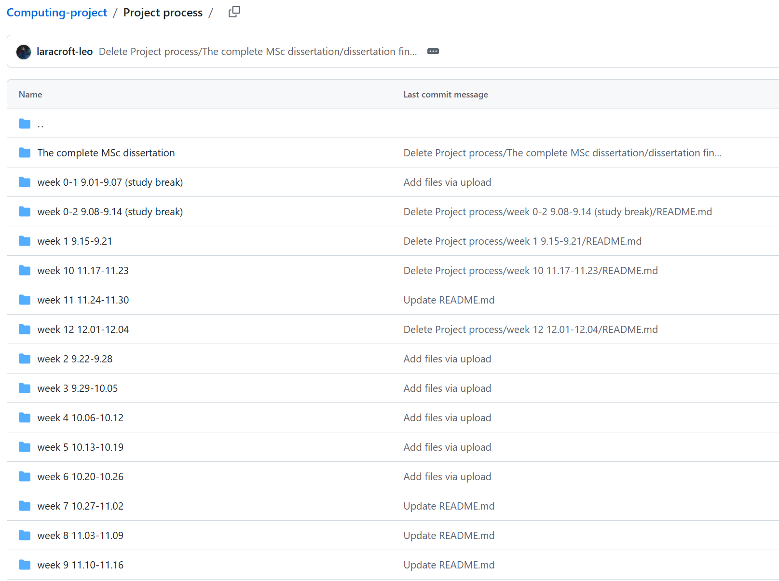
Figure 40 Project process of Computing project

Each weekly folder contains records of the project progress for that specific week. The weekly progress documentation is divided into a detailed version and a concise version. On average, each detailed version consists of several thousand words and documents the weekly action items, completed tasks, results, key findings, reflections, completion status, and planned action items for the following week. It also includes email correspondence with my supervisor, meeting discussions, questions raised, and meeting summaries. The concise version condenses the detailed version into several hundred words while retaining the core content.

In addition, each weekly folder includes meeting transcripts, documents edited and commented on by my supervisor, and revised assignment files updated based on my supervisor’s feedback.

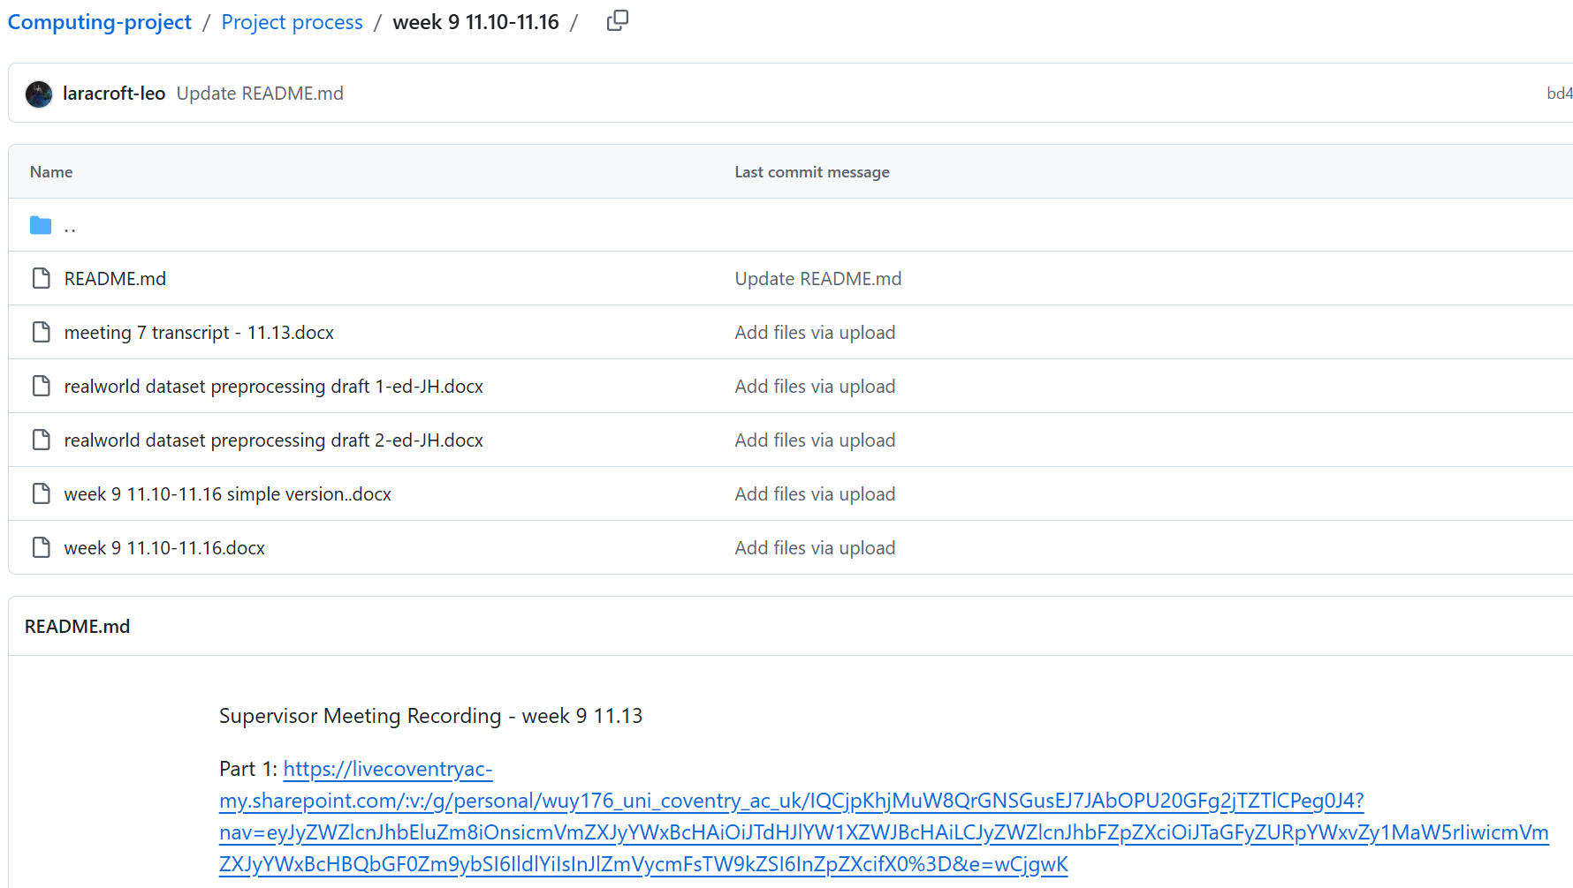
Figure 41 week 9 folder


Figure 42 Detailed Version of the Week 9 Project Process


Figure 43 Simplified Version of the Week 9 Project Progress
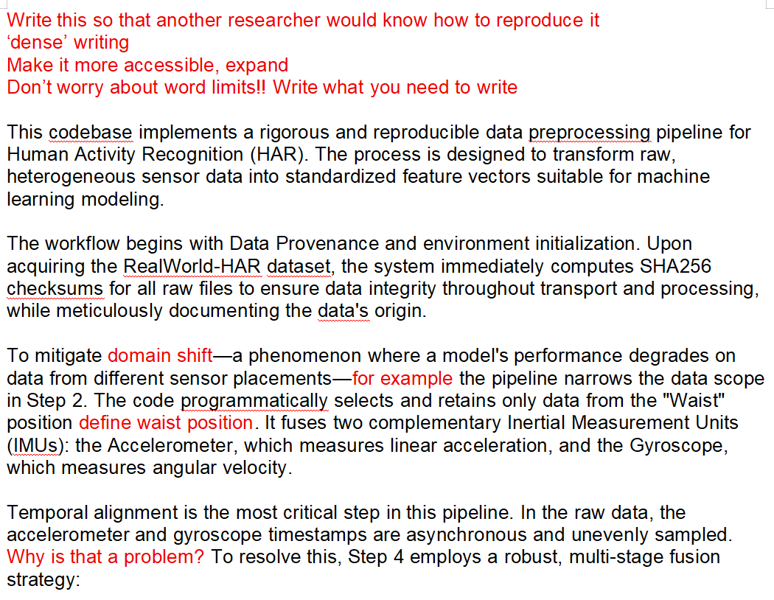
Figure 44 Supervisor’s Writing Feedback for Week 9

The Computing Project Source Code link contains the complete experimental code, results, and accompanying instructions.
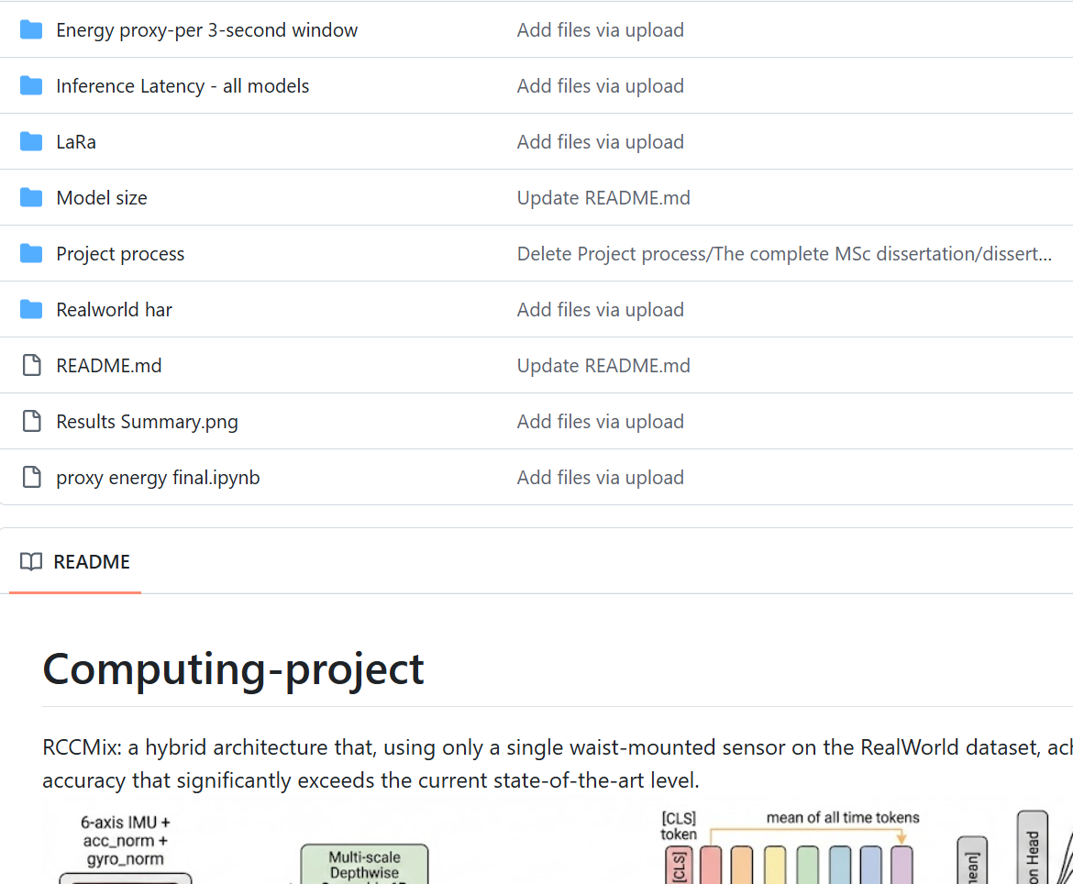
Figure 45 Github for computing project source code link

Computing Individual Research Project (timeline)
Week | Time | Action
0-1 | 9.01-9.07 | Determined the research topic, reviewed the existing knowledge on human activity recognition, and studied high-quality MSc dissertations and journal/conference papers in related areas.
0-2 | 9.08-9.14 | Understood how human activity recognition works and chose an appropriate platform for running the code.
1 | 9.15-9.21 | Gained an in-depth understanding of various aspects of human activity recognition, developed a comprehensive overview of the field as a whole, and determine a specific research direction.
2 | 9.22-9.28 | Gained an in-depth understanding of various aspects of human activity recognition, developed a comprehensive overview of the field as a whole, and determine a specific research direction.
3 | 9.29-10.05 | Ethics application, research proposal, and preprocessing of the RealWorld dataset.
4 | 10.06-10.12 | Completed the preprocessing of the full RealWorld dataset and repeatedly revised the proposal based on the supervisor’s feedback.
5 | 10.13-10.19 | Finished LaRa dataset preprocessing,completed the training and testing of KNN, Random Forest, and InceptionTime on two dataset
6 | 10.20-10.26 | Completed the training and testing of TST, MiniRocket, and MultiRocket on the two dataset.
7 | 10.27-11.02 | Completed the energy consumption measurements for all six baseline models, as well as the sensitivity and robustness experiments for MiniRocket and other statistical analyses.
8 | 11.03-11.09 | Completed the training and testing of DeepConvContext and rTsfNet on both datasets, and designed a lightweight version of rTsfNet.
9 | 11.10-11.16 | Designed RCCMix and RCCMix Lightweight.
10 | 11.17-11.23 | Completed the evaluation of all models in terms of accuracy, model size, inference latency, and energy consumption, and conduct an in-depth analysis of RCCMix and RCCMix Lightweight.
11 | 11.24-11.30 | dissertation
12 | 12.01-12.04 | Presentation and dissertation

Supervision (timeline)

Meeting | Time | Action
1 | 10.02 | Module and supervision arrangements, assessments and deadlines, project process requirements, literature review and references, ethics system and process
2 | 10.09 | Ethics Application vs Research Proposal, deadlines, grace periods and extensions, submission schedule, proposal structure and required content, Gantt chart
3 | 10.16 | Timeline and assessment schedule, marking and weighting, core and stretch objectives, and project management and planning methods
4 | 10.23 | Presented the results of KNN, Random Forest, and InceptionTime on the LARa dataset
5 | 10.30 | Presented the results of TST, MiniRocket, and MultiRocket on the LARa dataset
6 | 11.06 | Presented the results of the six baseline models on the RealWorld dataset, as well as the energy consumption comparison across these six models
7 | 11.13 | Presented the test results of DeepConvContext, rTsfNet, and my self-developed lightweight rTsfNet, and my supervisor helped me revise the draft of the dataset preprocessing section
8 | 11.20 | Canceled (Original plan: present the experimental results of RCCMix and RCCMix Lightweight)
9 | 11.27 | Presented the outcomes of the project process and the draft of the dissertation
Important time points
Time | Action
9.15 | Started of the third semester
9.24 | Release the assignment briefs for Coursework 1 (proposal), Coursework 2 (presentation), and Coursework 3 (dissertation)
9.26 | First lecture of the semester, followed by one lecture every two weeks.
10.02 | First meeting with the supervisor, followed by weekly meetings every Thursday
10.13 | Submission deadline for Coursework 1 (proposal)
10.23 | Changed from group meetings to one-to-one meetings with the supervisor
12.02 | Coursework 2 (presentation) presentation and assessment date
12.04 | Submission deadline for Coursework 3 (dissertation)

Reference
Angerbauer, S., Palmanshofer, A., Selinger, S., & Kurz, M. (2021). Comparing human activity recognition models based on complexity and resource usage. Applied Sciences, 11(18), Article 8473. https://doi.org/10.3390/app11188473

Attal, F., Mohammed, S., Dedabrishvili, M., Chamroukhi, F., Oukhellou, L., & Amirat, Y. (2015). Physical human activity recognition using wearable sensors. Sensors, 15(12), 31314–31338. https://doi.org/10.3390/s151229858

Ayub, M., & El-Alfy, E. S. M. (2025). Enhanced human activity recognition using mixture of Swin Transformers with recurrence plots of triaxial sensor data. IEEE Access, 13, 195719–195734. https://doi.org/10.1109/ACCESS.2025.3631392

Bai, S., Kolter, J. Z., & Koltun, V. (2018). An empirical evaluation of generic convolutional and recurrent networks for sequence modeling. arXiv. https://arxiv.org/abs/1803.01271

Baños, O., Gálvez, J.-M., Damas, M., Pomares, H., & Rojas, I. (2014). Window size impact in human activity recognition. Sensors, 14(4), 6474–6499. https://doi.org/10.3390/s140406474

Bao, L., & Intille, S. S. (2004). Activity recognition from user-annotated acceleration data. In A. Ferscha & F. Mattern (Eds.), Pervasive Computing (Lecture Notes in Computer Science, Vol. 3001, pp. 1–17). Springer. https://doi.org/10.1007/978-3-540-24646-6_1

Bassani, G., Avizzano, C. A., & Filippeschi, A. (2025). Deep learning algorithms for human activity recognition in manual material handling tasks. Sensors, 25(21), Article 6705. https://doi.org/10.3390/s25216705

Bennasar, M., Price, B. A., Gooch, D., Bandara, A. K., & Nuseibeh, B. (2022). Significant features for human activity recognition using tri-axial accelerometers. Sensors, 22(19), Article 7482. https://doi.org/10.3390/s22197482

Bock, M., Hölzemann, A., Moeller, M., & Van Laerhoven, K. (2022). Investigating (re)current state-of-the-art in human activity recognition datasets. Frontiers in Computer Science, 4, Article 924954. https://doi.org/10.3389/fcomp.2022.924954

Bock, M., Moeller, M., & Van Laerhoven, K. (2025). DeepConvContext: A multi-scale approach to timeseries classification in human activity recognition. arXiv. https://arxiv.org/abs/2505.20894

Bragança, H., Colonna, J. G., Oliveira, H. A. B. F., & Souto, E. (2022). How validation methodology influences human activity recognition mobile systems. Sensors, 22(6), Article 2360. https://doi.org/10.3390/s22062360

Brier, G. W. (1950). Verification of forecasts expressed in terms of probability. Monthly Weather Review, 78(1), 1–3. https://doi.org/10.1175/1520-0493(1950)078%3C0001:VOFEIT%3E2.0.CO;2

Bulling, A., Blanke, U., & Schiele, B. (2014). A tutorial on human activity recognition using body-worn inertial sensors. ACM Computing Surveys, 46(3), Article 33. https://doi.org/10.1145/2499621

Calvo, B., & Santafé, G. (2016). scmamp: Statistical comparison of multiple algorithms in multiple problems. The R Journal, 8(1), 248–256. https://doi.org/10.32614/RJ-2016-017

Chan, S., Hang, Y., Tong, C., et al. (2024). CAPTURE-24: A large dataset of wrist-worn activity tracker data collected in the wild for human activity recognition. Scientific Data, 11, Article 1135. https://doi.org/10.1038/s41597-024-03960-3

Chandramouli, S., et al. (2024). Enhanced human activity recognition in medical emergencies using a hybrid deep CNN and bi-directional LSTM model with wearable sensors. Scientific Reports, 14, Article 30391. https://doi.org/10.1038/s41598-024-82045-y

Chen, J., Kao, S.-H., He, H., Zhuo, W., Wen, S., Lee, C.-H., & Chan, S.-H. G. (2023). Run, don’t walk: Chasing higher FLOPS for faster neural networks. arXiv. https://doi.org/10.48550/arXiv.2303.03667

Contoli, C., Freschi, V., & Lattanzi, E. (2024). Energy-aware human activity recognition for wearable devices: A comprehensive review. Pervasive and Mobile Computing, 104, Article 101976. https://doi.org/10.1016/j.pmcj.2024.101976

Cornacchia, M., Ozcan, K., Zheng, Y., & Velipasalar, S. (2017). A survey on activity detection and classification using wearable sensors. IEEE Sensors Journal, 17(2), 386–403. https://doi.org/10.1109/JSEN.2016.2628346

Daghero, F., Burrello, A., Xie, C., Castellano, M., Gandolfi, L., Calimera, A., Macii, E., Poncino, M., & Jahier Pagliari, D. (2022). Human activity recognition on microcontrollers with quantized and adaptive deep neural networks. ACM Transactions on Embedded Computing Systems, 21(5), Article 81. https://doi.org/10.1145/3542819

Dehghani, A., Sarbishei, O., Glatard, T., & Shihab, E. (2019). A quantitative comparison of overlapping and non-overlapping sliding windows for human activity recognition using inertial sensors. Sensors, 19(22), Article 5026. https://doi.org/10.3390/s19225026

Demšar, J. (2006). Statistical comparisons of classifiers over multiple data sets. Journal of Machine Learning Research, 7, 1–30.

Dempster, A., Petitjean, F., & Webb, G. I. (2020). ROCKET: Exceptionally fast and accurate time series classification using random convolutional kernels. Data Mining and Knowledge Discovery, 34, 1454–1495. https://doi.org/10.1007/s10618-020-00701-z

Dempster, A., Schmidt, D. F., & Webb, G. I. (2021). MiniRocket: A very fast almost deterministic transform for time series classification. In Proceedings of the 27th ACM SIGKDD Conference on Knowledge Discovery & Data Mining (pp. 248–257). Association for Computing Machinery. https://doi.org/10.1145/3447548.3467231

Dutt, A., Rachuri, S. P., Lobo, A., Shaik, N., Gandhi, A., & Liu, Z. (2023). Evaluating the energy impact of device parameters for DNN inference on edge. In Proceedings of the 14th International Green and Sustainable Computing Conference (pp. 52–55). Association for Computing Machinery. https://doi.org/10.1145/3634769.3634809

Enokibori, Y. (2024). rTsfNet: A DNN model with multi-head 3D rotation and time series feature extraction for IMU-based human activity recognition. Proceedings of the ACM on Interactive, Mobile, Wearable and Ubiquitous Technologies, 8(4), Article 166. https://doi.org/10.1145/3699733

Gneiting, T., & Raftery, A. E. (2007). Strictly proper scoring rules, prediction, and estimation. Journal of the American Statistical Association, 102(477), 359–378. https://doi.org/10.1198/016214506000001437

Guo, C., Pleiss, G., Sun, Y., & Weinberger, K. Q. (2017). On calibration of modern neural networks. In D. Precup & Y. W. Teh (Eds.), Proceedings of the 34th International Conference on Machine Learning (Vol. 70, pp. 1321–1330). PMLR.

Hammerla, N. Y., Halloran, S., & Plötz, T. (2016). Deep, convolutional, and recurrent models for human activity recognition using wearables. In Proceedings of the Twenty-Fifth International Joint Conference on Artificial Intelligence (pp. 1533–1540). IJCAI.

Hernandez, V., Suzuki, T., & Venture, G. (2020). Convolutional and recurrent neural network for human activity recognition: Application on American sign language. PLOS ONE, 15(2), Article e0228869. https://doi.org/10.1371/journal.pone.0228869

Huang, Y., Zhou, Y., Zhao, H., Riedel, T., & Beigl, M. (2024). A survey on wearable human activity recognition: Innovative pipeline development for enhanced research and practice. In 2024 International Joint Conference on Neural Networks (IJCNN) (pp. 1–10). IEEE. https://doi.org/10.1109/IJCNN60899.2024.10650060

Ismail Fawaz, H., Forestier, G., Weber, J., Idoumghar, L., & Muller, P.-A. (2019). Deep learning for time series classification: A review. Data Mining and Knowledge Discovery, 33(4), 917–963. https://doi.org/10.1007/s10618-019-00619-1

Ismail Fawaz, H., Lucas, B., Forestier, G., Pelletier, C., Schmidt, D. F., Weber, J., Webb, G. I., Idoumghar, L., Muller, P.-A., & Petitjean, F. (2020). InceptionTime: Finding AlexNet for time series classification. Data Mining and Knowledge Discovery, 34(6), 1936–1962. https://doi.org/10.1007/s10618-020-00710-y

Jaén-Vargas, M., Leiva, K. M. R., Fernandes, F., Gonçalves, S. B., Silva, M. T., Lopes, D. S., & Sánchez-Olmedo, J. J. (2022). Effects of sliding window variation in the performance of acceleration-based human activity recognition using deep learning models. PeerJ Computer Science, 8, Article e1052. https://doi.org/10.7717/peerj-cs.1052

Jordão, A., Nazare, A. C., Jr., Sena, J., & Schwartz, W. R. (2018). Human activity recognition based on wearable sensor data: A standardization of the state-of-the-art. arXiv. https://arxiv.org/abs/1806.05226

Kaseris, M., Kostavelis, I., & Malassiotis, S. (2024). A comprehensive survey on deep learning methods in human activity recognition. Machine Learning and Knowledge Extraction, 6(2), 842–876. https://doi.org/10.3390/make6020040

Khan, A. R., Manzoor, H. U., Ayaz, F., Imran, M. A., & Zoha, A. (2023). A privacy and energy-aware federated framework for human activity recognition. Sensors, 23(23), Article 9339. https://doi.org/10.3390/s23239339

Kumar, A., Sarawagi, S., & Jain, U. (2018). Trainable calibration measures for neural networks from kernel mean embeddings. In J. Dy & A. Krause (Eds.), Proceedings of the 35th International Conference on Machine Learning (Vol. 80, pp. 2805–2814). PMLR.

Kuncan, F., Kaya, Y., & Yiner, Z. (2022). A new approach for physical human activity recognition from sensor signals based on motif patterns and long-short term memory. Biomedical Signal Processing and Control, 78, Article 103963. https://doi.org/10.1016/j.bspc.2022.103963

Lara, O. D., & Labrador, M. A. (2013). A survey on human activity recognition using wearable sensors. IEEE Communications Surveys & Tutorials, 15(3), 1192–1209. https://doi.org/10.1109/SURV.2012.110112.00192

Lawal, I. A., & Bano, S. (2020). Deep human activity recognition with localisation of wearable sensors. IEEE Access, 8, 155060–155070. https://doi.org/10.1109/ACCESS.2020.3017681

Macbeth, G., Razumiejczyk, E., & Ledesma, R. D. (2011). Cliff’s Delta Calculator: A non-parametric effect size program for two groups of observations. Universitas Psychologica, 10(2), 545–555. https://doi.org/10.11144/javeriana.upsy10-2.cdcp

Mahmud, S., Tonmoy, M. T. H., Bhaumik, K. K., Rahman, A. K. M. M., Amin, M. A., Shoyaib, M., Khan, M. A. H., & Ali, A. A. (2020). Human activity recognition from wearable sensor data using self-attention. In ECAI 2020 (Frontiers in Artificial Intelligence and Applications). IOS Press. https://doi.org/10.3233/FAIA200236

Mekruksavanich, S., & Jitpattanakul, A. (2024). Device position-independent human activity recognition with wearable sensors using deep neural networks. Applied Sciences, 14(5), Article 2107. https://doi.org/10.3390/app14052107

Moya Rueda, F., Grzeszick, R., Fink, G. A., Feldhorst, S., & ten Hompel, M. (2018). Convolutional neural networks for human activity recognition using body-worn sensors. Informatics, 5(2), Article 26. https://doi.org/10.3390/informatics5020026

Nguyen, D.-A., & Le-Khac, N.-A. (2024). SoK: Behind the accuracy of complex human activity recognition using deep learning. In 2024 International Joint Conference on Neural Networks (pp. 1–8). IEEE. https://doi.org/10.1109/IJCNN60899.2024.10650322

Niemann, F., Reining, C., Moya Rueda, F., Nair, N. R., Steffens, J. A., Fink, G. A., & ten Hompel, M. (2020). LARa: Creating a dataset for human activity recognition in logistics using semantic attributes. Sensors, 20(15), Article 4083. https://doi.org/10.3390/s20154083

Nixon, J., Dusenberry, M. W., Zhang, L., Jerfel, G., & Tran, D. (2019). Measuring calibration in deep learning. In Proceedings of the IEEE/CVF Conference on Computer Vision and Pattern Recognition Workshops (pp. 38–41).

Nweke, H. F., Teh, Y. W., Al-Garadi, M. A., & Alo, U. R. (2018). Deep learning algorithms for human activity recognition using mobile and wearable sensor networks: State of the art and research challenges. Expert Systems with Applications, 105, 233–261. https://doi.org/10.1016/j.eswa.2018.03.056

Ordóñez, F. J., & Roggen, D. (2016). Deep convolutional and LSTM recurrent neural networks for multimodal wearable activity recognition. Sensors, 16(1), Article 115. https://doi.org/10.3390/s16010115

Rashid, N., Demirel, B. U., & Al Faruque, M. A. (2022). AHAR: Adaptive CNN for energy-efficient human activity recognition in low-power edge devices. IEEE Internet of Things Journal. https://doi.org/10.1109/JIOT.2022.3140465

Ravi, N., Dandekar, N., Mysore, P., & Littman, M. L. (2005). Activity recognition from accelerometer data. In Proceedings of the Seventeenth Innovative Applications of Artificial Intelligence Conference (pp. 1541–1546). AAAI Press.

Rehman, S. U., Ali, A., Khan, A. M., & Okpala, C. (2024). Human activity recognition: A comparative study of validation methods and impact of feature extraction in wearable sensors. Algorithms, 17(12), Article 556. https://doi.org/10.3390/a17120556

Rivas-Caicedo, J. L., Niño-Tejada, K., Saldaña-Aristizábal, L., & Patarroyo-Montenegro, J. F. (2025). A distributed wearable computing framework for human activity recognition. Electronics, 14(16), Article 3203. https://doi.org/10.3390/electronics14163203

Rooney, T. (2023). A cross-platform extension of IrEne: Measuring GPU energy consumption using an NVML-based approach. University of Edinburgh Undergraduate Project Report.

Rosati, S., Balestra, G., & Knaflitz, M. (2018). Comparison of different sets of features for human activity recognition by wearable sensors. Sensors, 18(12), Article 4189. https://doi.org/10.3390/s18124189

Ruiz, A. P., Flynn, M., Large, J., Middlehurst, M., & Bagnall, A. (2021). The great multivariate time series classification bake off: A review and experimental evaluation of recent algorithmic advances. Data Mining and Knowledge Discovery, 35, 401–449. https://doi.org/10.1007/s10618-020-00727-3

Scheurer, S., Tedesco, S., Brown, K. N., & O’Flynn, B. (2020). Comparing person-specific and independent models on smartphone-based human activity recognition. Sensors, 20(13), Article 3647. https://doi.org/10.3390/s20133647

Serpush, F., Menhaj, M. B., Masoumi, B., & Karasfi, K. (2022). Wearable sensor-based human activity recognition in the smart healthcare system. Computational Intelligence and Neuroscience, 2022, Article 1391906. https://doi.org/10.1155/2022/1391906

Sun, H., Yao, J., Li, X., Liu, Y., & Gu, H. (2025). Robust two stages federated learning for sensor based human activity recognition with label noise. Scientific Reports, 15, Article 17227. https://doi.org/10.1038/s41598-025-02395-z

Sztyler, T., & Stuckenschmidt, H. (2016). On-body localization of wearable devices: An investigation of position-aware activity recognition. In 2016 IEEE International Conference on Pervasive Computing and Communication Workshops (pp. 1–6). IEEE. https://doi.org/10.1109/PERCOMW.2016.7457161

Tan, C. W., Dempster, A., Bergmeir, C., & Webb, G. I. (2022). MultiRocket: Multiple pooling operators and transformations for fast and effective time series classification. Data Mining and Knowledge Discovery, 36(5), 1623–1646. https://doi.org/10.1007/s10618-022-00844-1

Tello, A., Degeler, V., & Lazovik, A. (2024). Too good to be true: Accuracy overestimation in (re)current practices for human activity recognition. In 2024 IEEE International Conference on Pervasive Computing and Communications Workshops and Other Affiliated Events (pp. 511–517). IEEE. https://doi.org/10.1109/PerComWorkshops59983.2024.10503465

Vargha, A., & Delaney, H. D. (2000). A critique and improvement of the CL common language effect size statistics of McGraw and Wong. Journal of Educational and Behavioral Statistics, 25(2), 101–132. https://doi.org/10.3102/10769986025002101

Vaswani, A., Shazeer, N., Parmar, N., Uszkoreit, J., Jones, L., Gomez, A. N., Kaiser, Ł., & Polosukhin, I. (2017). Attention is all you need. In Advances in Neural Information Processing Systems, 30.

Wang, G., Li, Q., Wang, L., Wang, W., Wu, M., & Liu, T. (2018). Impact of sliding window length in indoor human motion modes and pose pattern recognition based on smartphone sensors. Sensors, 18(6), Article 1965. https://doi.org/10.3390/s18061965

Wang, Y., Cang, S., & Yu, H. (2019). A survey on wearable sensor modality centred human activity recognition in health care. Expert Systems with Applications, 137, 167–190. https://doi.org/10.1016/j.eswa.2019.04.057

Wen, Q., Zhou, T., Zhang, C., Chen, W., Ma, Z., Yan, J., & Sun, L. (2023). Transformers in time series: A survey. In Proceedings of the Thirty-Second International Joint Conference on Artificial Intelligence (pp. 6778–6786). https://doi.org/10.24963/ijcai.2023/759

Yang, J. B., Nguyen, M. N., San, P. P., Li, X. L., & Krishnaswamy, S. (2015). Deep convolutional neural networks on multichannel time series for human activity recognition. In Proceedings of the Twenty-Fourth International Joint Conference on Artificial Intelligence (pp. 3995–4001). IJCAI.

Zeng, M., Nguyen, L. T., Yu, B., Mengshoel, O. J., Zhu, J., Wu, P., & Zhang, J. (2014). Convolutional neural networks for human activity recognition using mobile sensors. In Proceedings of the 6th International Conference on Mobile Computing, Applications and Services (pp. 197–205). ICST. https://doi.org/10.4108/icst.mobicase.2014.257786

Zerveas, G., Jayaraman, S., Patel, D., Bhamidipaty, A., & Eickhoff, C. (2021). A Transformer-based framework for multivariate time series representation learning. In Proceedings of the 27th ACM SIGKDD Conference on Knowledge Discovery & Data Mining (pp. 2114–2124). Association for Computing Machinery. https://doi.org/10.1145/3447548.3467401

Zhang, S., Li, Y., Zhang, S., Shahabi, F., Xia, S., Deng, Y., & Alshurafa, N. (2022). Deep learning in human activity recognition with wearable sensors: A review on advances. Sensors, 22(4), Article 1476. https://doi.org/10.3390/s22041476

Use of AI:
Searched for in-depth information in specialized fields, corrected my grammatical mistakes, sentence structures and identified the research gap, corrected code mistakes, modified model’s pictures, org, convert the supervision meeting transcripts into Chinese

Appendices
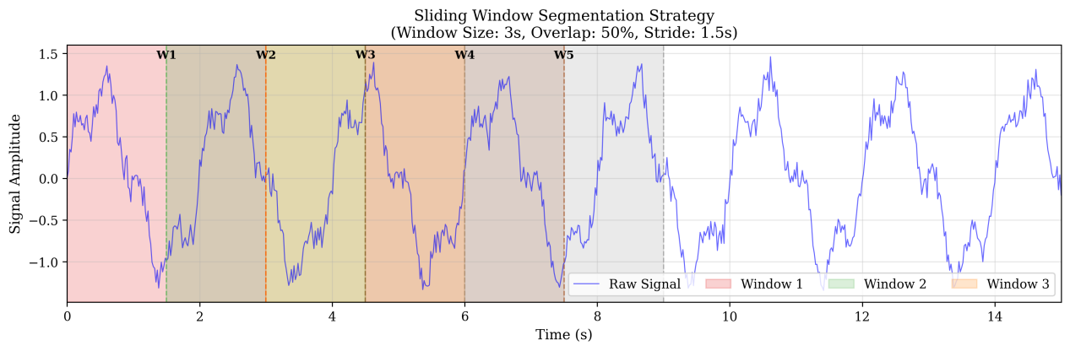
Figure 46 Sliding window segmentation strategy
Figure 46 illustrates the sliding-window segmentation strategy used to convert continuous sensor signals into fixed-length samples. In this study, each window has a length of 3 seconds, and adjacent windows overlap by 50%, resulting in a stride of 1.5 seconds. This approach preserves local temporal patterns in the IMU signal while increasing the number of training samples. Each segmented window is then treated as one input sample for model training and evaluation.

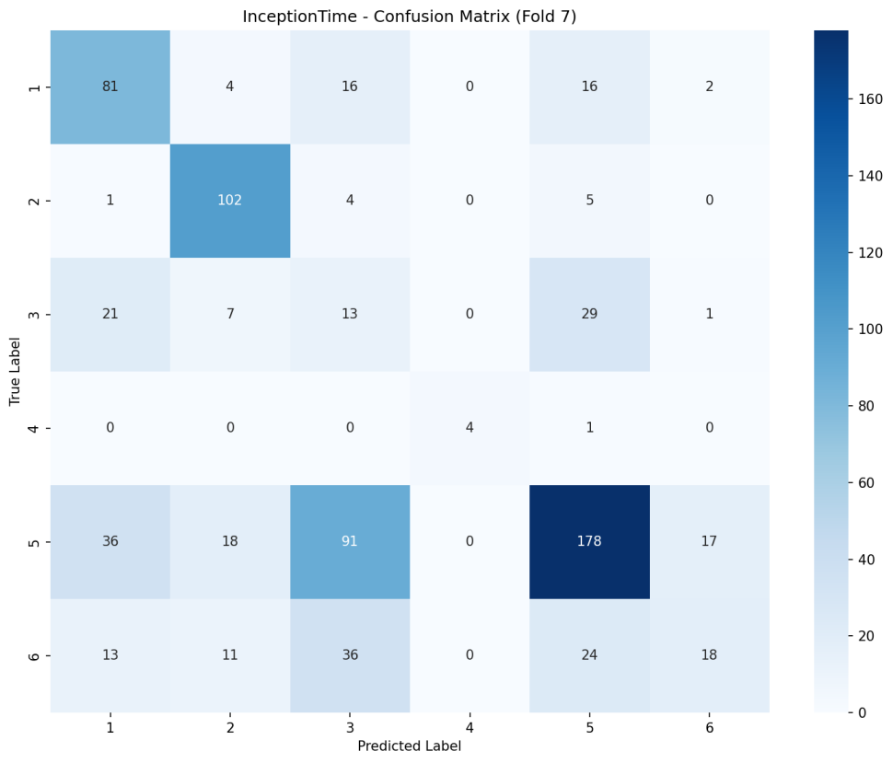
Figure 47 Confusion matrix of InceptionTime on the LARa right-wrist dataset in Fold 7
Figure 47 shows the Fold 7 confusion matrix for InceptionTime on the LARa dataset. The model performs well on class 2, with most samples correctly classified, and also captures a large proportion of class 1 and class 5 samples. However, clear confusion appears between several activity classes, especially class 3 and class 5, and between class 6 and classes 3/5. This indicates that some LARa activities have highly similar wrist-motion patterns, making them difficult to distinguish using the right-wrist sensor alone. The very small number of samples in class 4 also suggests that class imbalance may affect the stability of per-class performance. Overall, the matrix shows that InceptionTime can learn useful temporal patterns, but its performance is limited by inter-class similarity and uneven class distribution in the LARa subset.

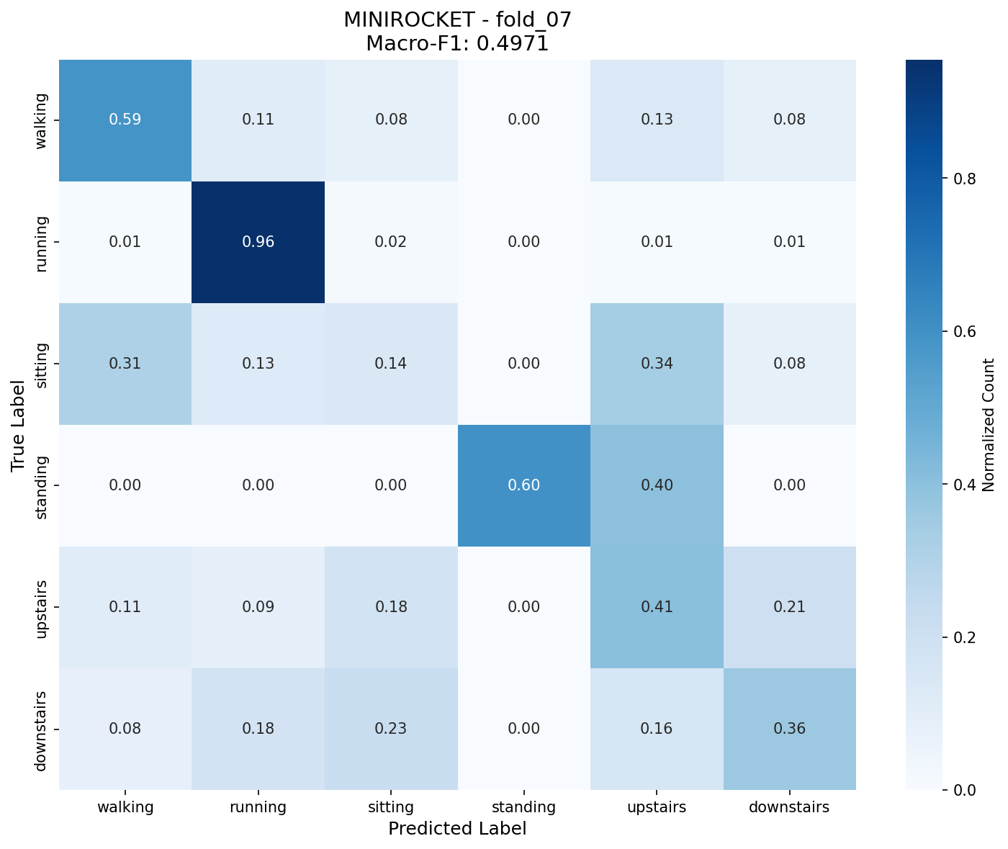
Figure 48 Row-normalised confusion matrix of MiniRocket on the LARa right-wrist dataset in Fold 7
Figure 48 shows the Fold 7 confusion matrix for MiniRocket on the LARa dataset, with a Macro-F1 score of 0.4971. The model performs very well on running, achieving a high recall of 0.96, and shows moderate recognition for walking and standing. However, several activities remain difficult to distinguish. In particular, sitting is often misclassified as walking or upstairs, while upstairs and downstairs are frequently confused with each other. This indicates that MiniRocket can capture some discriminative motion patterns, but its performance is limited by the similarity of wrist-motion signals across several LARa activities.

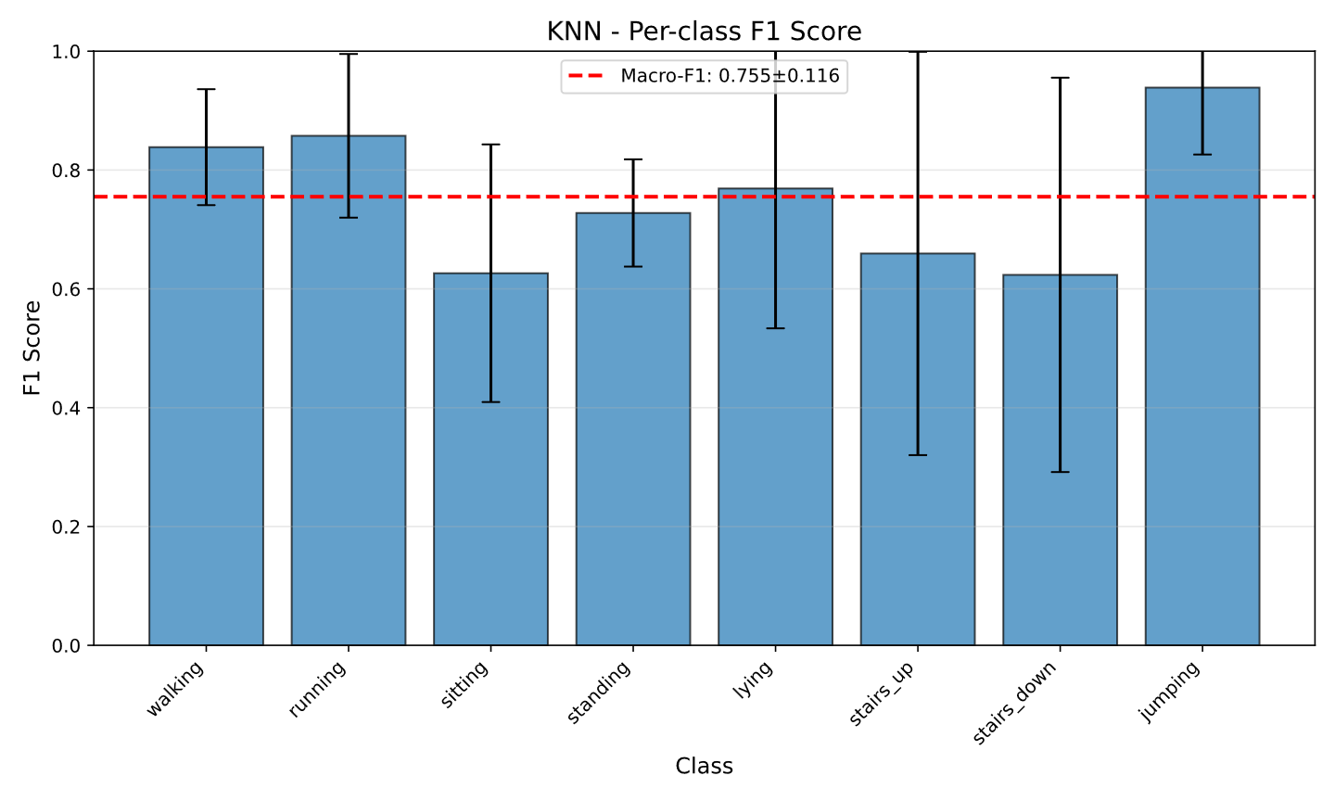
Figure 49 Per-class F1 scores of KNN on the RealWorld dataset
Figure 49 presents the per-class F1 scores of KNN on the RealWorld HAR dataset. The red dashed line represents the overall Macro-F1 score of 0.755 ± 0.116. KNN performs best on jumping, running, and walking, suggesting that activities with distinctive motion patterns are easier to recognise. In contrast, sitting, stairs up, and stairs down obtain lower F1 scores, indicating that static or stair-related activities are more difficult to separate. The larger error bars for stair-related classes also suggest stronger performance variation across LOSO folds.

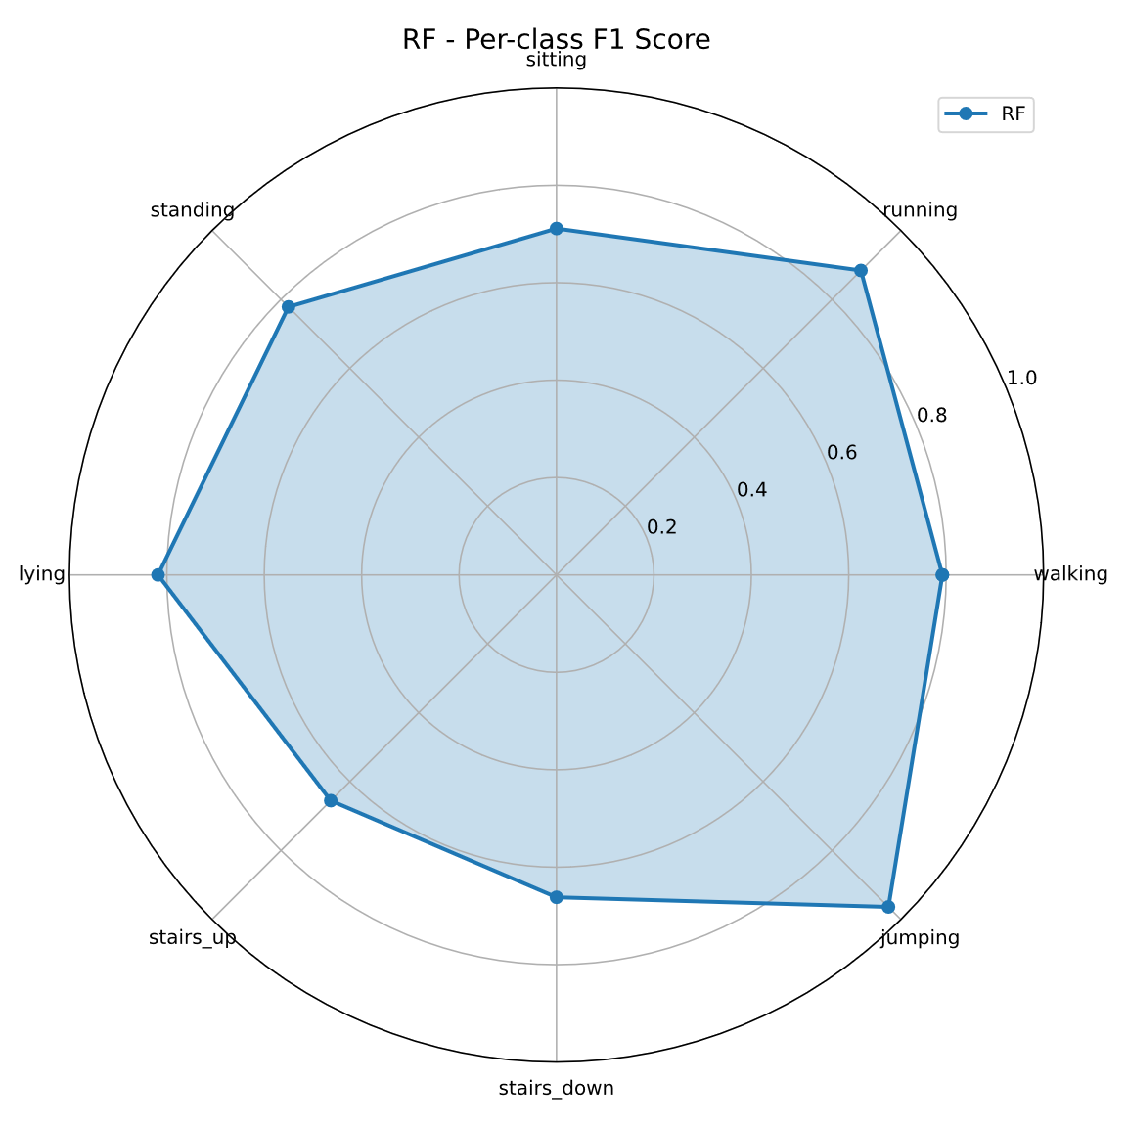
Figure 50 Per-class F1 scores of Random Forest on the RealWorld dataset
Figure 50 shows the per-class F1 scores of Random Forest on the RealWorld HAR dataset. The model achieves strong performance on jumping, running, lying, and walking, indicating that RF can effectively recognise activities with distinct motion patterns. However, the F1 scores for stairs up and stairs down are lower, suggesting that stair-related activities are more difficult to distinguish from other locomotion classes. Overall, RF shows relatively balanced performance across most classes, but still struggles with activities that have similar waist-mounted sensor signals.

